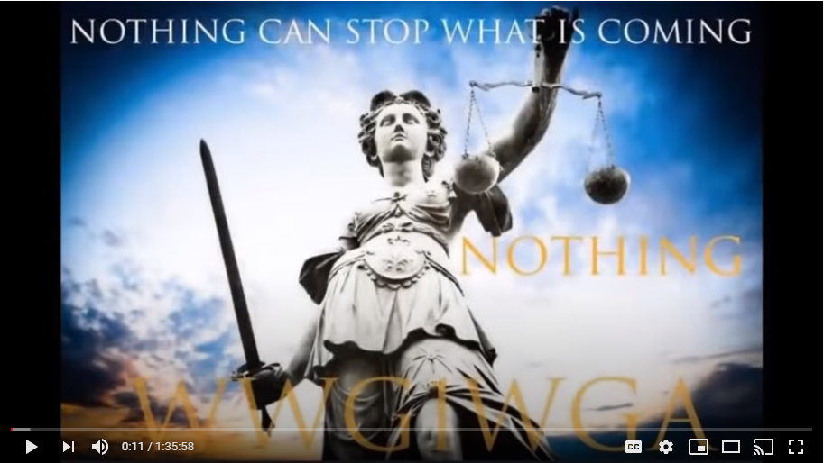
This is going to be the proof for you. To give you the strength to have the courage to trust in the plan for the next six months. You're going to see overwhelming proof across the entire earth.
From the summer of 2017 until now, you're going to see this play itself out.

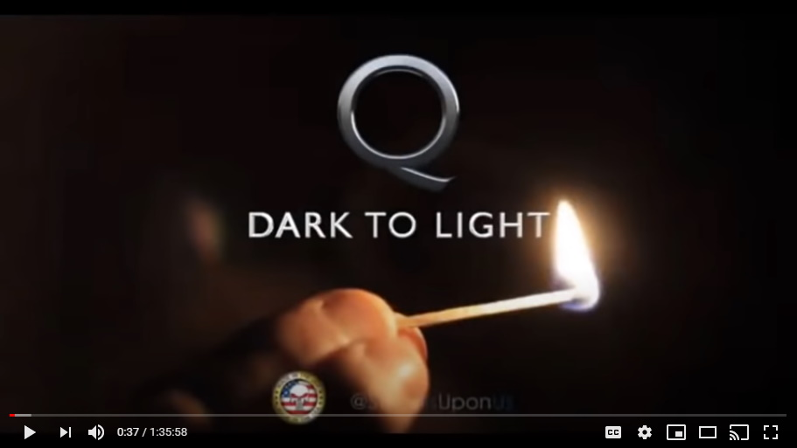

To make it clear again CNN is now in control by POTUS, Donald J Trump. Boris Johnson and the British government is under control of POTUS and the NSA and the Q Plan, the Q group. This is all being run by this group.
Every single government on earth, all of them, have capitulated over to Trump, and that's why Trump made from 2017 to early 2019.
Colleen: He hit the ground running.

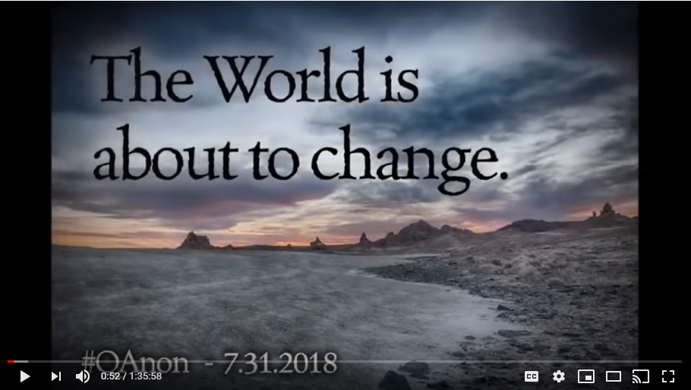
Yes he did and he took six months to clean house, clean the swamp in Washington and then...and we're going to start here in a sec...then he went to Saudi Arabia first because he needed to. There's a reason he went to Saudi Arabia first. That was the summer of 2017 and that's where this whole story I'm going to tell you today begins.

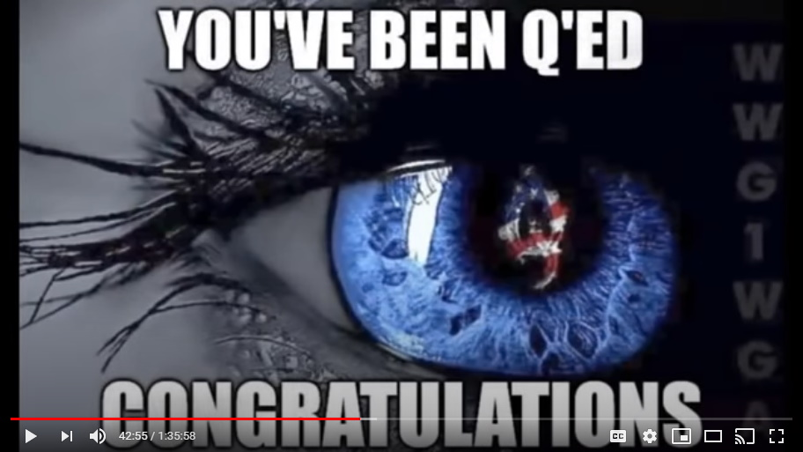
So, we're listening and you're gonna be...you're just gonna walk away from this angry or whatever, but you need to understand mia culpa; it rests with you, it rests with me. If it wasn't for us being so asleep none of this would have been allowed to happen.

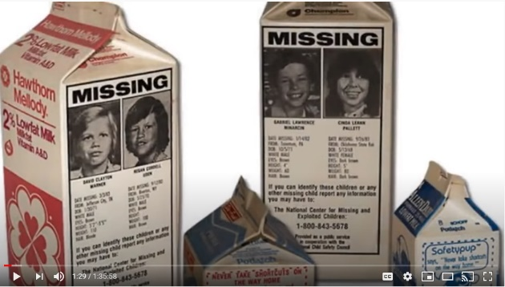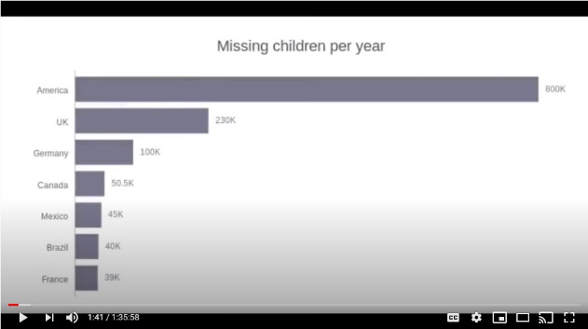
We should have woken up to the milk cartons 30-40 years ago with all of these children going missing. If we live in the most advanced western world in the history of the world then what the heck are so many children going missing for and why are so many kids on milk cartons?

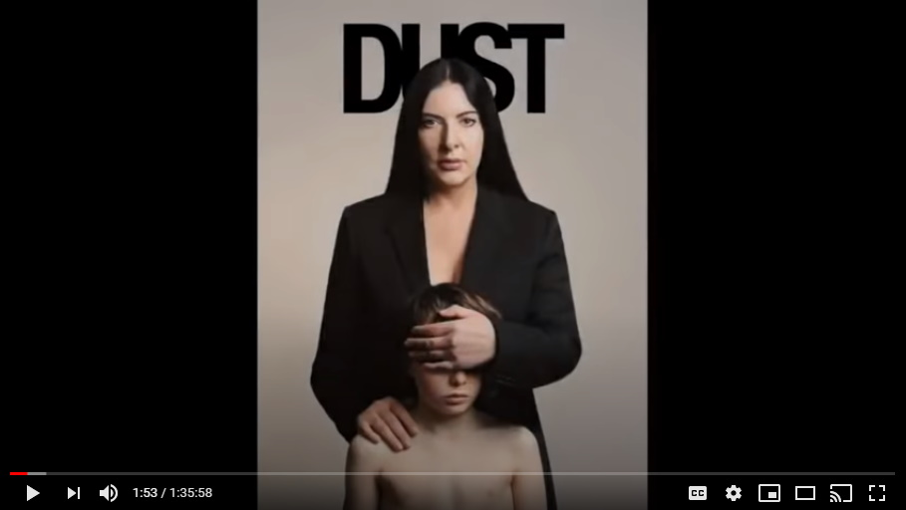
Colleen: Yeah, the excuse of us being asleep just doesn't cut it when you see what's been taking place right under our nose...that just doesn't cut it.

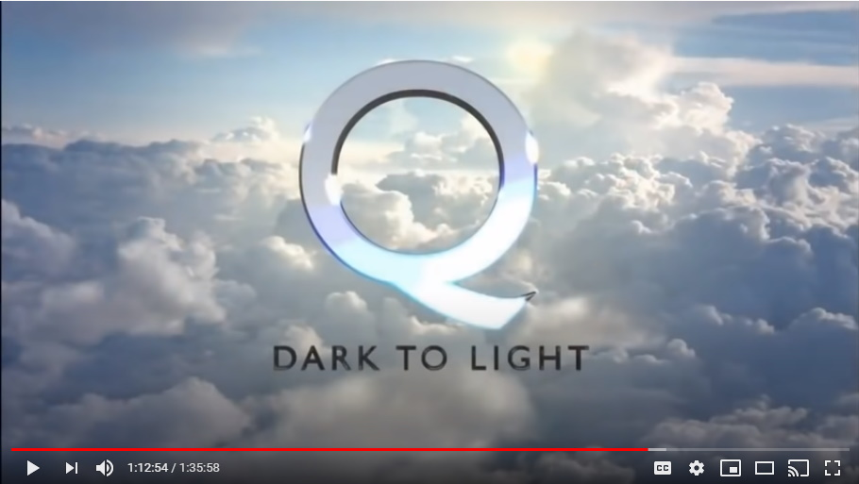
I know some of you are going to be very angry with this...all I can say to you is that we are responsible. All of us are responsible for this and also need to see this as an opportunity. The next six months are an opportunity. It's an opportunity for all of you to become the kind of hero you've always wanted to be in your eyes.

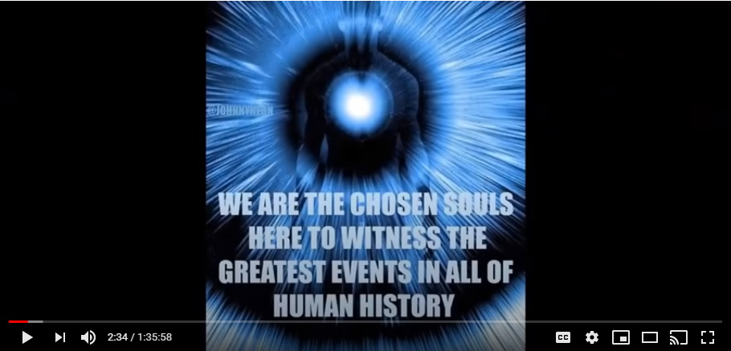
Trust in you. Trust in the plan that there are good people fighting against the sickest, evil, most evil people in the creation of evil. Come on. Come on. There are good people out there...you get up and be part of this.
Colleen: They are our tribe. Support them. We're the digital warriors, we're the...

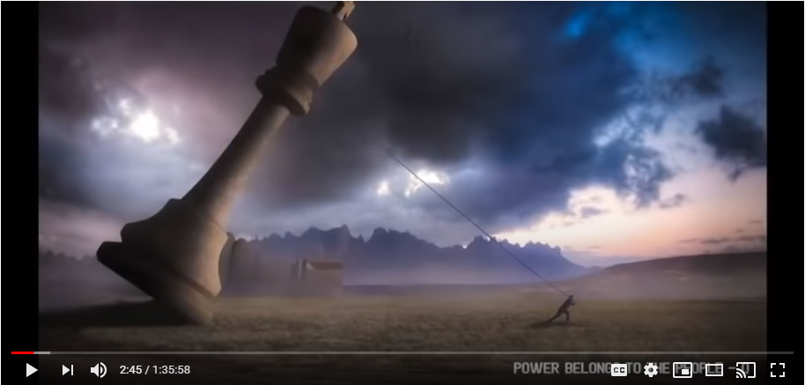
Absolutely, and be strong for your kids like so many of you already are, and be that hero. This is your chance. These six months is for you to write a new story in your life and you to become the strong person you've always wanted to be and the hero that you have always deserved to be.
Be strong, not weak. Don't sit back and just go Trump's gonna do everything. No. No, no, no. No more with BOJO playing this role, no more with Matt Hancock...enough of this.
It's your country, it's not theirs. Who are you afraid of? The police? Remember, they get paid by you. The Army? They get paid by you. They took oaths to protect you, not their immediate superiors.

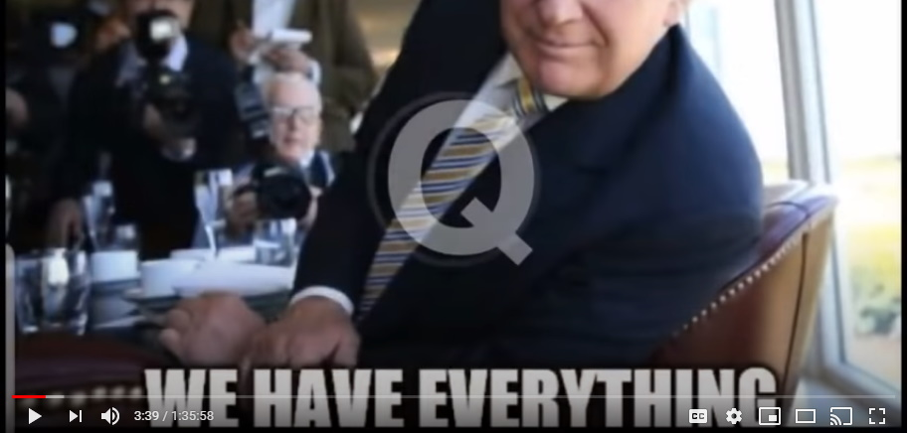
So be strong. These six months are a gift, an opportunity for you. You may not be able to wrap your heads around that...it is what it is. But it is an opportunity. This is a gift and we need to take this gift.

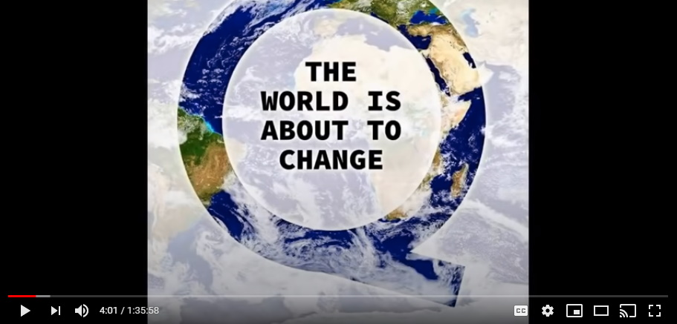
Mark: And who imagined on January 1st of this year, that 2020 would roll out the way it has. Nobody had any idea of what was coming, but here we are almost halfway through it. So, I think this is a pretty good point for you to take it away and just say what you wanted to say today.

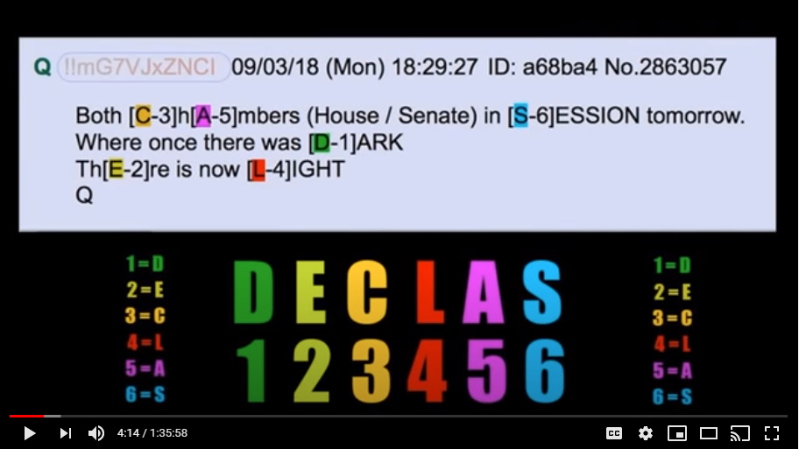
Okay, let's start first, everything is about Donald Trump and the abbreviation you get with Q called DECLAS, an abbreviation for de-class, short for declassify.
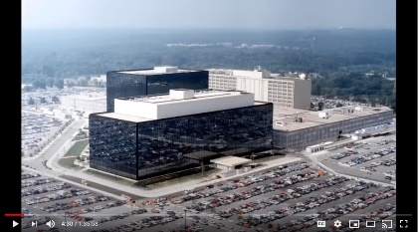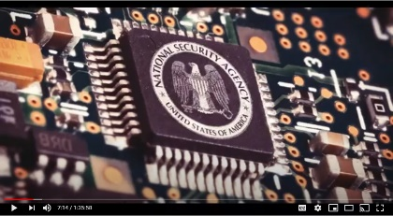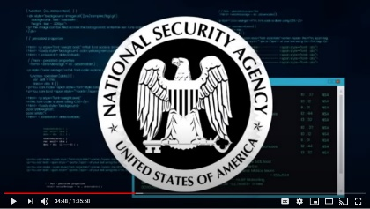
So, the main people behind all of this have been the NSA, because once the military was given access to all of this--cameras everywhere, and spying technology everywhere, access to your cell phone, access to everything about you--as soon as that information became available, a group of military people said, this is our chance, there is a moment in time and we must act upon this because what they don't seem to get, and by that meaning the minions who are running things for whoever is hidden in the background, what these minions don't seem to get is that they're just as vulnerable as we are.

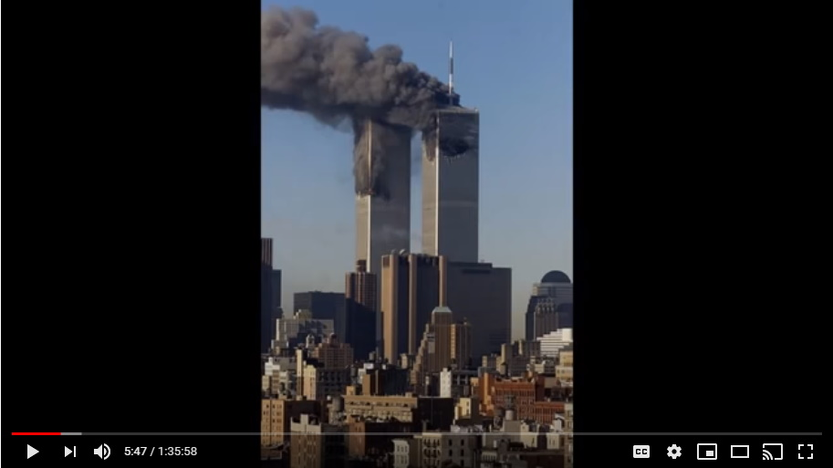
And so, what has been going on my friends since 9/11--so remember 911, how evil that is, and it was evil you know, the Cremation Of Care--11, the twin pillars, that's the two temples of your brain, and 9 is God consciousness, and it was the killing of God on September 11th 2001. That's the symbology of it, they were laying out for us in plain sight what they were about to do and finish in the coronavirus through 5G towers, 5G wireless signal was their coup de gras, was their kill shot.

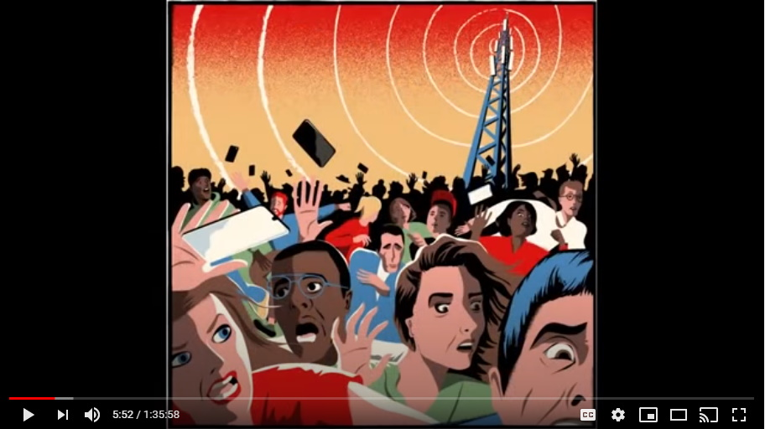
That was going to be the kill shot for us and everything went wrong when Hillary didn't win that election.

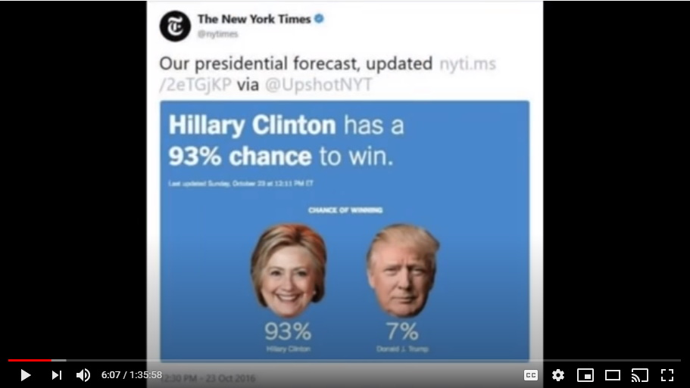
What you all need to wrap your mind around, is they still to this day don't understand how they lost that election in November 2016 to Donald Trump.

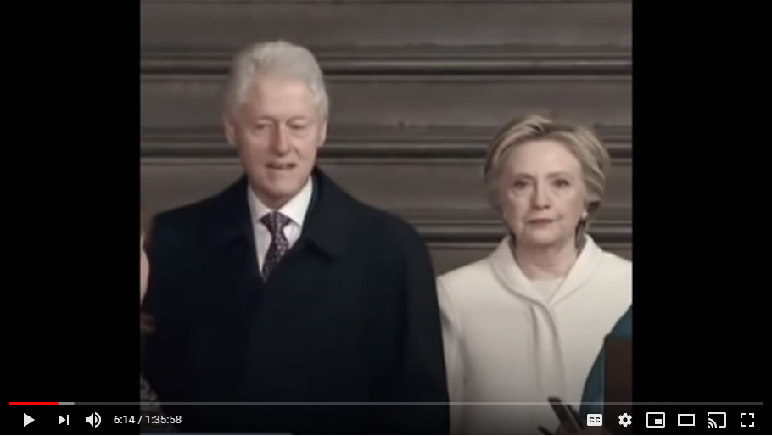
They don't know how, because it was rigged in their favor. The machines were rigged in all the key states and that's why Trump actually won in a landslide. The machines, California, all the key states, were rigged for Clinton, that's why as the night went on, she started to catch up a little bit, but no, it was a run away for Trump across the entire land.

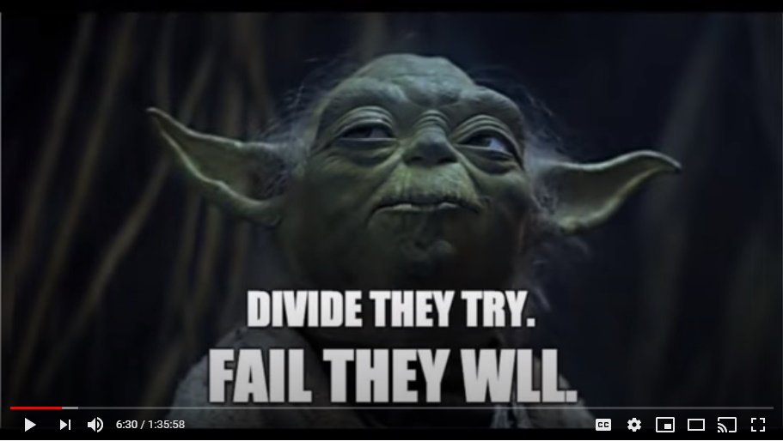
They had it rigged for a massive Hillary victory and if that had happened we'd already be in the FEMA camps.

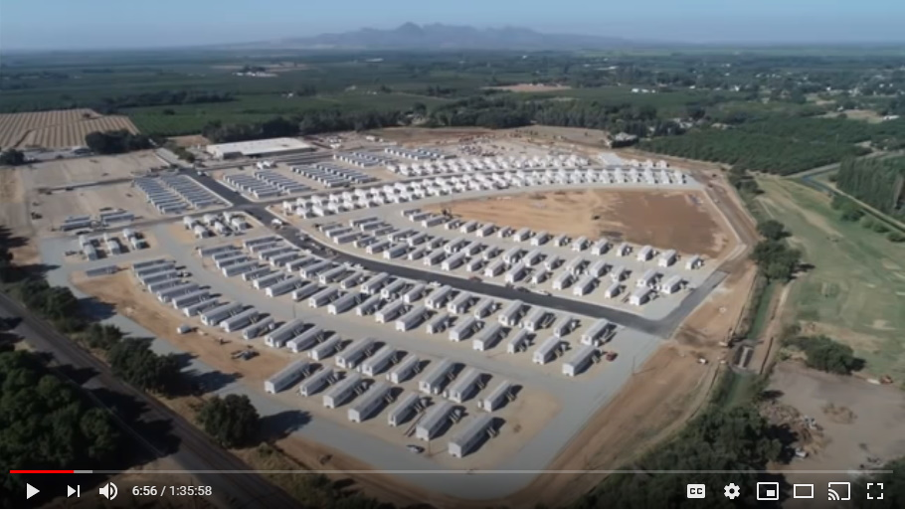
We'd already be locked in our homes. Those of us that didn't comply to that would be in FEMA camps or in body bags.

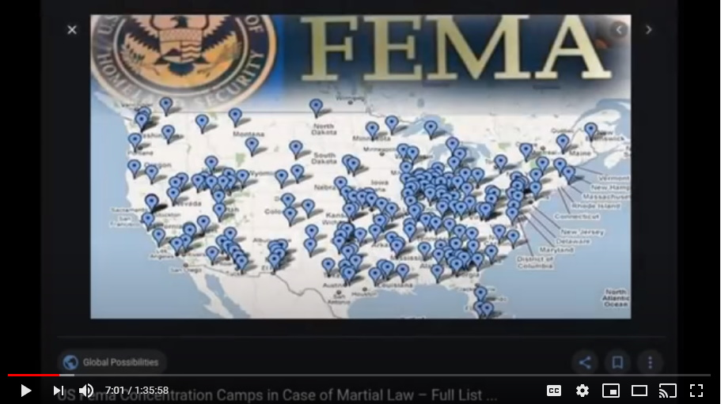
So this was it, this is the plan.

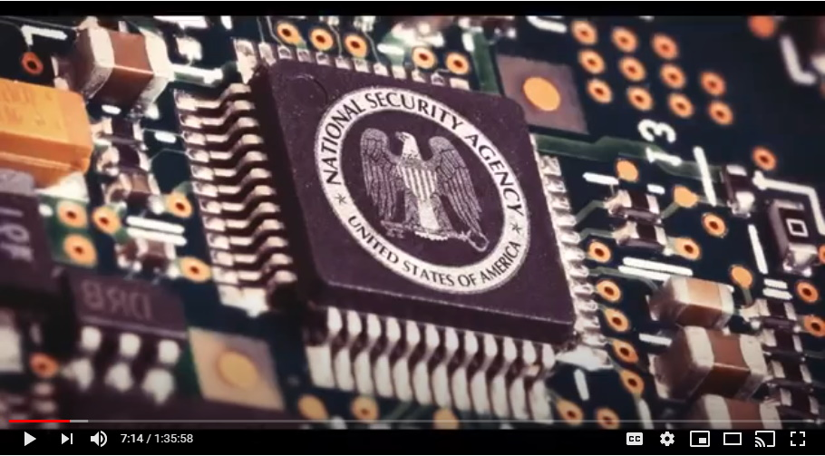
So it all starts with the symbol DECLAS—declassify--this comes from the NSA. They have been spying on them and they have it all.

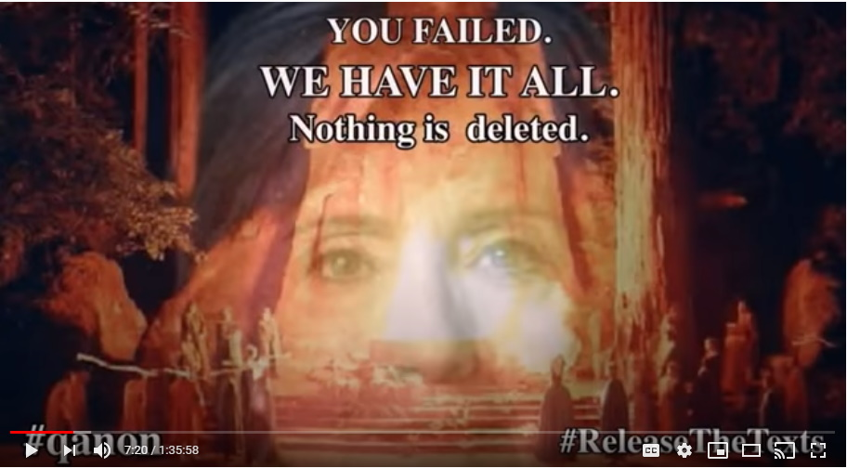
Nothing can stop this plan. Nothing can stop what's coming because they have everything.

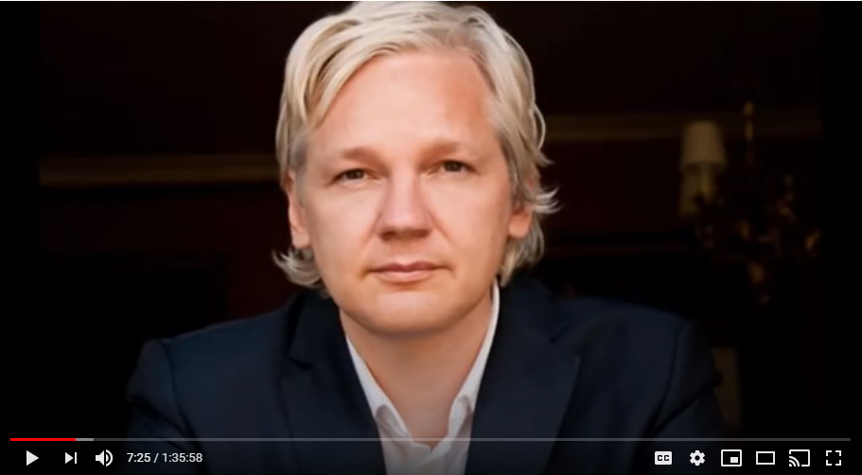
And Julian Assange has been a big player in doing that.

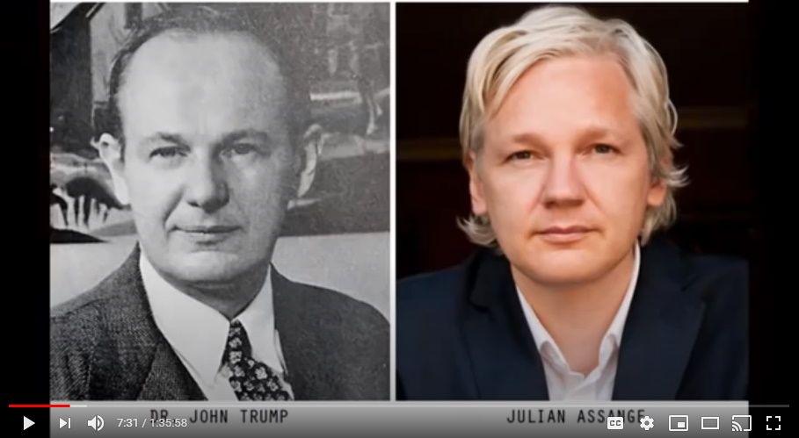
And eventually, when the truth comes out about Julian Assange, you'll go, oh, I should have noticed that, I should have picked up on that but I didn't.
You'll see. I don't want to give too much away.

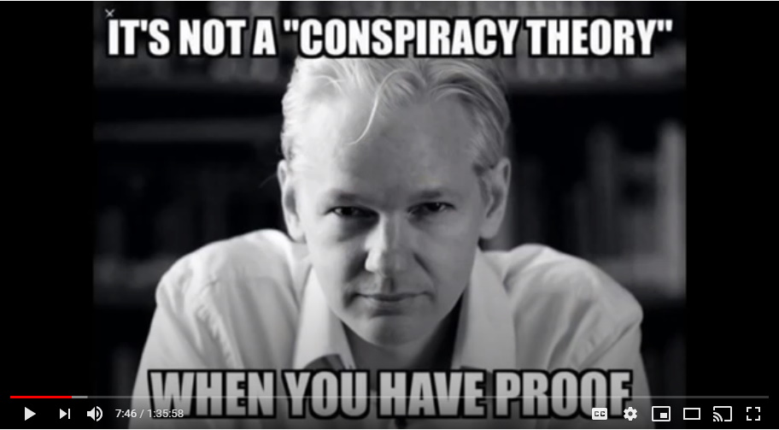
So, number one is declassify.
Mark: Was Assange really under arrest, or was that some kind of ruse?
All part of a ruse for the mainstream media to buy into it, to brand him a certain way and stuff. So, yeah he's played a very dangerous role. None of this has been safe and easy for Julian Assange. He's been at risk, he's put himself at risk, but then that whole family has. And there's much more to this family that were talking about that is yet to come.

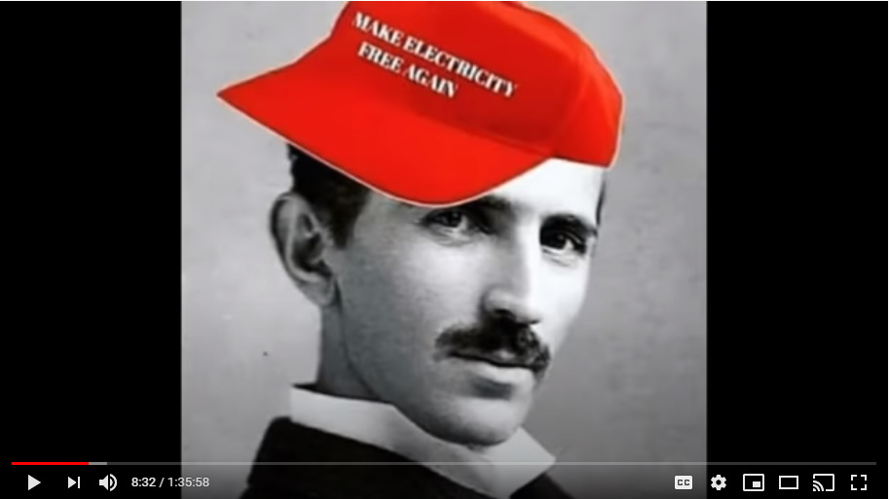
You don't know all of it yet. You don't know who's coming out next because it's going to be another person in this family that's going to be able to shine in the coming months because this is all about technology at the end of the day. We'll get to that later.

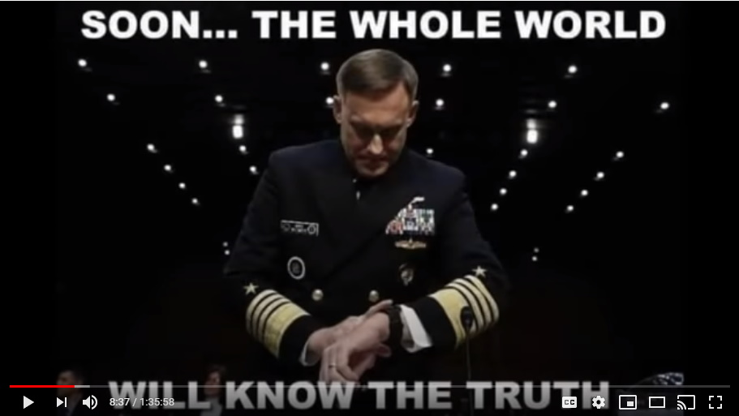
Now, number one, they took all of this information, Trump, by the way folks, didn't do anything although Attorney General Barr was placed well in advance to be kind of like a fly on the wall for the CIA.

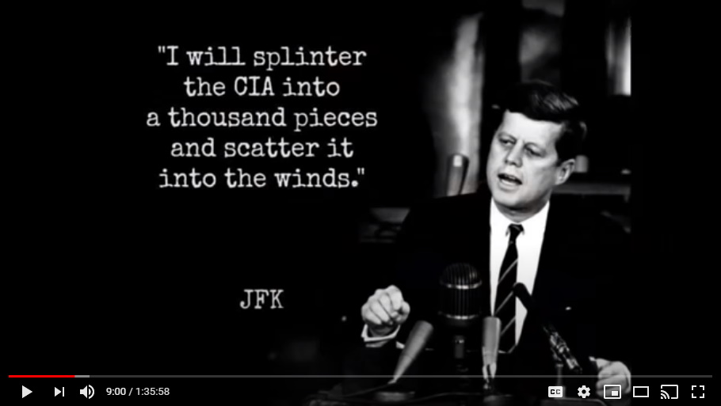
They realized a long time ago from the Kennedy's, that the CIA was too far gone and too dangerous to try and take down and too many tentacles out there, so they haven't even tried to take down the CIA, they have just cut them off.

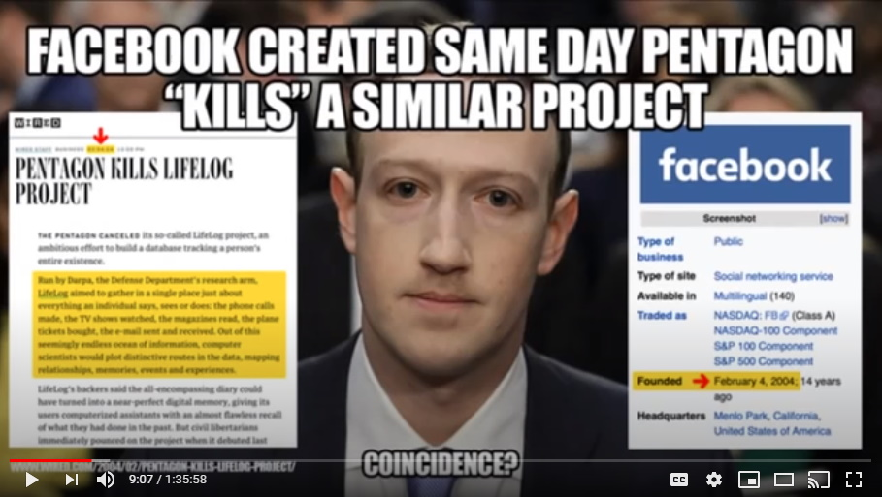
The CIA is what it always has been, it's just in plain sight now. They are a rogue agency, they always have been a rogue agency. They exist for the 13 families. That's all they exist for, that's all they answer to.

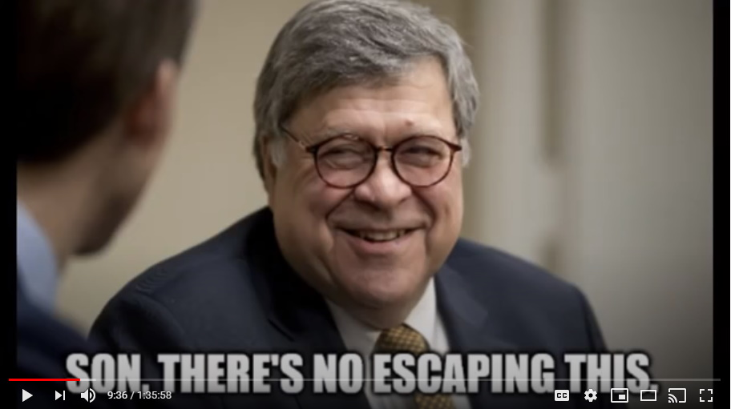
AG Barr was put there in a special position as a fly on the wall, and he's gleaned a lot of information that has been valuable in helping them understand the CIA's role in all of this, and what they were likely to do when this all came down okay, so remember that.

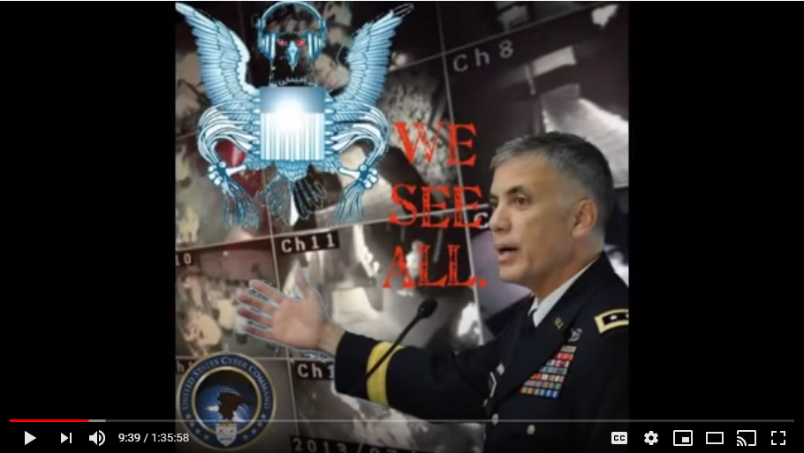
DECLAS is everything because the NSA has everything. Trump is armed with everything by June of 2017.

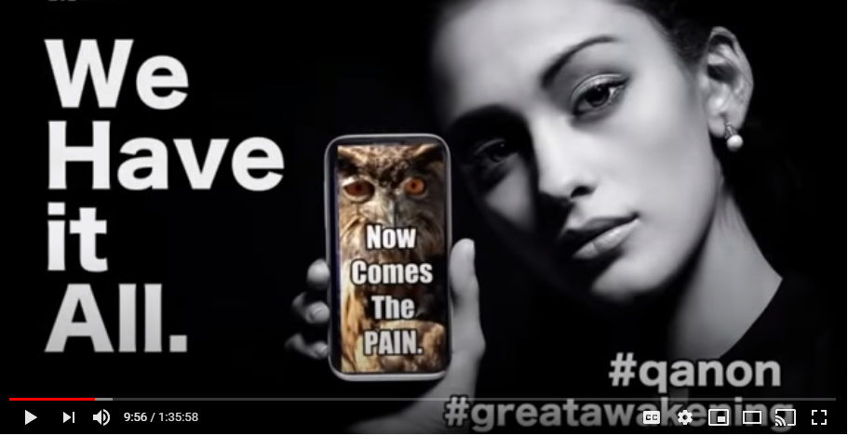
This is only six months in office, a little underneath that, and Trump has for the most part cleaned most of the swamp, restructured the DOJ and the FBI which is most important, and some other key offices closer to home, closer to the president, were all cleaned up and the proper people that they had waiting in the wings were put there, okay.

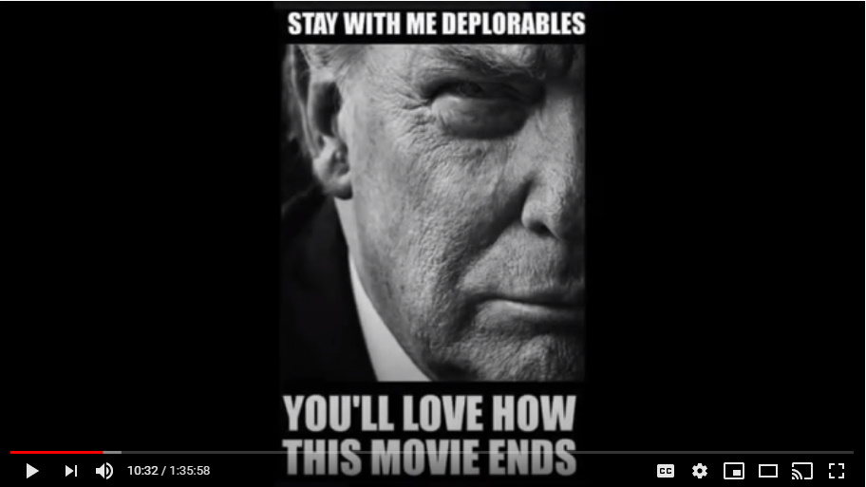

Step Number One – Saudi Arabia
So, in the summer of 2017 it began.
Where did trump go first? He went to Saudi Arabia. There, he went and paid a visit to the crown Prince Al-Waleed bin Talal, he was the crown Prince at that time.

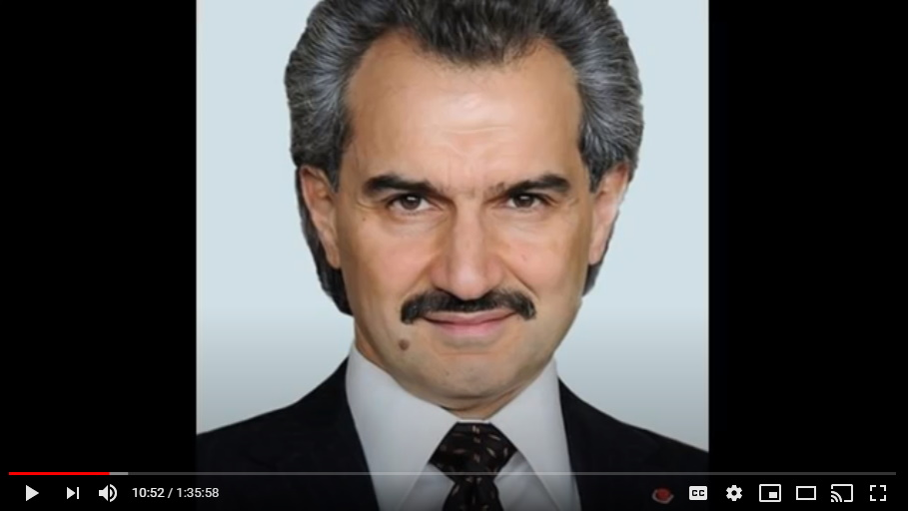
He got right into the whole adrenochrome thing, and the harvesting of children, and Saudi Arabia begin to put in massive tunnel networks underneath the ground.

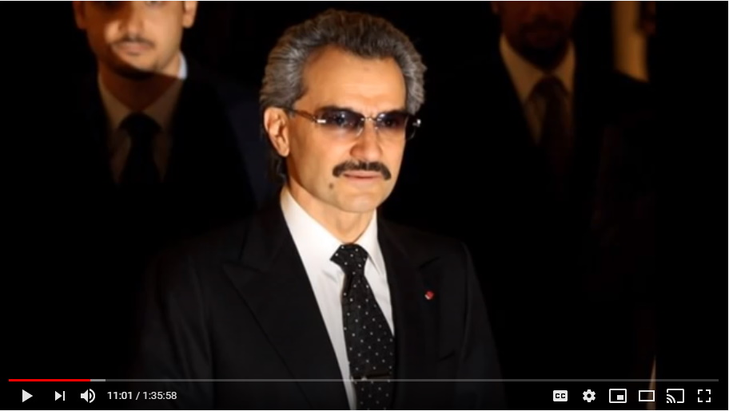
This is all because Al-Waleed got sucked in by the cabal, the 13th families, as a huge, huge player. One of the three main arms of their weaponry. He was exalted with enormous power amongst dominions. Al-Waleed became one of the key minions by going really, really, really evil and there are a lot of Saudis that didn't like this. They knew what was going on and they didn't like it. You can say whatever you want about some of their other beliefs and stuff, but there's a lot of people that draw lines with children. And so that's what he did and this is why he needed to be taken down. There are articles everywhere you do your own research.

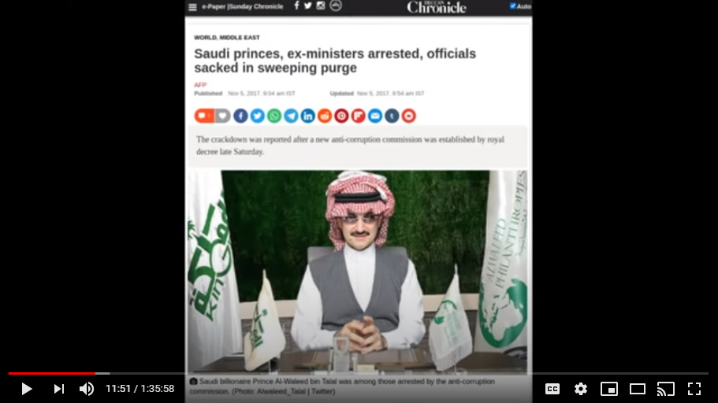
The CBS News even did an article, we're talking about weeks after Trump came on his visit in July of 2017 to Saudi Arabia.

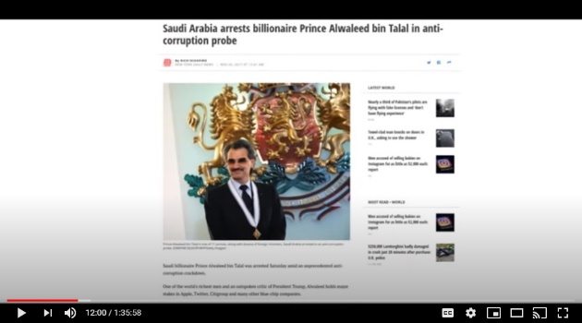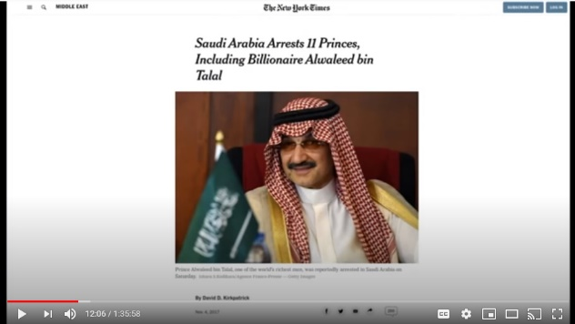
After Trump left, that's when the arrests happened. Al-Waleed was arrested, taken down.

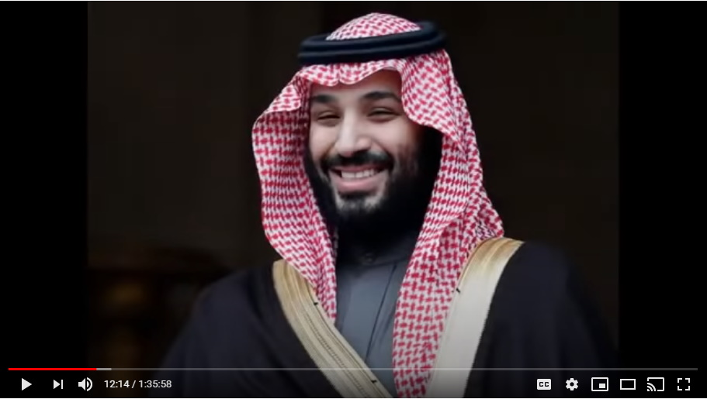
In his place was bin Salman (Mohammed bin Salman bin Abdulaziz al-Saud) and bin Salman is somebody who was not okay with what Al-Waleed was doing.

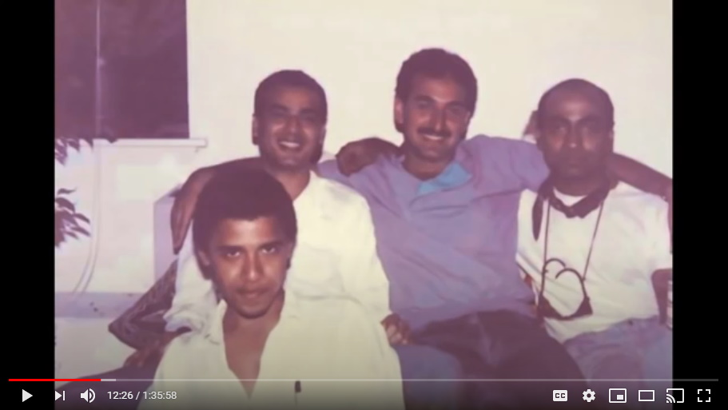
Now a bit of backstory quickly here because we've got so much to go through, but Al-Waleed is the one that sort of handpicked Barack Obama as somebody they could work with and exalt into power.

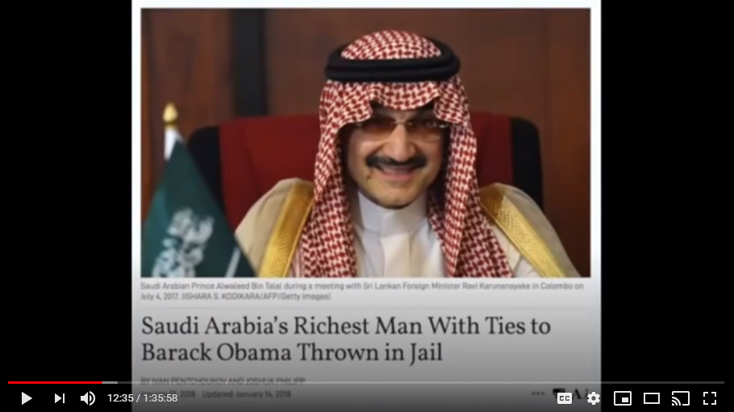
He's the guy that funded him.

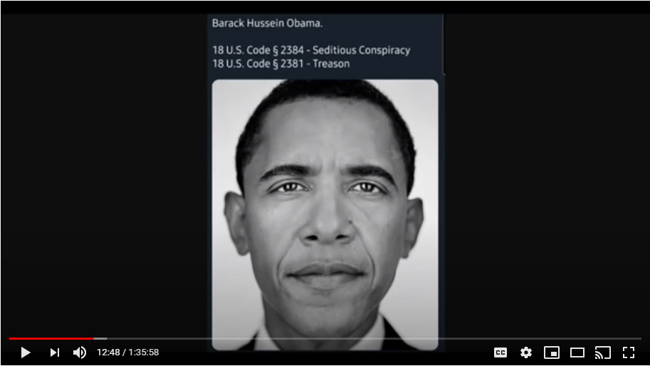
That's why Obama has this real kind of Muslim background and sort of the whole Middle Eastern kind of thing with his name and all of it.

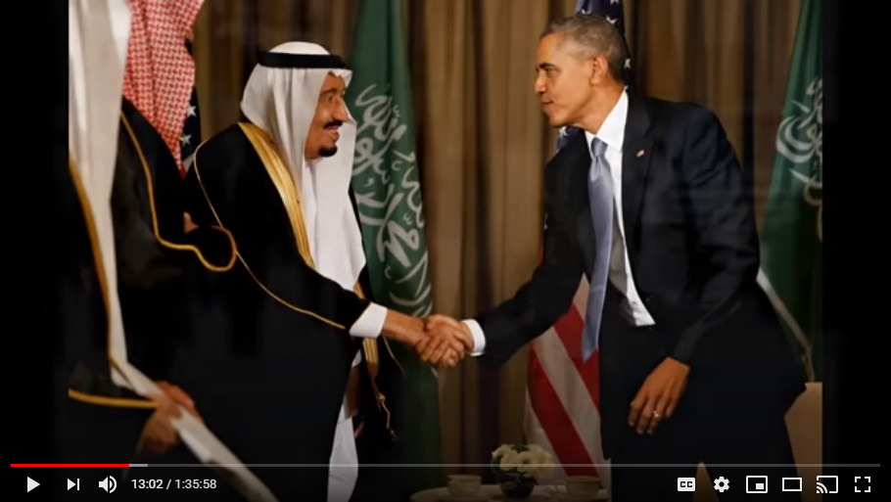
It's because it was this crown Prince Alwaleed of Saudi Arabia that decided to make Obama the one that they were going to turn into this linchpin of US presidents.

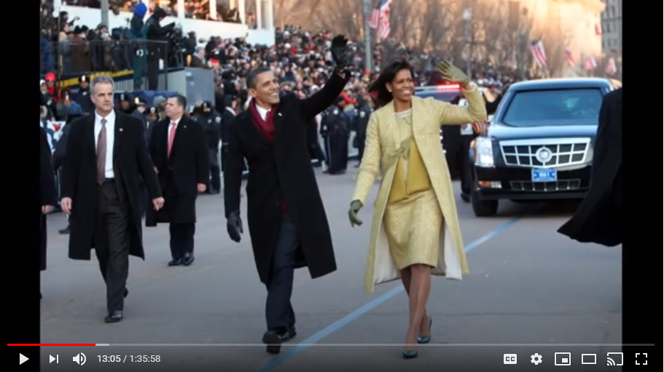
So, he funded Obama, and Obama, quick if you're not aware of this, as a kid Obama was passed around as a sex toy at some of these bigger gatherings of powerful men. He was sodomized, and it explains a lot about Barack Obama, but it doesn't excuse him for anything. Suffice to know that he had a rough, rough upbringing for sure. He was ripe for the picking and they chose him, so Al-Waleed funded him.

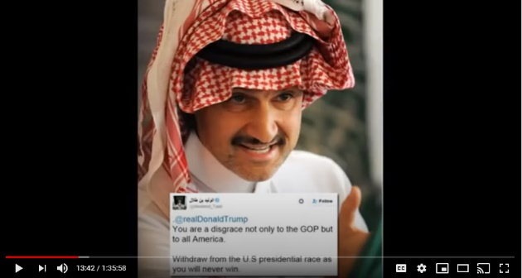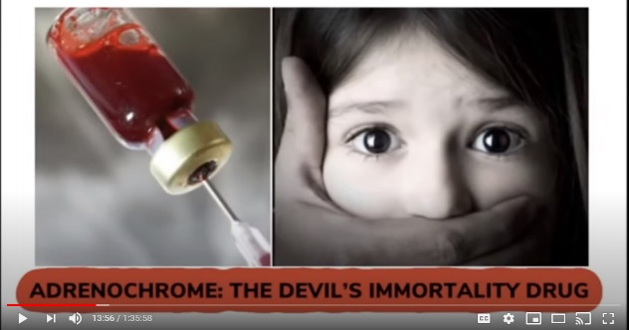
This is the same Saudi crown Prince that got Saudi Arabia heavily invested in and into adrenochrome, child trafficking, and set up in the murder of all of these children for adrenochrome.

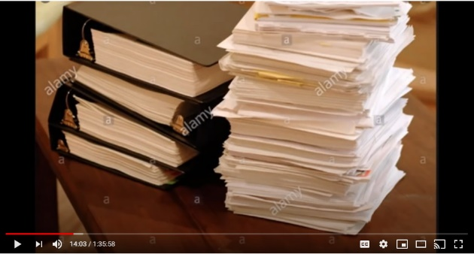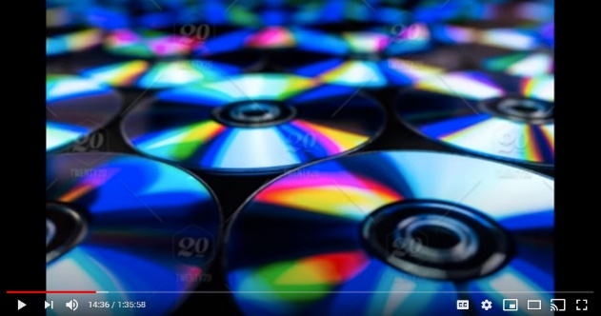
When Trump arrived in the summer of 2017, he laid out all of the documents. That's what they did to everyone. They had folders, and the folders had all the documents, there were photographs, they came with disks, CDs and DVDs. The CD's and DVD's had fantastic production value, and it had all of their footage doing the most horrific things.

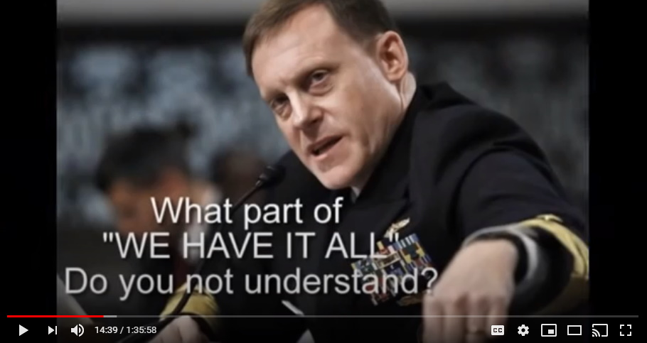
The NSA has it all on all of these people. I think probably the big things that scared them the most were these DVD compilation of their greatest hits of evil. Trump was there the first day, handed all of this stuff out.

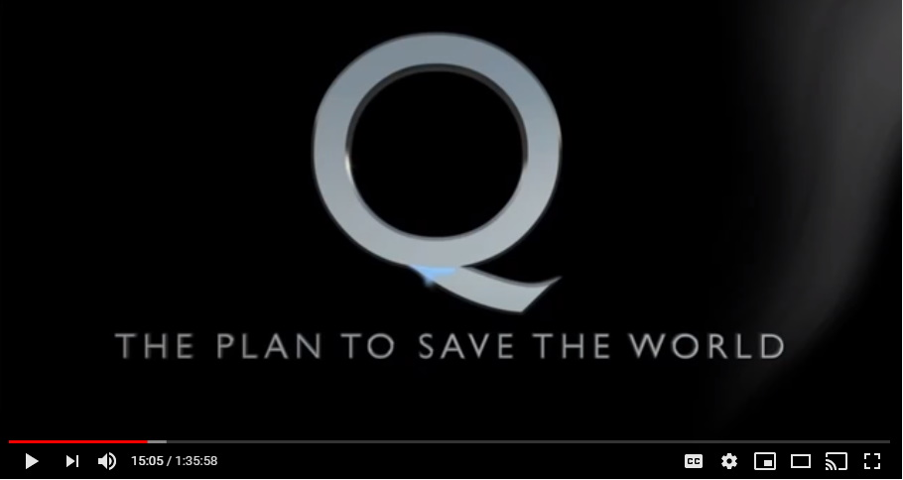
Now, this is absolutely the truth, what happened the second day? The second day the crown prince and the king both submitted publicly, control over Saudi Arabia to Donald J Trump. And how do you know this? Because they publicly held this sword dance ritual.

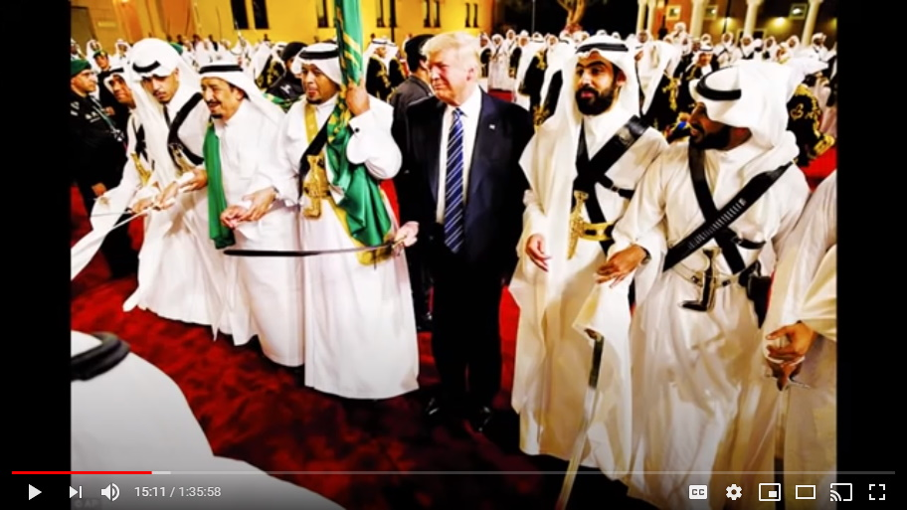
A very, very big deal to the Muslim culture. Only the King holds the sword.

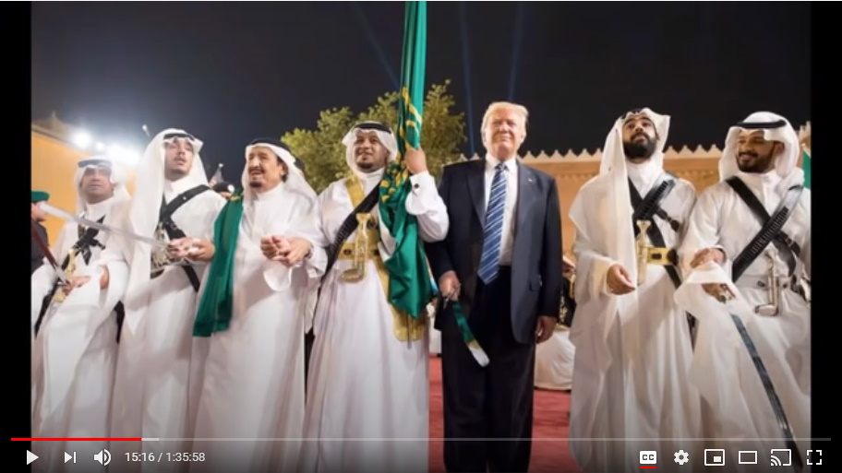
During this festival of which we've got the images here...who's holding the sword? Who's at the center? Who's at the very center, at the top of the podium, and who's everyone else around in show in support of?

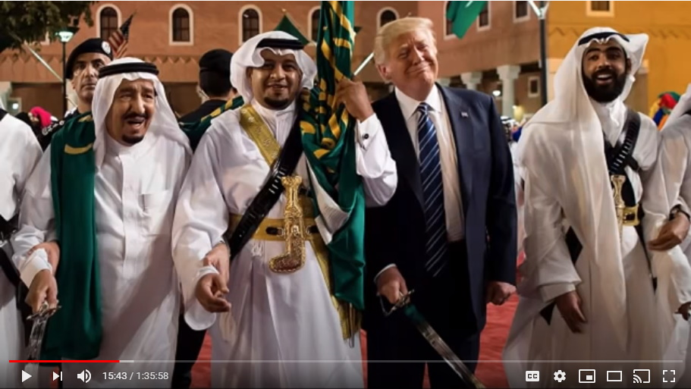
Donald Trump is holding the sword. He is at the center of the stage. This is Saudi Arabia publicly capitulating. And in that one of the photos that we have, it shows the Saudi king and he looks like he's about to die. He's in so much pain at what's going on here. It was very fresh for them. They just handed over the keys to Saudi Arabia to Donald J Trump.

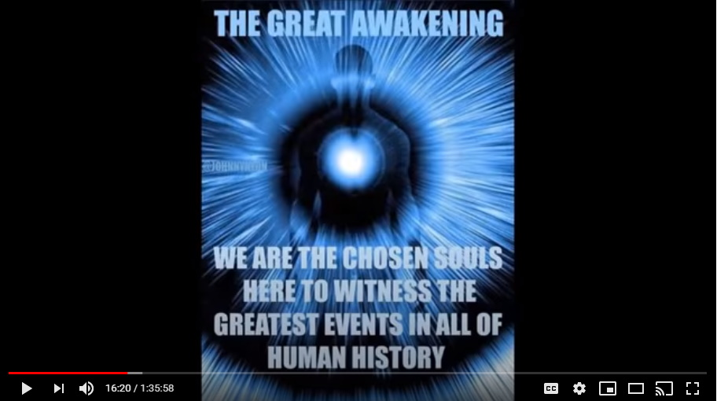
That happened in the summer of 2017. That's step number one after the declassify of this documentation via the NSA. This was step number one.
Saudi was the big player that they needed to get on site. What is important to note is that where Trump went next, he went with Saudi as part of his team.

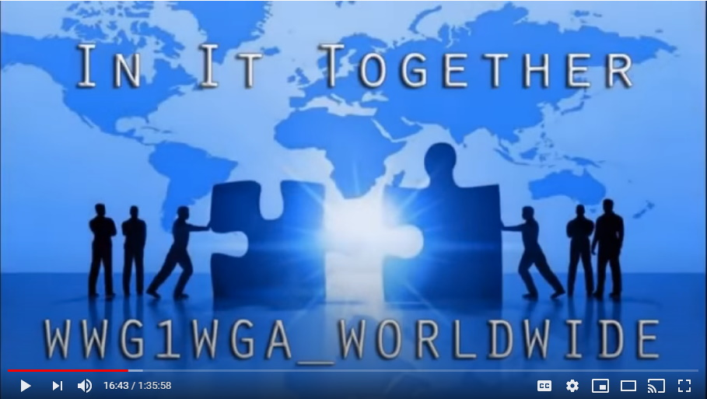
So, you need to understand, it's not just that he didn't go there and take them down and that they're never going to do.... No, they're working for him. They're earning credits towards their own safe Salvation and their own not being as harshly punished as they could have been and all the rest of this. We'll see how that all plays out, but they're part of this team. They're part of the Q plan now. You need to wrap your heads around this.

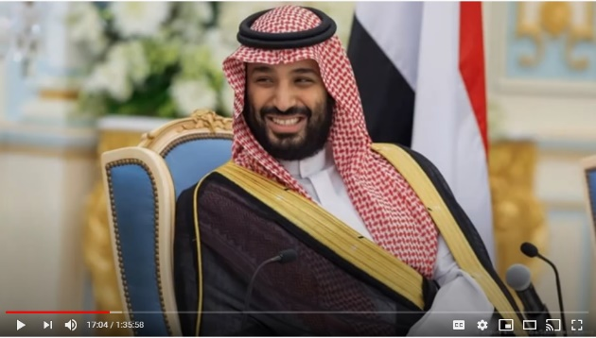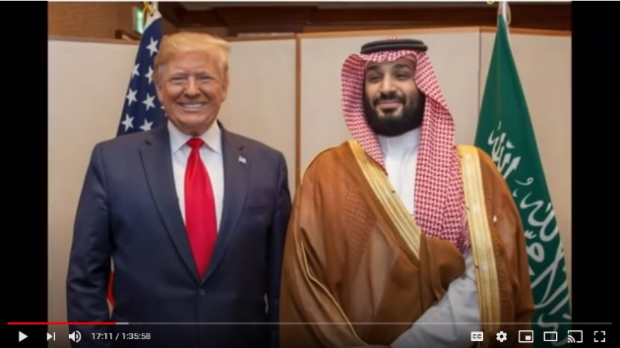
The new crown Prince that replaced Al-Waleed was bin Salman, and bin Salman really stepped up and became a key player and did a lot of things to help Donald Trump. We're going to get to that.
So, that was step number one.

Step Number Two - Israel
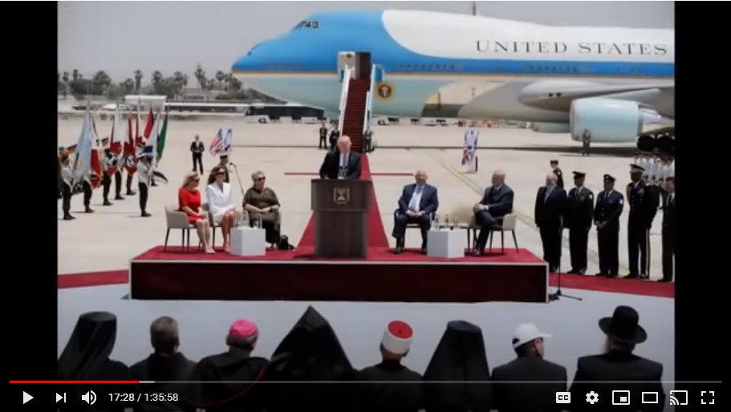
Then the days that followed, Trump left Saudi Arabia and went immediately to Israel.

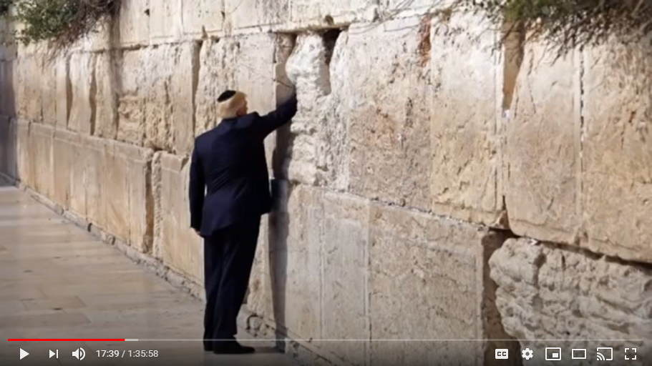
Okay, do you remember how angry most of you got when you saw those pictures of Donald trump at the Wailing Wall in Israel? Confirming all of our worst fears that he was a Zionist tool?

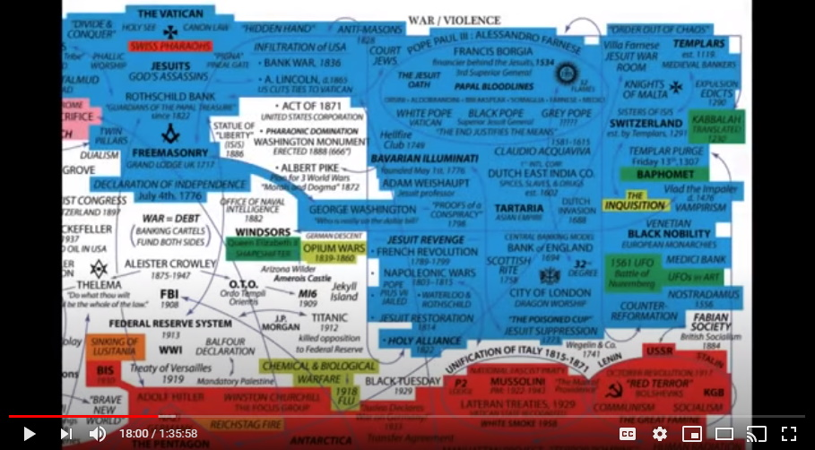
Mark: After the video that I put out yesterday a few people commented in YouTube that "how can you be so naïve? Trump is a Zionist tool. He's in there with, you know, the Zionist regime of Israel." That seems to be one of the main bugbears that people have with Trump and it seems to prevent them from getting him any further credence because they just write him up as a Zionist puppet.
Right, and you know folks, let me burst your bubbles here a little bit, this whole thing with Israel being the linchpin and being the real king's behind this and that these Zionist.... It's none of it even real. You're just gonna see, it's all fakery, it's all subterfuge.
There is no such thing, and I'm sorry this is gonna probably offend some people, but there is no such thing as a genetic Jew. There are lots of Hungarian's, and Pols (Polish), and Czech's, and Germans. Jews are just like us, they come from all over the place, but there's no genetic race called the 'Jew'.

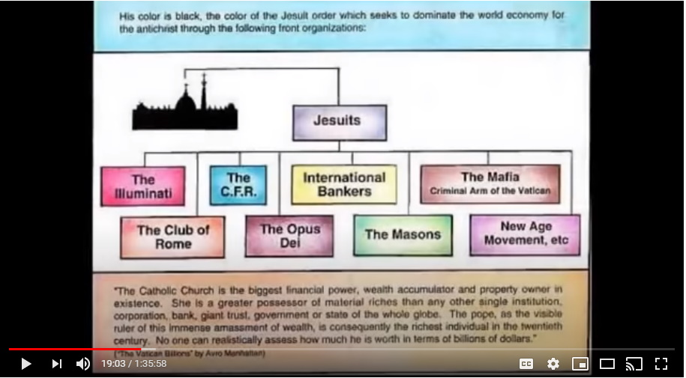
Israel is—Colleen calls it the ultimate Trojan horse—it is subterfuge. It is designed to take you down a rabbit hole and there's no getting out of this rabbit hole because none of this really exists.
Colleen: It's just like they're playing the black card right now?
Yes.
Colleen: They like to play the Jew card.
They play the Jew card. So, they invented all of this with Jews and then the bad Jews, Zions...I just feel terrible for all these people that have been dragged into this that are innocent and beautiful people that truly see themselves as Jews, and that they're oppressed and they're hated by everyone, and now they're just being used by the Phoenicians.
He's (Trump) not a puppet for the Zionist, there are no Zionists.

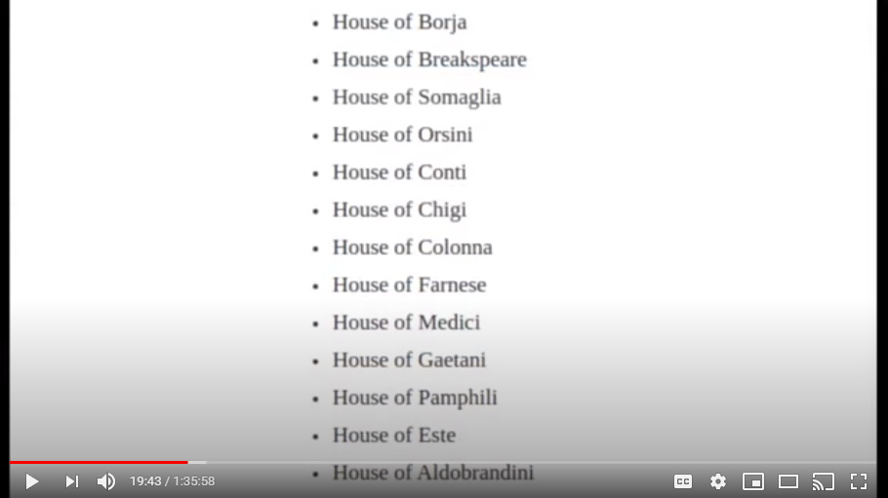
There's, remember folks, there's just the Phoenician. There's just those 13 families, and they're very smart, and they're very good. And they created this ultimate Trojan horse subterfuge of the Jew being a literal creation just like, you know, you're going to hate this, but Jesus Christ being an actual Swiss-looking white dude in the holy land 2000 years ago.

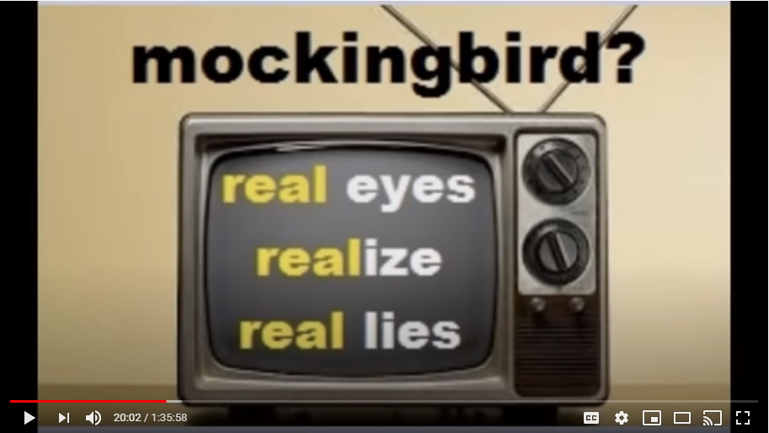
That didn't happen. There's just lies everywhere.

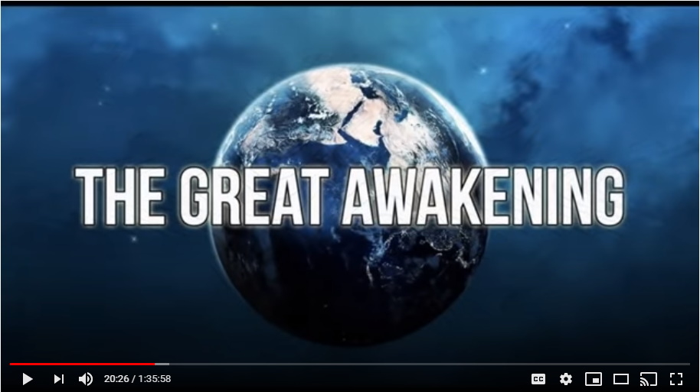
So, Trump went to Israel and he sat down with everybody in front of the camera and behind the cameras, with the people that are really in power, and he laid it all out on these minions.

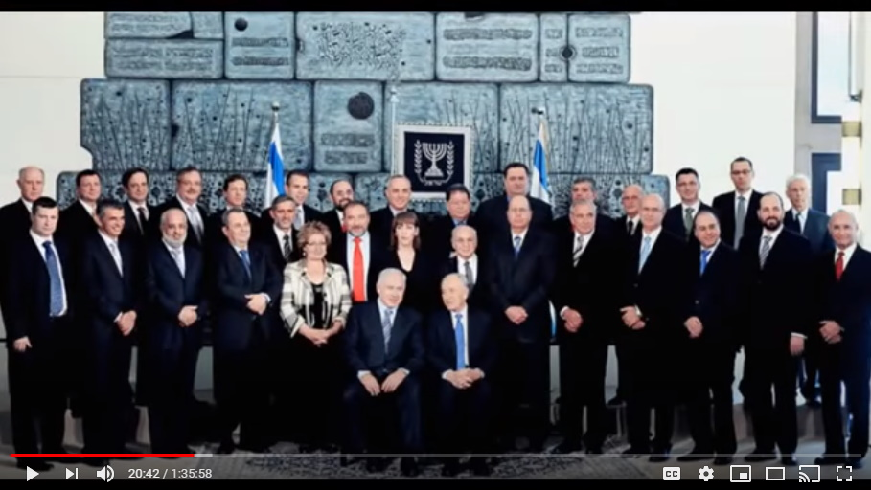
I'm talking to you, he said, not who you try to present yourself to be to everybody else, but I'm talking to you, minion Netanyahu, and everybody else who is a child eater. This is for you and you have a choice to make here.

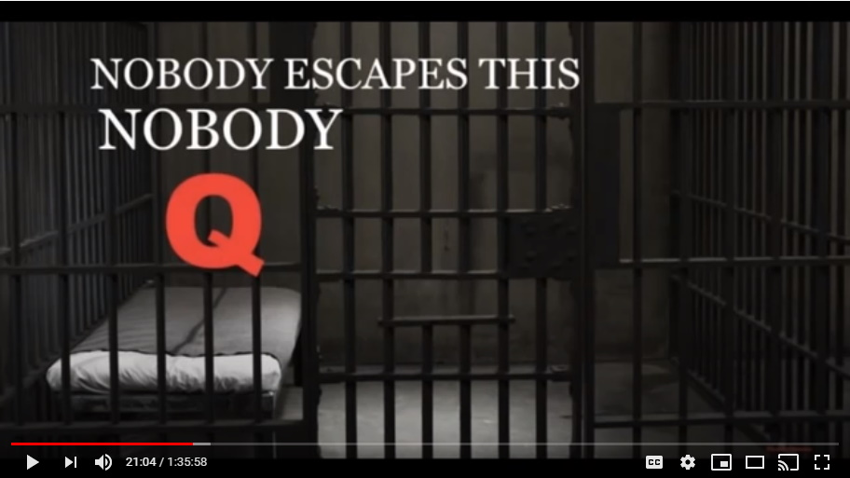
And Trump, they were balking at him, even though he showed that the Saudi's had signed over. The Israelis were balking at Trump and were not prepared to sign over and that's why Trump stayed an extra day and they finally capitulated.

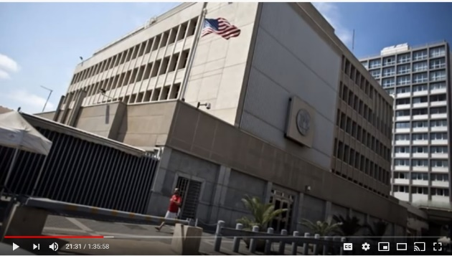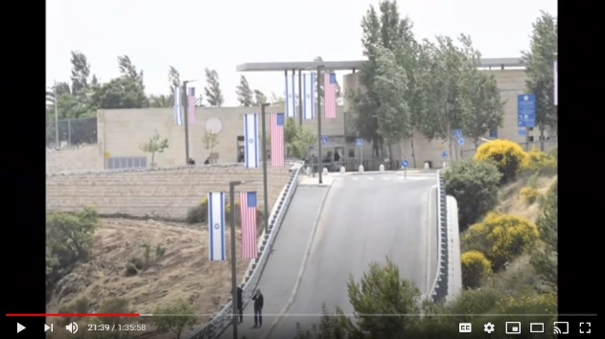
Trump was not going to leave Israel without them capitulating to him. And the sort of, how do you know moment, is after visiting the Wailing Wall, Israel publicly submitted allowing the United States to move their embassy to Jerusalem. Jer USA lem! To move the embassy to Jerusalem with the Americans military protection.

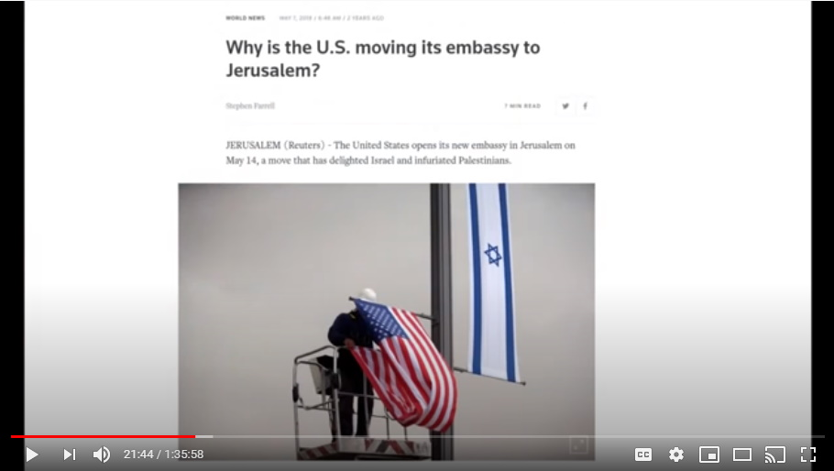
This is symbolic. It is a symbolic act to show who has the power, even in the holy land with the Jews and these Zionist who are in charge of the sacred, sacred, sacred, sacred truth about the Jewish heritage and tradition. That's why it was done. It was only done for one reason. Just to be a symbolic act to show those who had eyes to see it that Trump had now taken down Israel.
They submitted. Step number two of the journey completed. Saudi Arabia, Israel, on board.

Step Number Three – The Vatican
So, where would he go next? Who are the three big players?
Saudi, Israel, and then the Vatican.

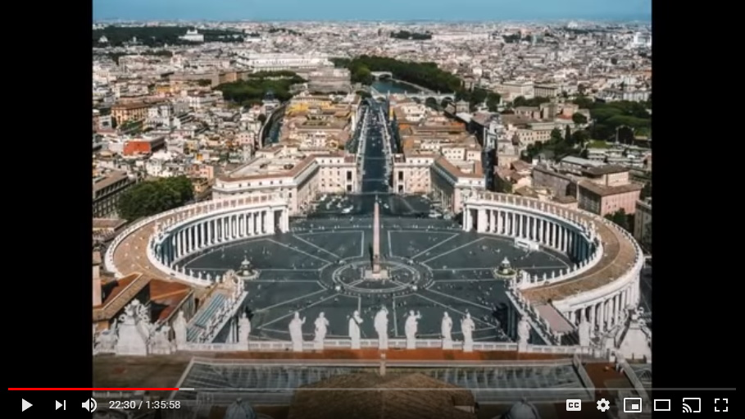
So, days later he shows up at the Vatican and presents to Pope Francis a massive, apparently the folder was absolutely huge, and handed it over to them, and said, yeah, you know, take your time, have a looksee...

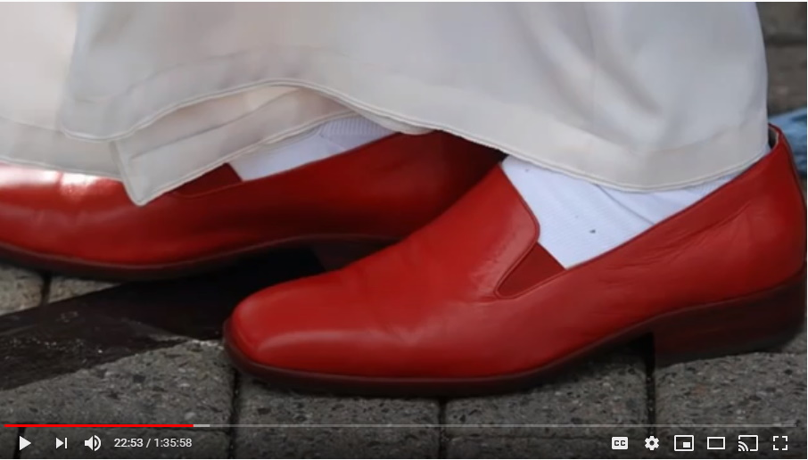
...and put your red shoes on. Apparently Trump kept making little digs at Pope Francis about his red shoes.

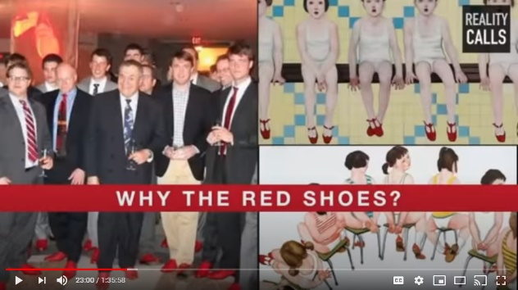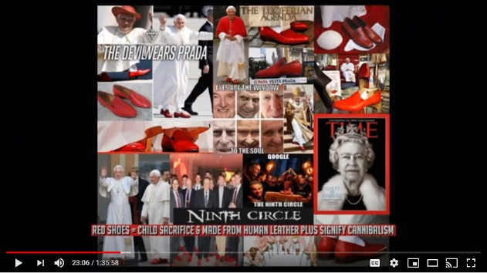
Yeah, you might want to put your red shoes on when you look at all of this stuff, and you might want to wear your red shoes when you come back and give me your answer.
So, that's what Trump is saying; I'm not leaving here until you sign some documents for me. We're going to get to why that was in a sec.

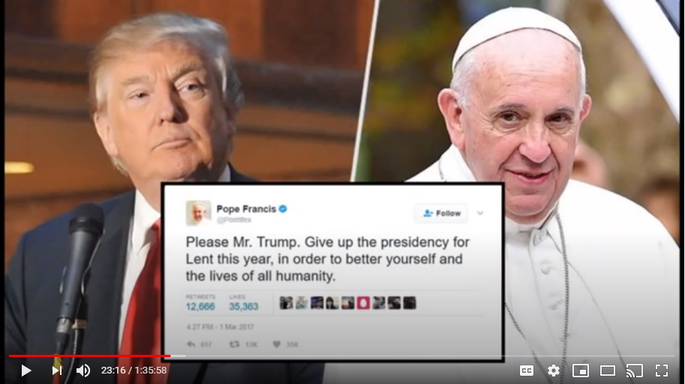
It took the Vatican that night, and the next day they capitulated to Donald Trump.

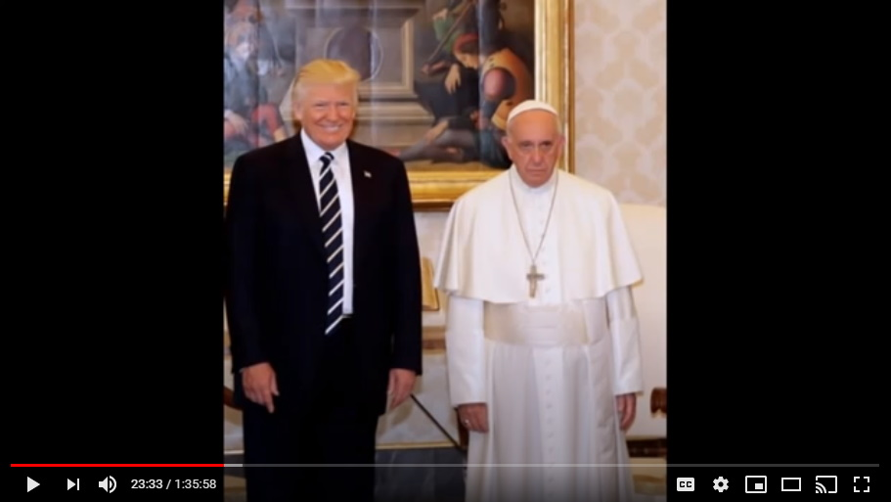
There is a very famous photo that summer of 2017 with trump at Vatican City right next to Pope Francis. Pope Francis looks like he's been run over by about 60 semi trucks.

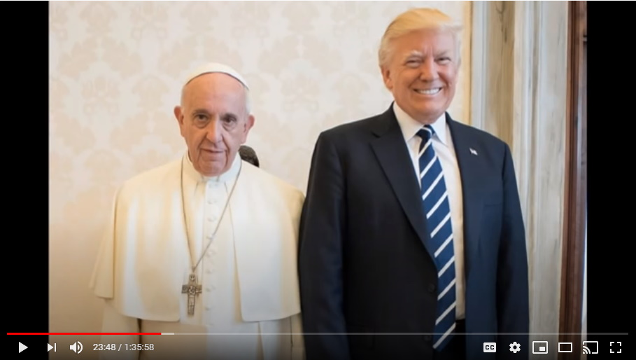
Donald Trump has a look on his face that is a mixture of victory, joy, and mischievousness. Like he knows he's committed a big, big act here. So, Trump has a massive grin on his face. Pope Francis looks like he's had both of his eyes punched in by about 60 thugs, he looks so horrific. They symbolically signed off.
Now what did the Vatican have to do to sign off?

You see, the FED is controlled by a certain group within the Catholic Church. Who went forth and spread the teachings of Christianity? The Jesuits...because they're holy men...no, no, no, no. The Jesuits are the real Mafia my friends.

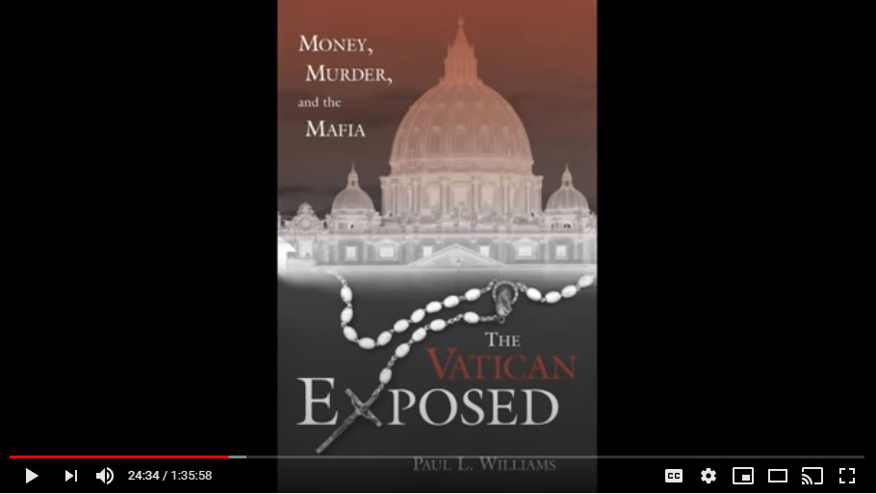
Every little group of Mafia in every single town around or across this vast earth.

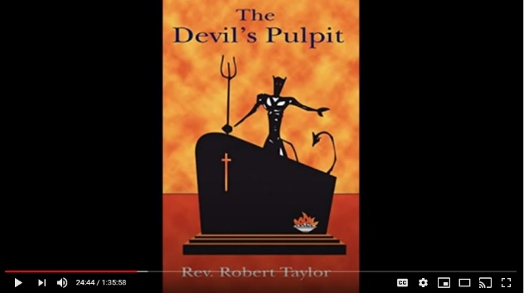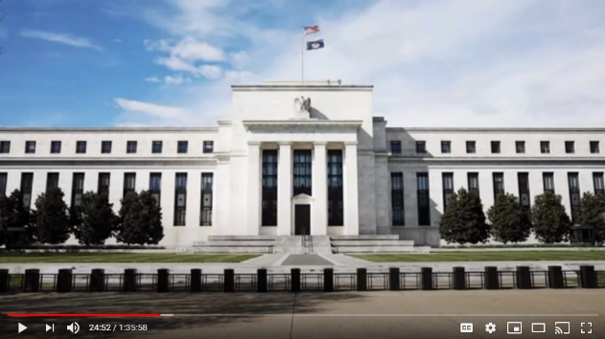
Every little mafia pays homage to this particular group in the Catholic Church. They are in charge. They are the true Mafia and they were in control of the FED.

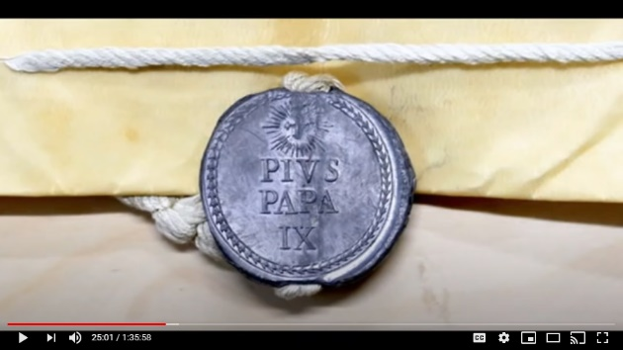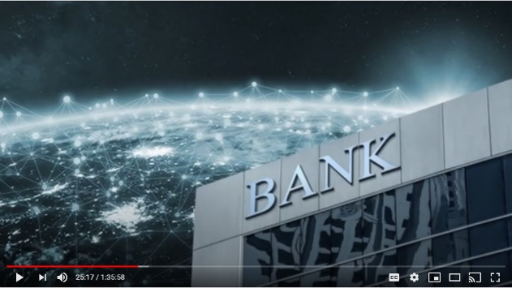
So, Trump did not leave until Pope Francis issued a papal bull announcing that by a certain date the Vatican Bank, which was in charge of all...was the head executor...the exchequer of all of the earth-wide Federal Reserve banking systems in each country, would be handed over to one Donald J Trump.

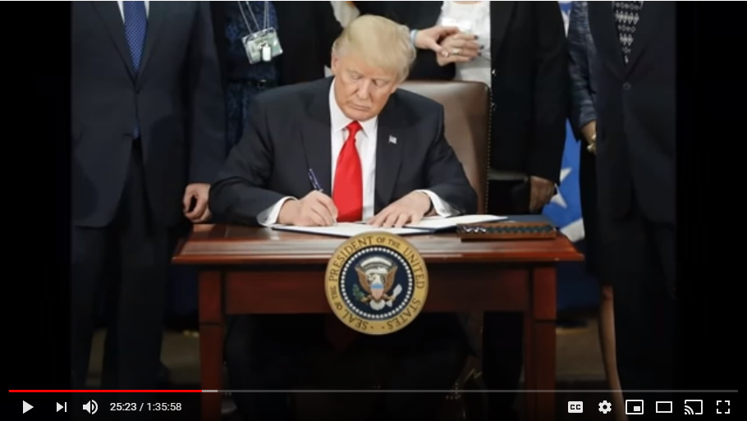
Donald J Trump is not, Mark, just the executor, the exchequer of the U.S. Treasury and therefore the Fed within the United States, he is the exchequer for earth. He is the exchequer for the treasuries for every single country on earth.

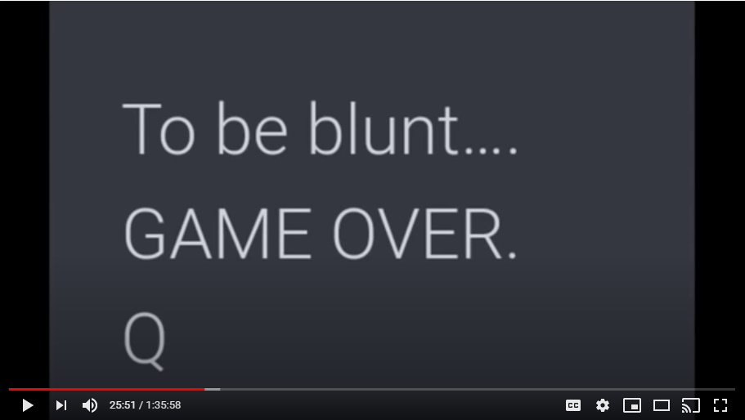
That's what I told you earlier, he, no human being in history, has ever been more powerful, own more things, or richer than Donald Trump.
Mark: Charlie, let me ask you where this leaves the Rothschild's? Because this is what we hear about the Rothschild family, they are said to be in control of the central banks in every country around the world. So, where are they left in all this?
Brilliant, brilliant question, because at this meeting, that just cut the legs off at the knees of the Rothschild's in London.

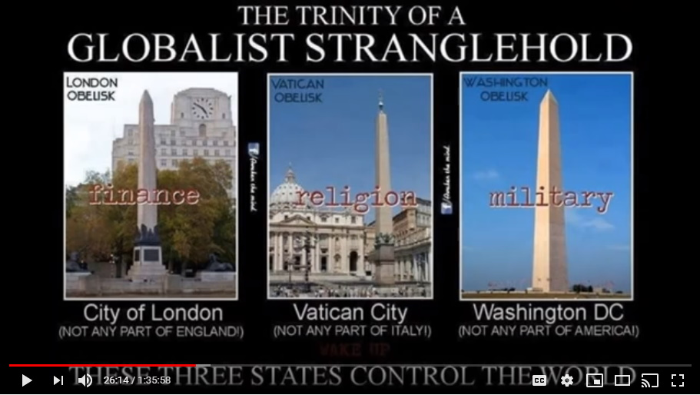
London was the financial arm of all of this. Washington was the military arm. Rome was the central brain, the core they call it, the spirit, but it's not. It's sort of the central brain of this unholy trinity of power.

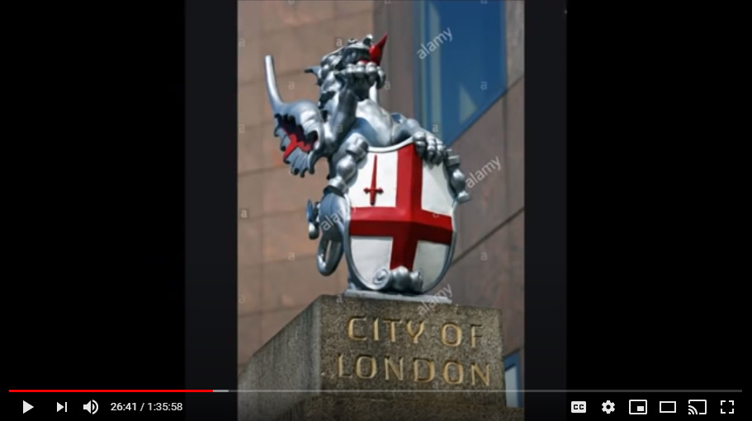
What they did by doing this is that... So, Trump's thinking is like the CIA. The Rothschild's and the financial district of the City of London is too evil, it's too far gone, don't even want to work with them. And he's not. He circumvented them.

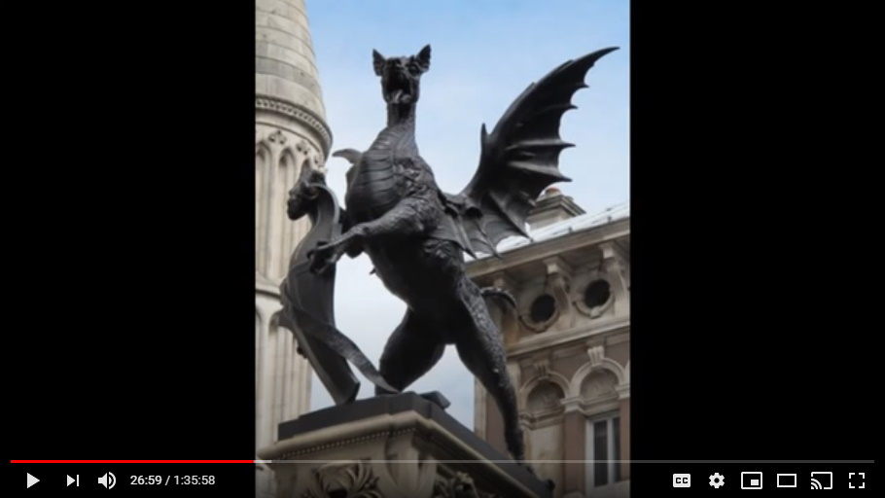
Like the crucifixion in the human Physiology, you can't get through Atlas the 33rd vertebrae, so you have to go up and around. Trump went up and around the Rothschild's who are really a nasty, evil piece of work.

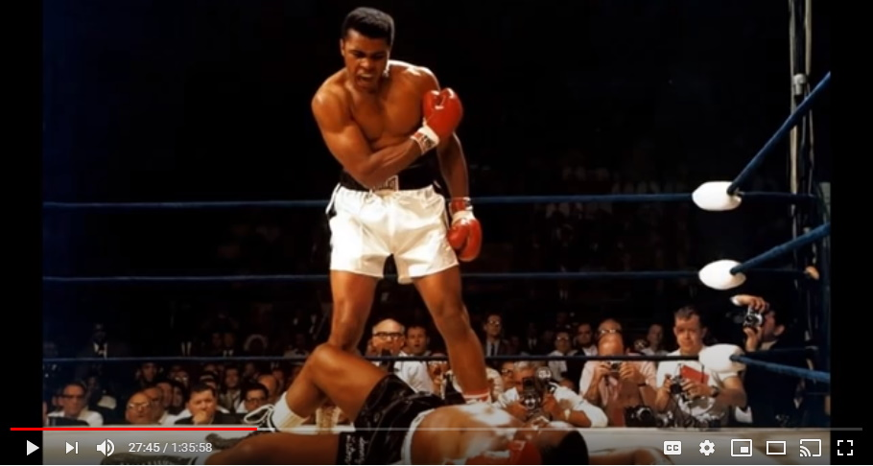
So, the City of London in the summer of 2017 had the, and I'm talking about the real City of London owned by ultimately the Phoenicians, but run, ruled by the Rothschild's, they had their legs cut off at the knees, and they have not been a real player ever since. All of their power was cut off and they have been forced to do some really humbling things, over the last 18 months in particular, by POTUS.
So, you want to know about the Rothschild's? They're still looking for their legs from the knees down.

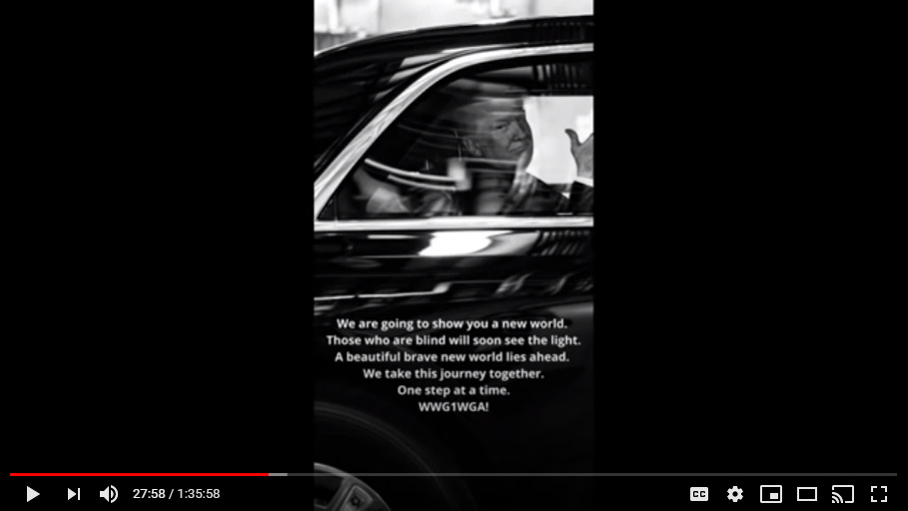
That was step number 3 and now you see the three main arms, or the three main geometrical pillars of the pyramid, this evil unholy pyramid, have now all been controlled. Saudi Arabia, Israel, and the Vatican. Those were his first three stops.

Step Number Four - Brussels
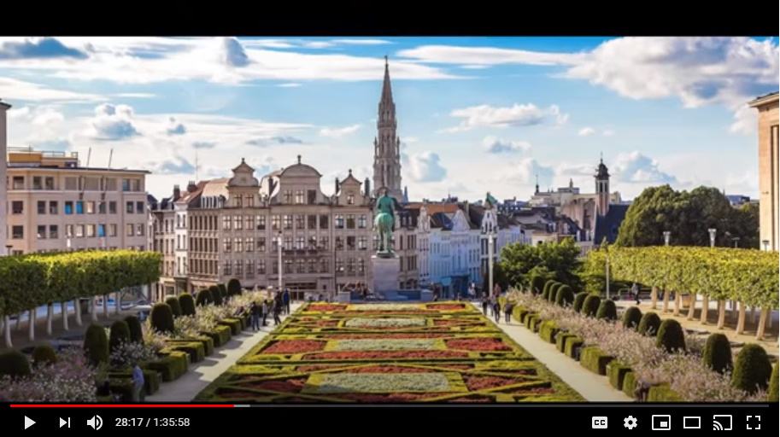
Now when Trump left Rome, he flew directly to Brussels. You all know the two big players that are in Brussels. You have the European parliamentary for the EU, and then you also have NATO (North Atlantic Treaty Organization) that just happens to be in Brussels as well.

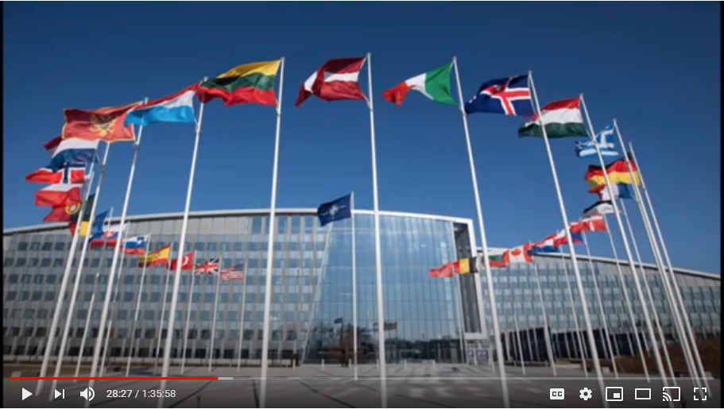
Trump called the meeting, they were all there, the political heads along with their finance ministers, and all of the behind-the-scenes individual players, were all there for this.

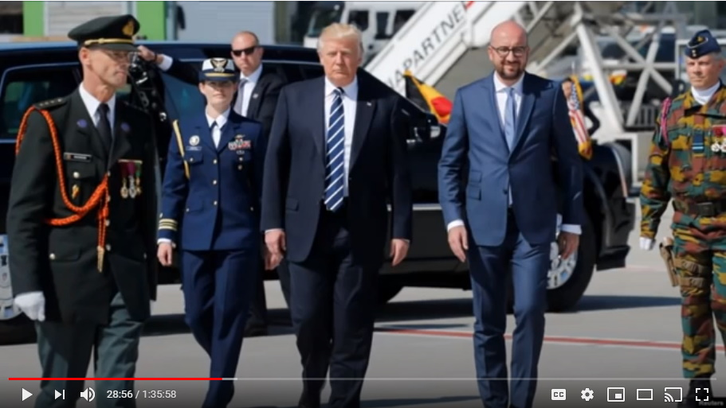
Trump apparently very famously called everyone together for this meeting and then he purposely came late. He made them just sweat it out. He made these pieces of dung in Brussels sweat it out because they didn't know quite what to think and what was coming.

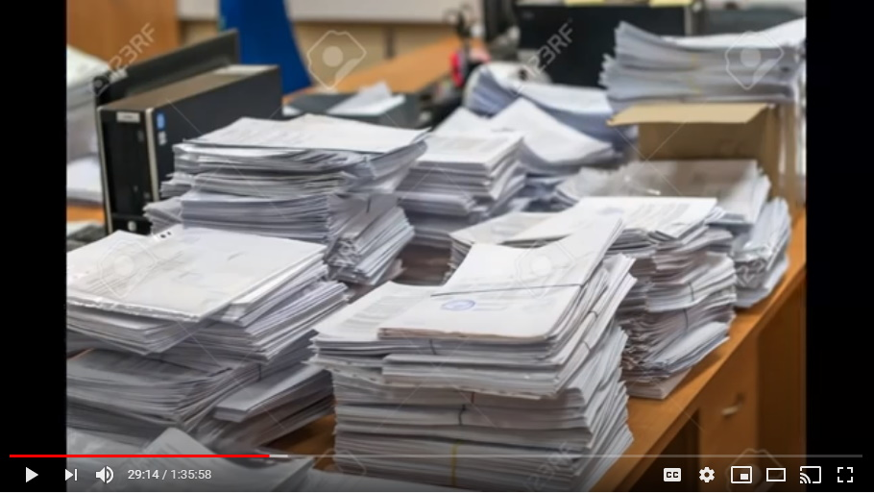
So, Trump makes them wait, he walks in late, he throws this big folder on the table and he said we have it all. We have it all, what's your answer? That's what he did. And he played just incredible hardball with the EU and NATO. And in short order those little rats, those little cowards, they all capitulated in very, very short order.

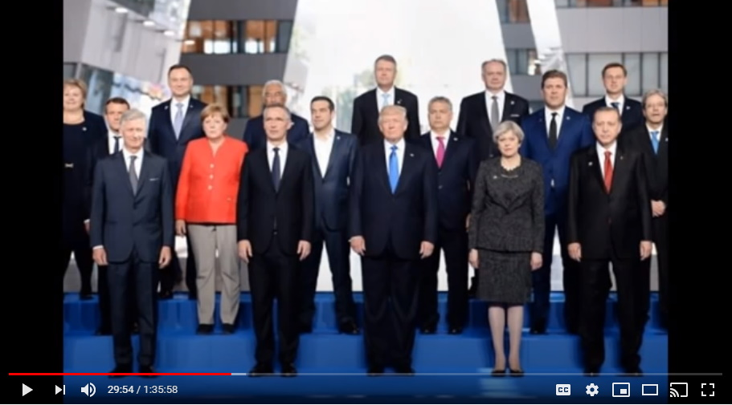
There was a whole bunch of things that occurred in the following days from there including the EU backing down on Brexit, and NATO having to step up and basically pay for the bulk, and all of these different nations, instead of the United States having to fund all of them.
It's not like that's a big deal in terms of saving money or anything. No, it's symbolic. You're going to pay for NATO from now on. We're not, because I'm in charge. I'm the boss says Donald Trump and you do what I tell you to do.
So, when the photo op came for this famous meeting in Brussels, Trump again came late. So, all the film crews are there, and all the cameramen are there, and all these heads of both the EU and NATO are there and they're all under bright lights and they've got their fancy suits on and they're all sweating like crazy, and Trump is making them all wait.
He walks in late, he does not acknowledge any of them and he's kind of whistling when he comes in and stuff like this and then he just shows to everyone who was there that he was in charge of the meeting. He disseminated the information to the press, he said what was going down. He showed them, he came in late and then he left. And he owns the EU and NATO.
That's it folks. That's why they've done everything they've done ever since.

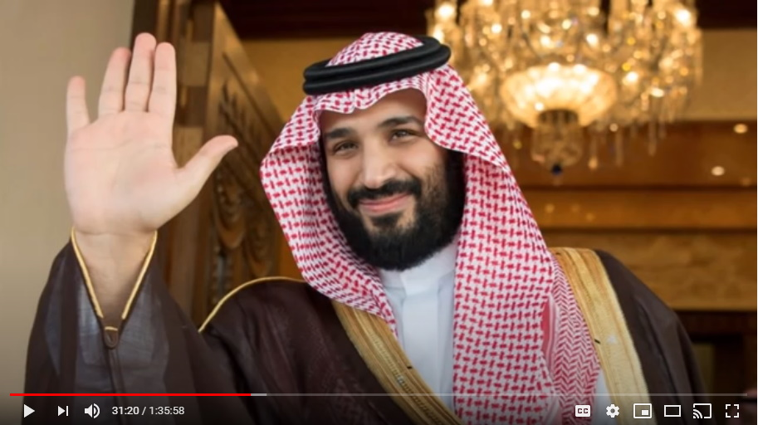
Now, in October of 2017 there was an attempt on the life of the new Saudi crown Prince bin Salman who replaced Al-Waleed and was helping Trump. We're gonna get to how much he was helping Trump in just a sec here.

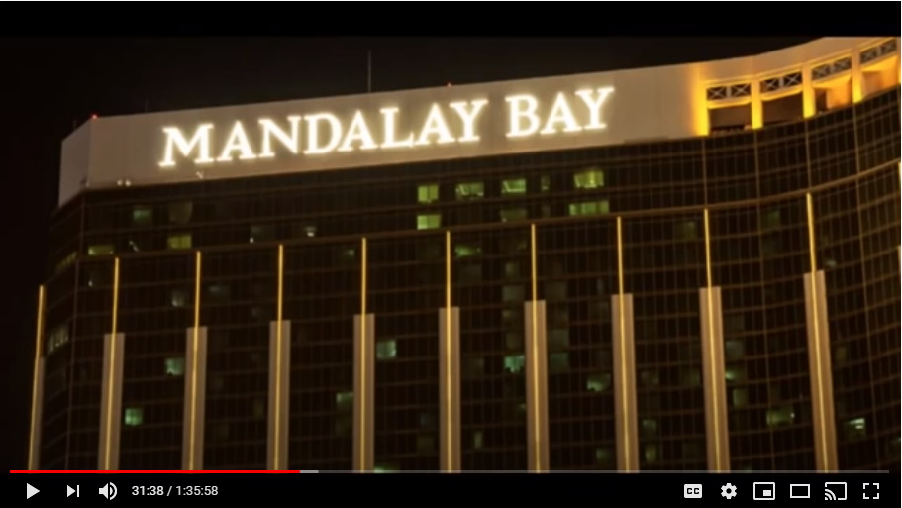
This little operation that was set for him in Las Vegas was taken down at the last second and he was protected. So, from then, Al-Waleed... there's conflicting reports whether he's still in custody or he's been exterminated now for this little indiscretion from behind the scenes. They had a plan to do that.

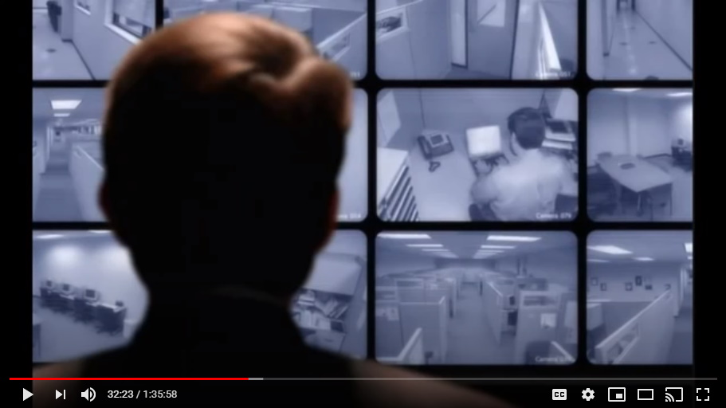
Now what happened at this Las Vegas battle was, when bin Salman was saved by the U.S. military through the intel received by the NSA then given to bin Salman by Trump, he was asked to take on an even bigger role and he agreed to do it.

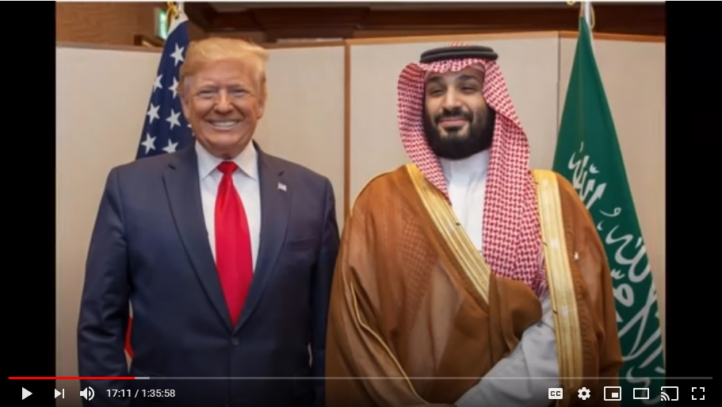
He basically was saying to Trump, anything, anything my brother, anything my brother.

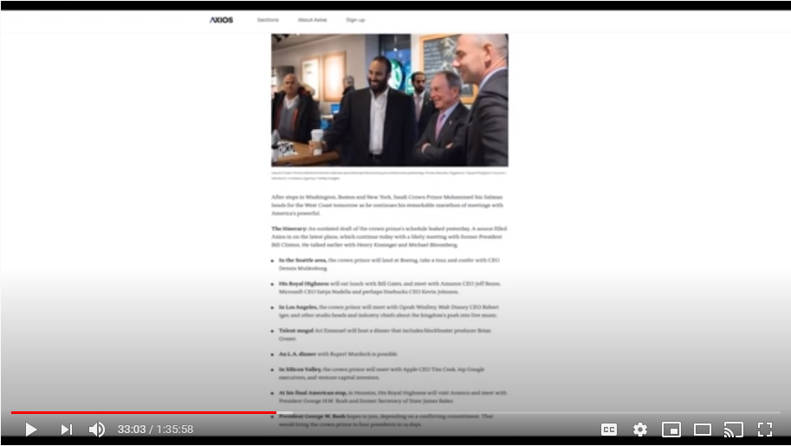
So what happened next? The next thing is that staying in the United States on Trump's behalf, bin Salman went to all of the major corporations, in particular the media companies—Google, Apple, Twitter, Facebook, Microsoft--all of these main, main companies were all targeted by bin Salman. And on Trump's behalf he visited all of them. And of course this is all verifiable. I've got all of the documentation, all the imagery showing all of these meetings taking place in late October, early November of 2017.

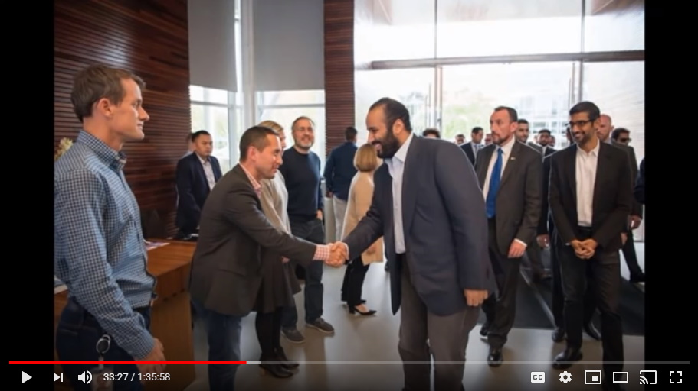
This is bin Salman essentially helping Trump, to do all of this work for him. He went and visited all of these puppet heads for all of these puppet companies and basically read them the riot act and told them, showed them, the documentation that the NSA had on all of them, and basically said, you play for team Trump, and Trump is now in control of these corporations or DECLAS. All of this information will be declassified one by one, and each one of you will be offered up to the masses as a child murderer.

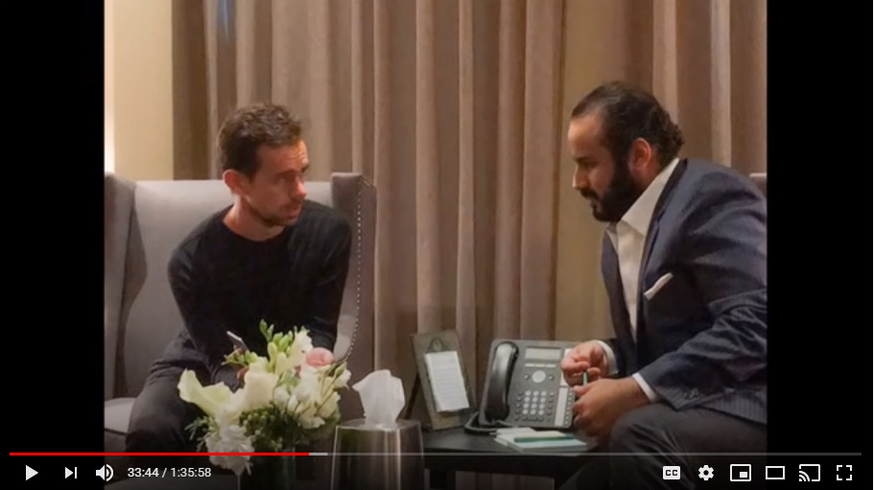
They all capitulated and there's the money shots of all these various heads of all these various companies including Jack Dorsey for Twitter.

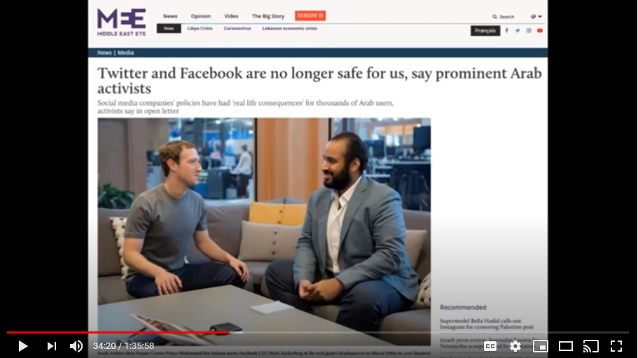
So, all this stuff that's been going on lately, with this censorship of Trump by Twitter, it's all part of the game that needs to be played out for people to get angry, and to wake up to what the heck is the evil that's going on, and say something about it, and to do something about it and begin to change their lives.

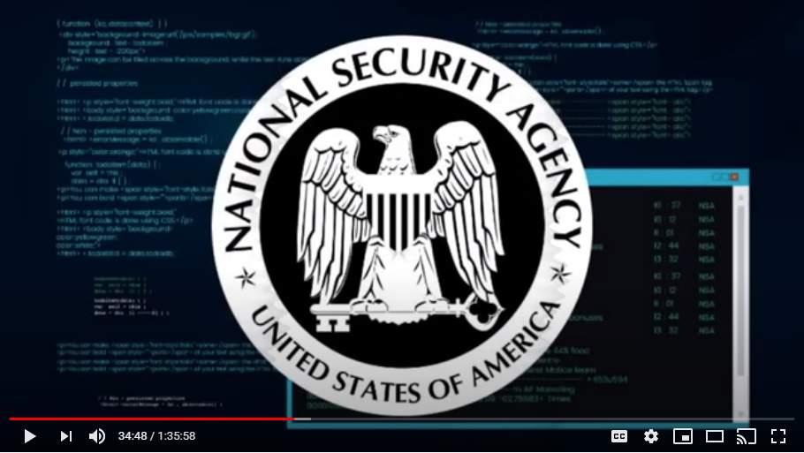
So that's real, all of that is real, and bin Salman helped Trump do this and he went to all of those CEO heads of all of those major media companies and social media companies.

Step Number Five - Japan
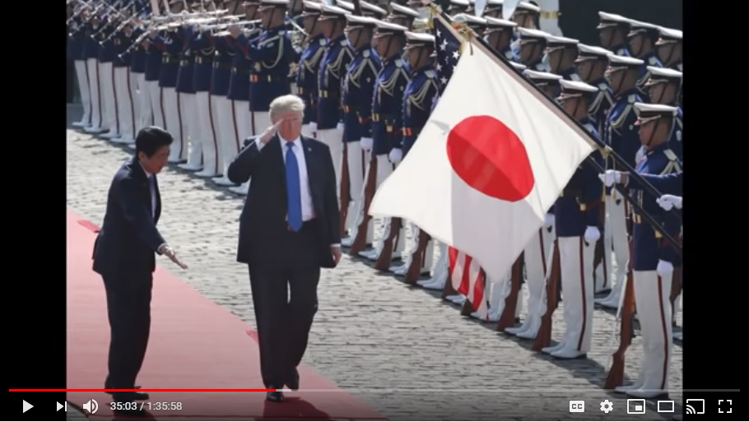
From there then, as everyone knows, in late November 2017 Trump took his Asian tour and again it's the same thing. He went to Japan first, and did the same thing.

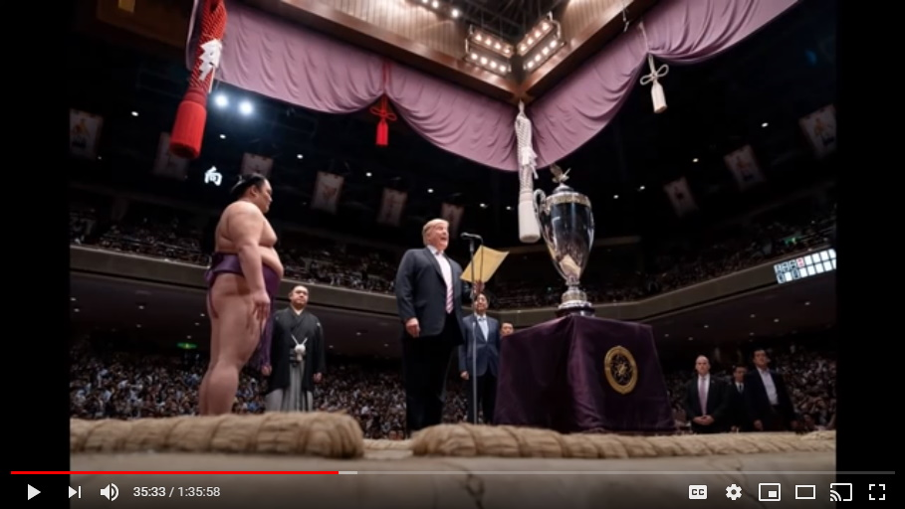
The Japanese capitulated without much fight at all and the symbolic gesture was that at this sumo wrestling championship event that was taking place they had trump come on stage and trump was the one...this is supposed to be left for only the highest figure of the land to present this trophy to the champions sumo wrestler...and Trump did it.

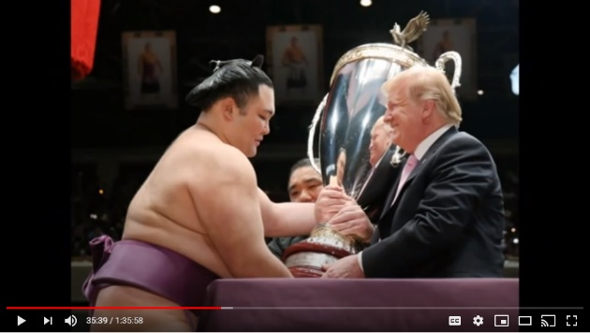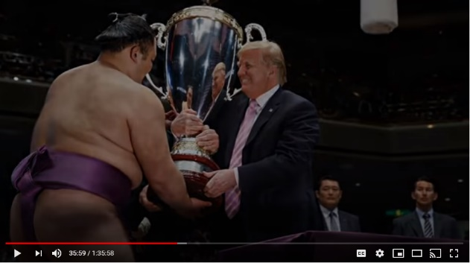
Trump had this enormous trophy in the center of this ring and it is the symbolization of Japanese submission to Trump, the NSA, and the Q plan, and capitulating control over to Trump.

Step Number Six – South Korea
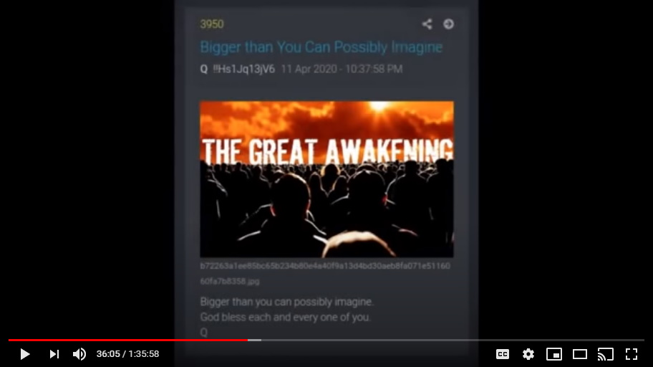
From there, now a lot of this has come out and a lot of the Q-Anons did great work in figuring this out, but all of this stuff with North Korea started when trump left Japan and flew directly to South Korea.

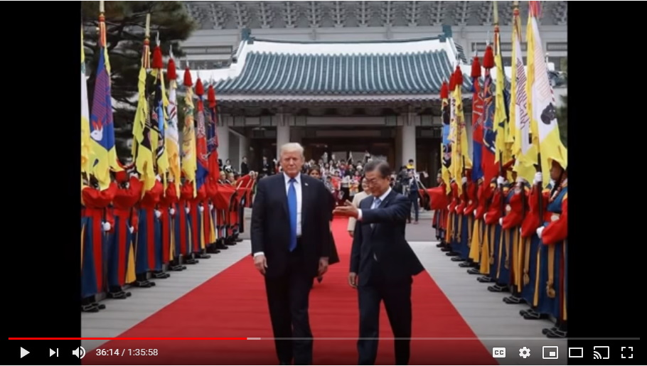
This first meeting was ostensibly to see if they could talk peace with North Korea.

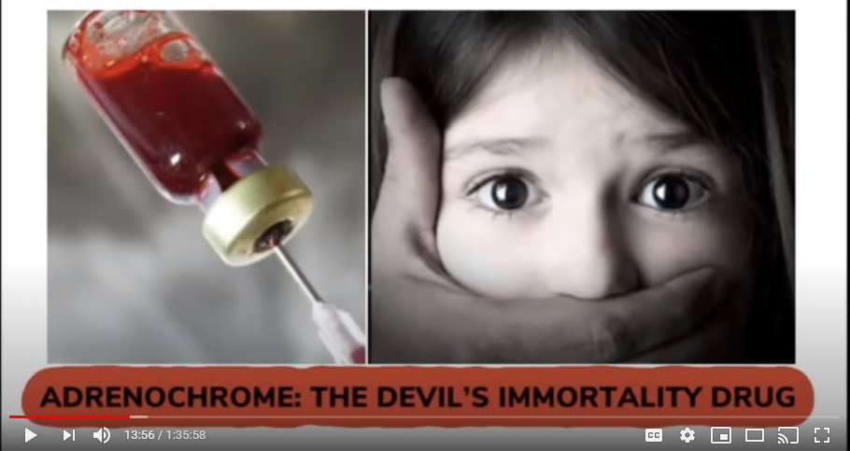
But no, what it was is to get all of these Asian governments to capitulate their control over to Trump via the documents they had, because remember, one of the biggest arms of procuring children for adrenochrome has always been Asia and South East Asia.

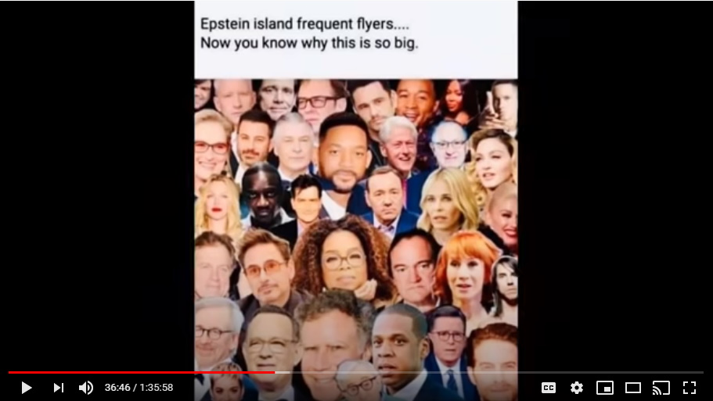
The Southeast Asian countries have been in cahoots with Hollywood, and Washington DC politicians, so, a lot of these people who need children have leaned heavily upon the Southeast Asian governments to procure for them children. They demand it from them and they've done it for years.

So, Trump showed up, showing all of the documents that they had, showing that they were all complicit and these were all capital punishment criminal acts, so, they all capitulated.

Step Number Seven – North Korea
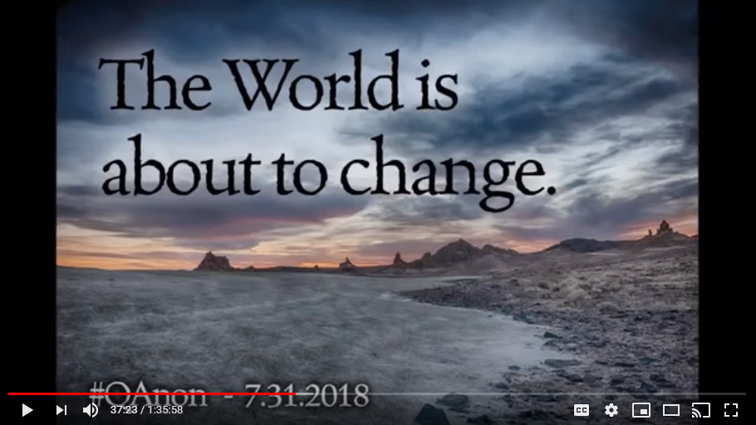
And in secret, with that first meeting that Trump had with South Korea in secret, Trump went to the North Korean border and he met with Kim and began to process of peace talks with the North Koreans.

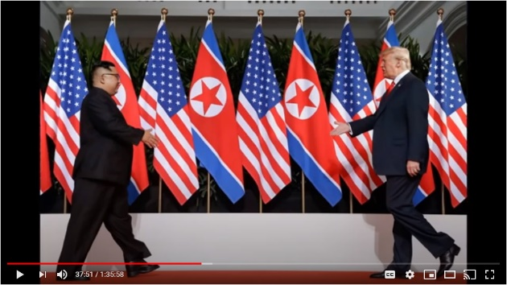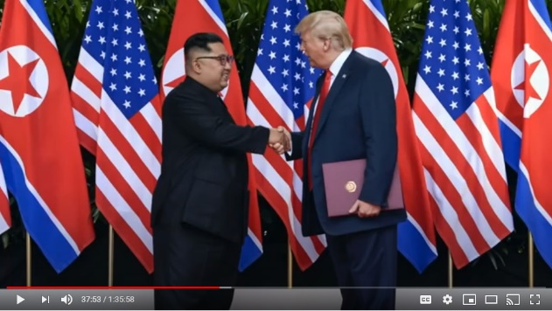
Then Trump in subterfuge, in complete silence, completed those things on his own and then of course as a huge surprise to the mainstream media announced his treaty with Kim and the North Koreans.

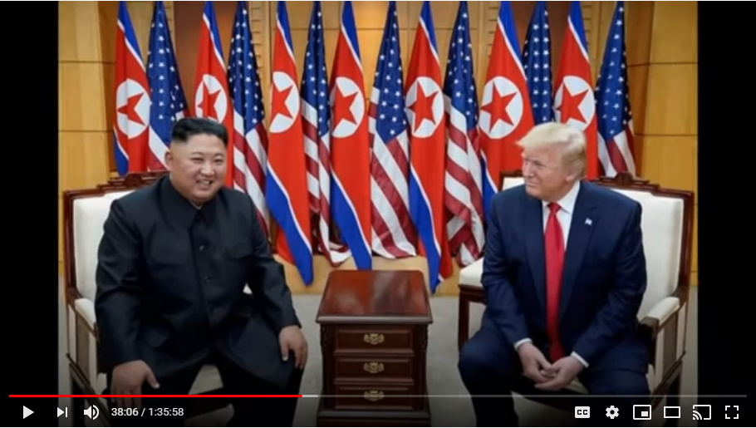
All of this was done because all Trump had to do was to show him the power that he had.
Now that was all of these countries, remember folks again, all of these countries are not just stepping down from doing evil, they are also being forced into helping the Q plan.

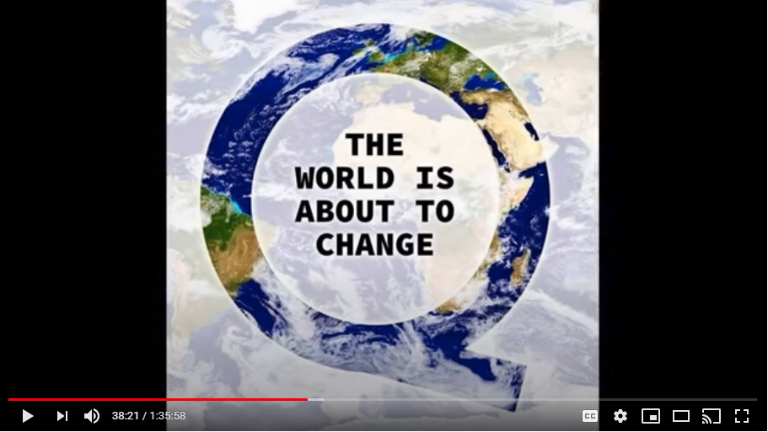
All of these countries are now part of this process to help.

Step Number Eight - China
Now, the next stop was China.

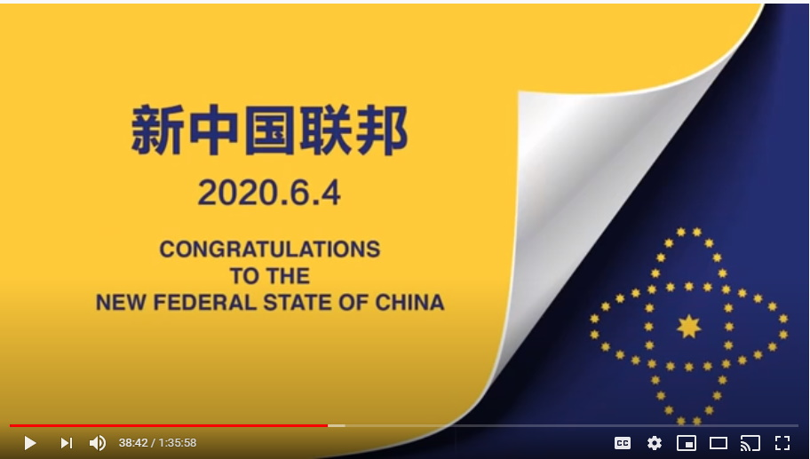
This was huge.

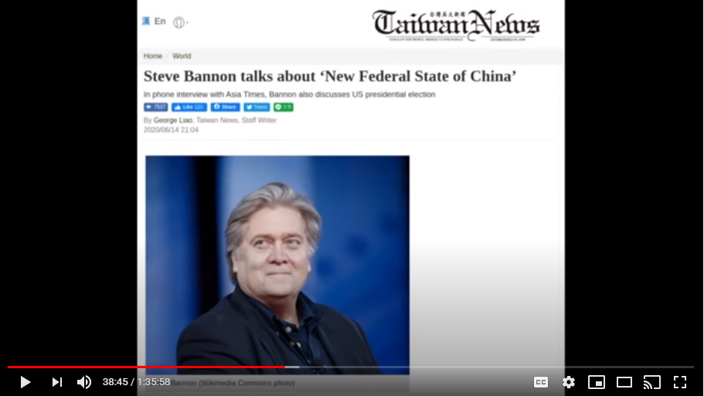
And Mark I know you have been very, very pleasantly surprised to see what the Chinese free peoples have announced publicly through Steve Bannon.
Mark: That's right. Another story the mainstream media just forgot to tell us about.

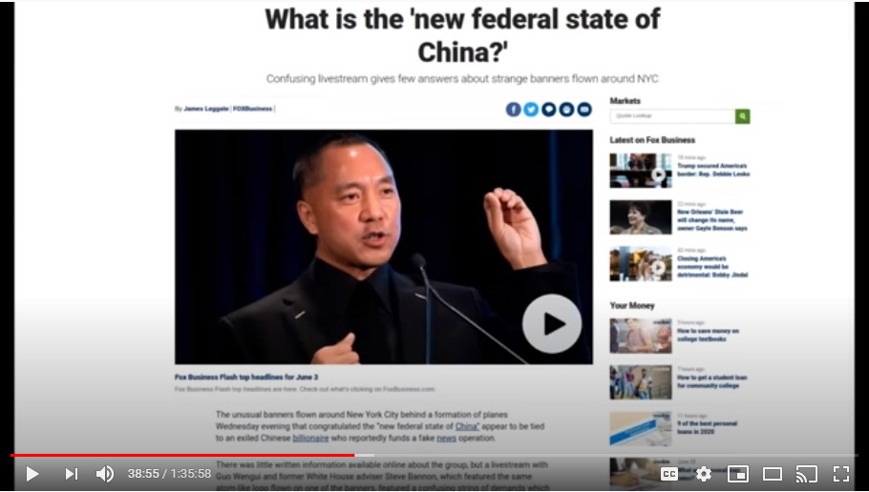
Completely forgot to mention that China has kicked out the communist devil worshiping Satanists and...
Mark: It's not that big of a deal, it's just a small story for the end of the news...

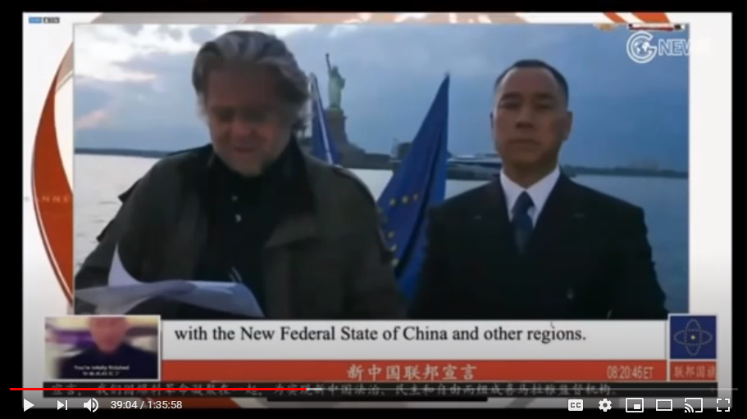
Yeah! There's a lot of people in China, maybe a 2 billion.

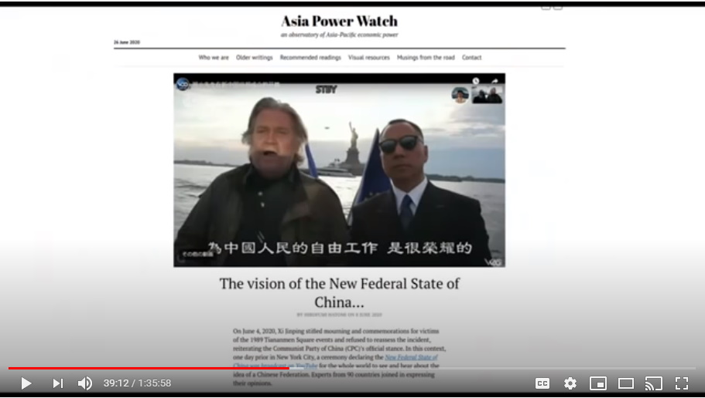
It's a huge deal folks and they (media) ignored all of it. This is huge stuff. First, everybody knows that, but the press didn't make a big deal of it.

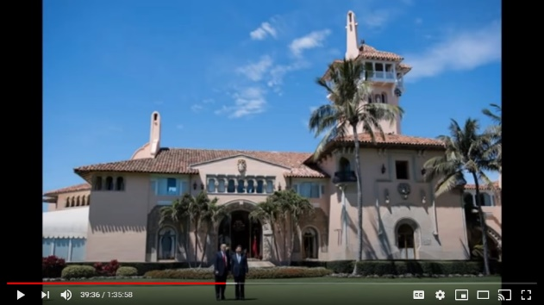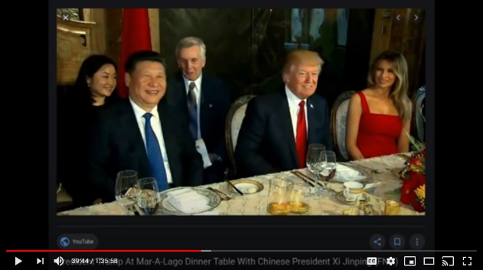
But in the spring, not long after Trump had become president, President Xi of China visited Trump at Mar-a-Lago in Florida.

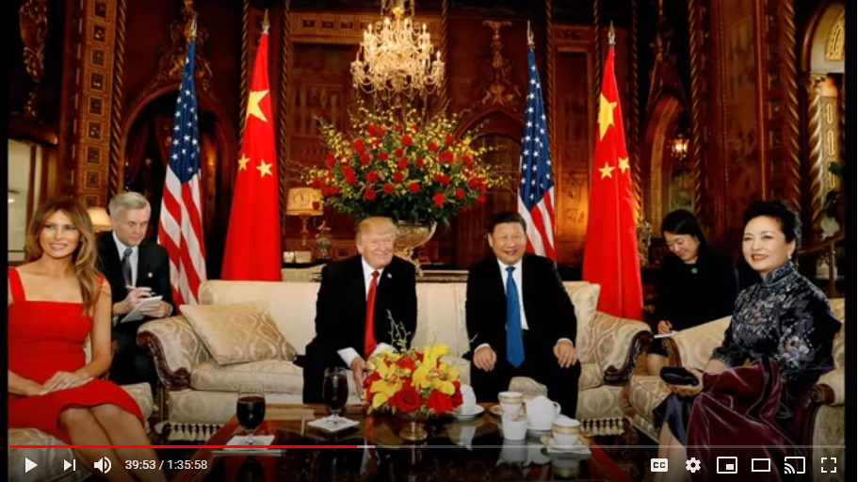
Trump's big resort house in Florida. He visited Trump. Trump hasn't been president for that long and people were just absolutely shocked, and they were also shocked because, you know, the mainstream didn't do much of a job in reporting on this or anything. But, he did, he came all the way from China and met Trump at Trump's leisure at Mar-a-Lago. That's a huge deal.

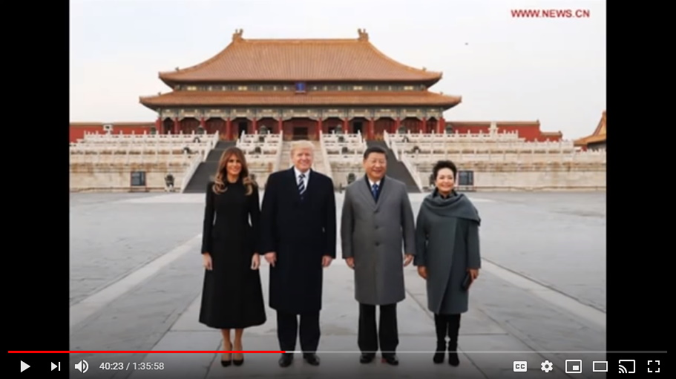
After Trump cleans all the house in Southeast Asia, he then goes to China, and where do he and Xi meet in China? In the Forbidden City.

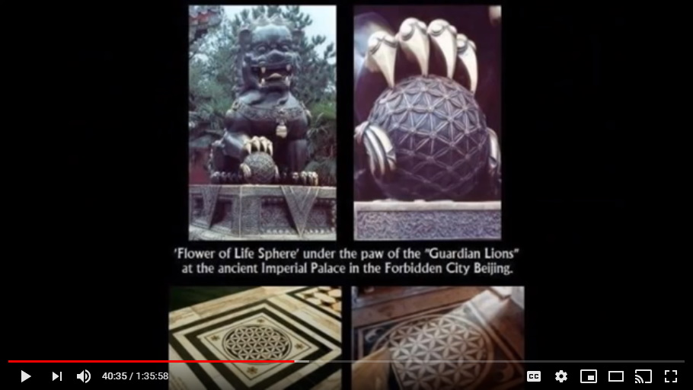
This is huge! It's called the Forbidden City for a reason, because it is a very private, spiritual, secretive place to Chinese heritage, Chinese culture.

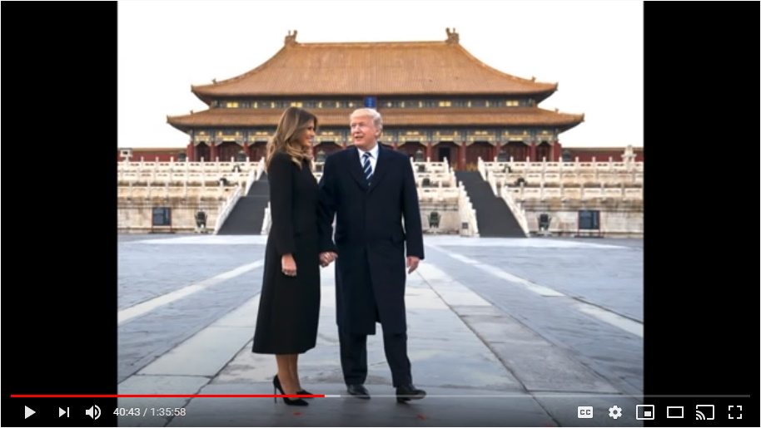
That's where they met, and of course that was at Trump's request, because for every one of these, there's always a marker showing how each of these nations has capitulated powerfully to trump as their overlord.

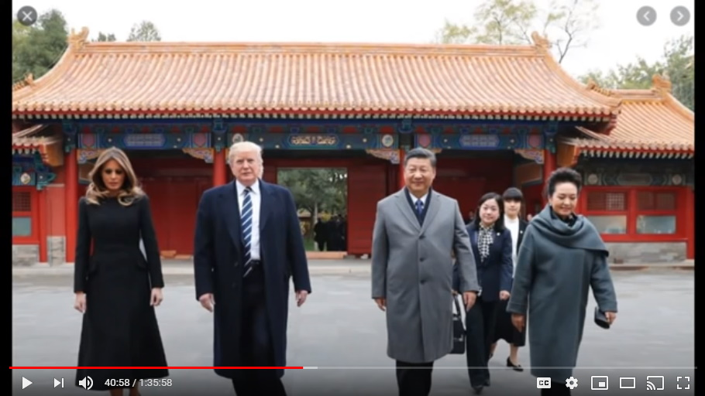
And this meeting with Trump in the Forbidden City, is this, this is probably the biggest one, you can't imagine folks how big of a deal this was. Of course the mainstream media just kind of silent about all of that. At that meeting apparently the Americans were very, very surprised to find out is how desperately all of these Chinese officials wanted these evil, evil communists within their midst to be kicked out.

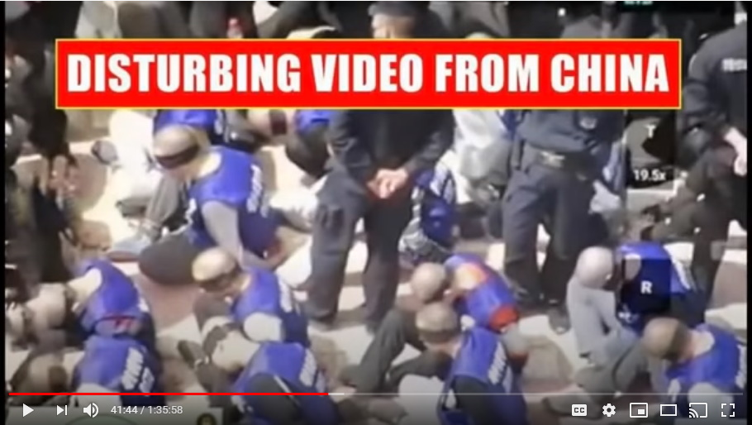
They wanted this, they wanted to get away from all of this evil, because remember, some of the worst, worst, worst, worst possible things have taken place in China and it has horrified people who have had a conscience and not everyone is an evil person. People do have conscience and it affected a lot of the Chinese. They were horrified by the things that they were being asked to do in China, and they wanted this.
So, they met Trump with open arms and they capitulated to Trump's authority willingly, because they wanted this end to the cabal rule over them through the subterfuge of a communist state.

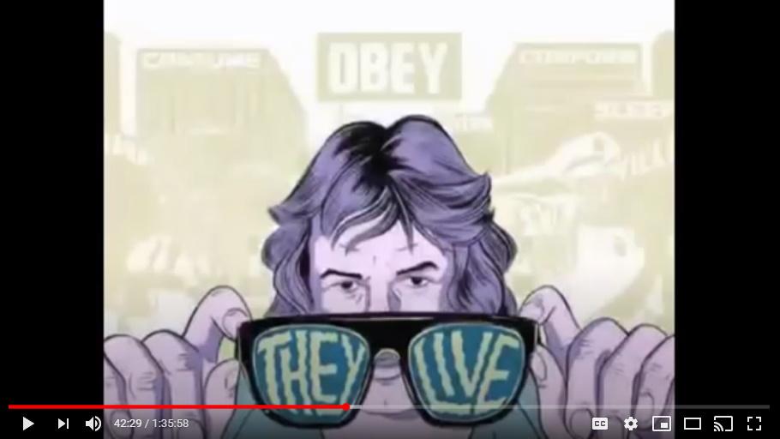
Mark: What's the deal with you being able to put out information like this? Because I know it's felt that the general public is not ready to handle this explosive information, yet you're able to reveal all this stuff on the podcast today. Is this because at most we're looking at maybe tens of thousands of people that actually hear this? It's going to be very limited. It's very far from the mainstream general populace getting to hear about this. It's just a few people that have an interest in these subjects that were able to get a heads up ahead of the news breaking officially. Is that what the thinking is here?

Exactly. Charlie Freak is a bit of a nutter isn't he? He's pretty extreme. He was the first one to say that, no, everything is a lie and I mean everything is a lie. That was Charlie Freak.

And then going into the religious aspect of things...Jesus is this figure of this Swiss looking white dude by the name of Jesus Christ is not real. Charlie Freak is a bit of a nut job. Now he's got some good stuff, granted, and he and Colleen are good people for what they do working so hard with all of the animals, but he's a bit of a nut job.

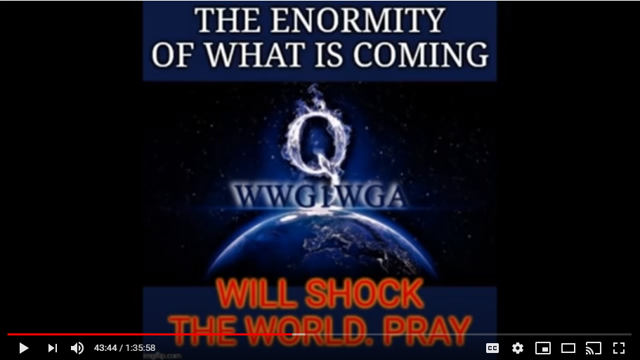
So, there's a reason why we have 4,000 subscribers and not 40,000 or 400,000 subscribers when all we teach is the holistic truth. We're kind of insulated by telling the truth and we don't sugarcoat it either, right?

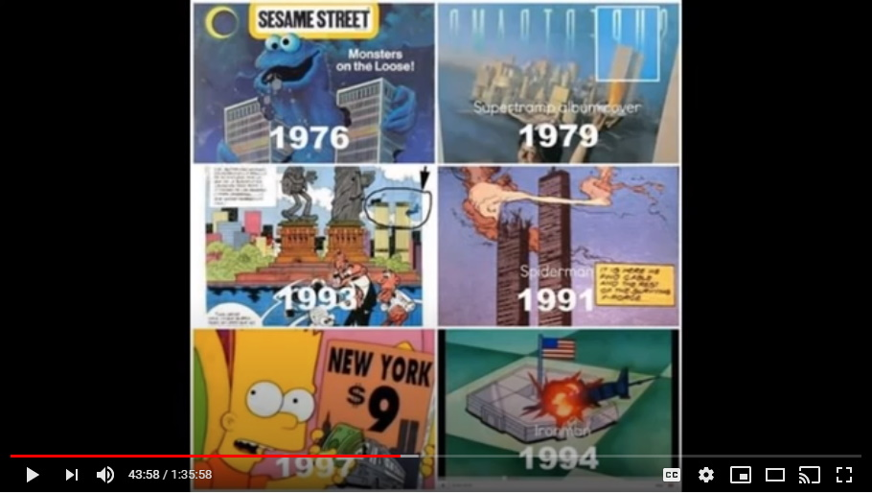
Mark: Right, this is like the reverse of the predictive programming that the cabal did because they put out their little clues in films and stuff and only a few are ever gonna decipher those clues and understand what they're pointing towards.

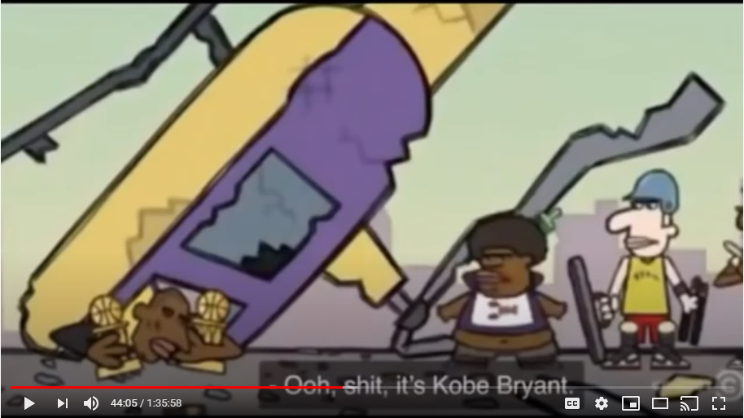
And this is like the reversal of that, so it's truth for just the few, the very minimal few, that are able to understand this information and take it on.

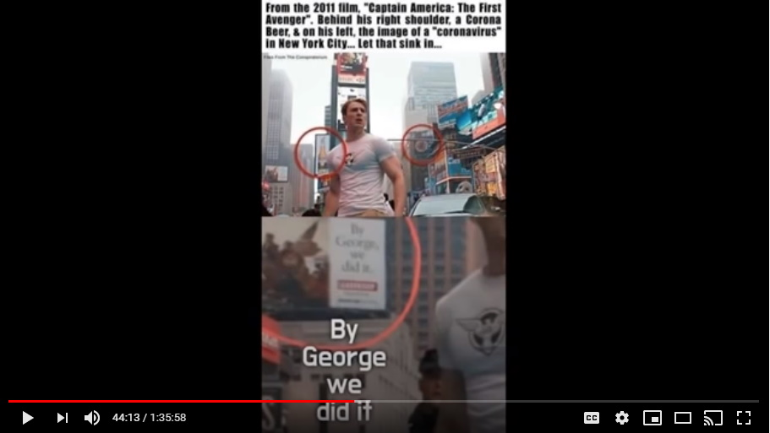
And it gives Colleen and I a lot of chuckles as well, and as you know we've never been concerned about our numbers as our numbers were never going to be...we're watched very, very closely on YouTube.

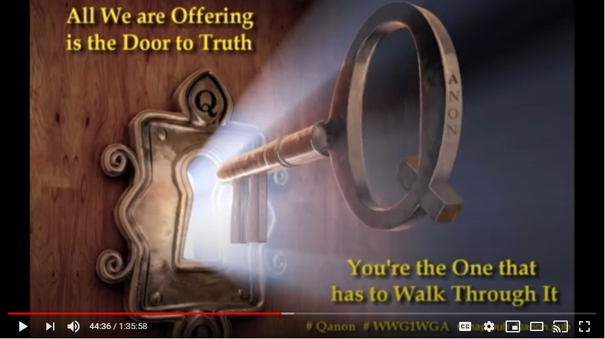
So, yeah, we're very safe to have this knowledge to come because we're good people, we're good folks and we care so much, but we're a couple of nutters.

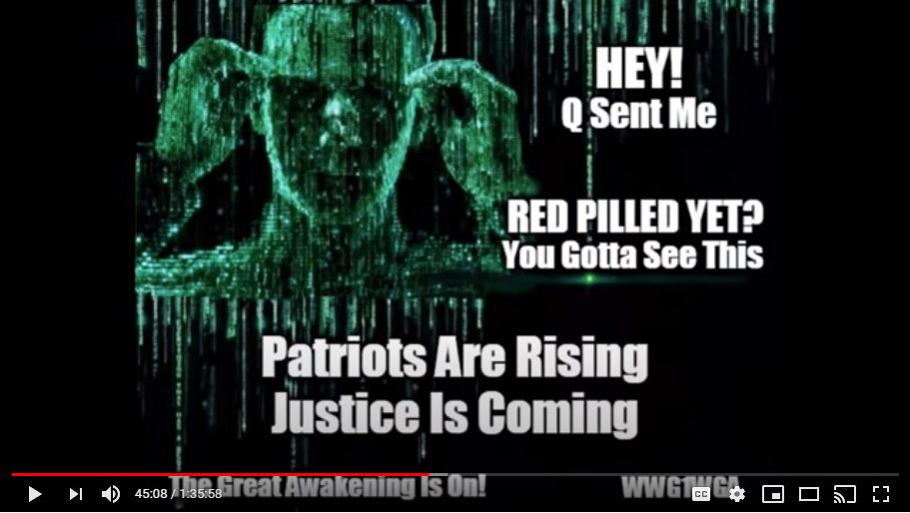
The thing is, remember what I said at the beginning of the show? Every day moving forward, Mark Devlin and Collywog and Charlie Freak become more and more valuable and more and more important because we surrounded ourselves by the truth and we've been sharing the truth, so, no matter what happens moving forward, our services are going to vastly and desperately be needed. Some of these others, not so much.

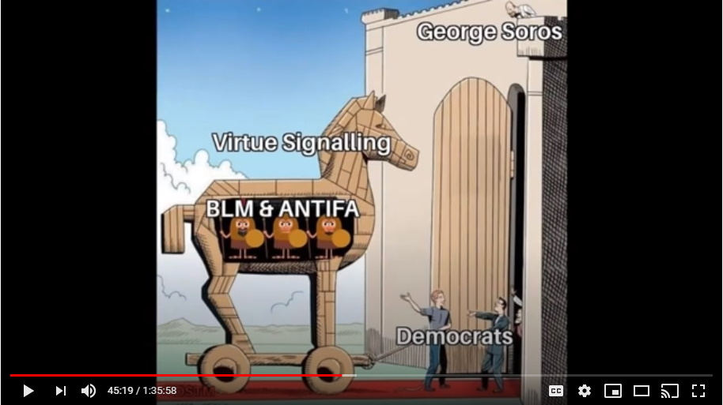
So, you find yourself in a situation where there are a lot of people who are rooting for the bad guys here. That's all I'm gonna say.

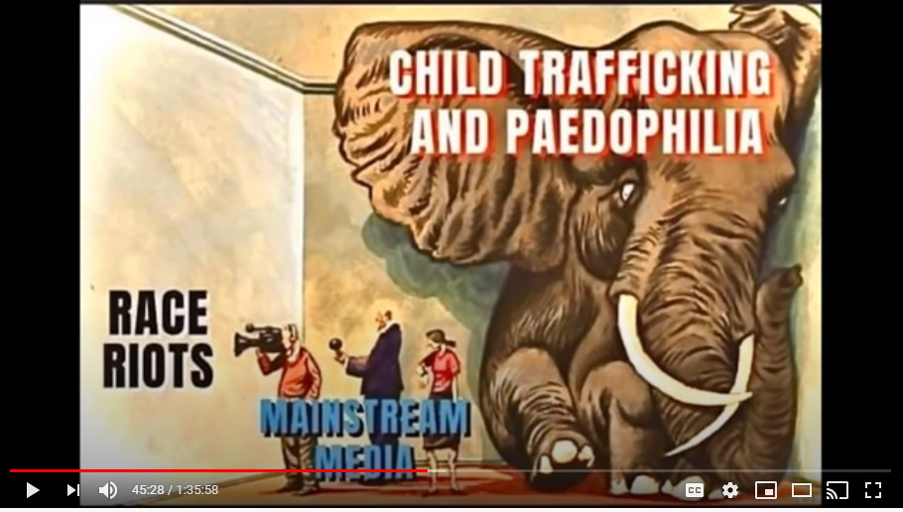
You guys do your own research, come to your own conclusion, it'll all come out in the end I promise you, but there's a lot going on here my friends, and it's pretty ugly. That's all I'm going to say about that.

Step Number Nine - Vietnam
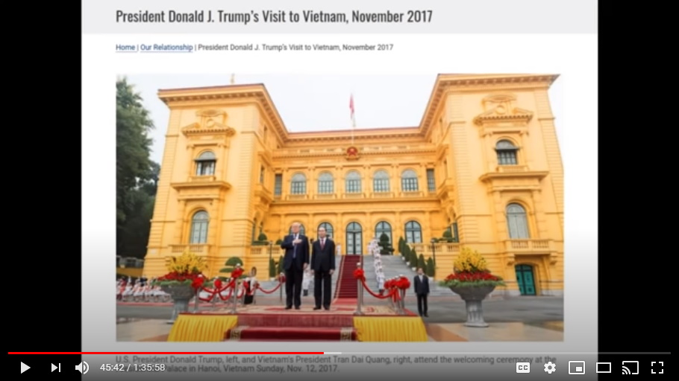
So, after China, Trump went to Vietnam. At this very public ceremony, Trump was placed slightly ahead and to the right of the Vietnam president and showed himself to be in charge.

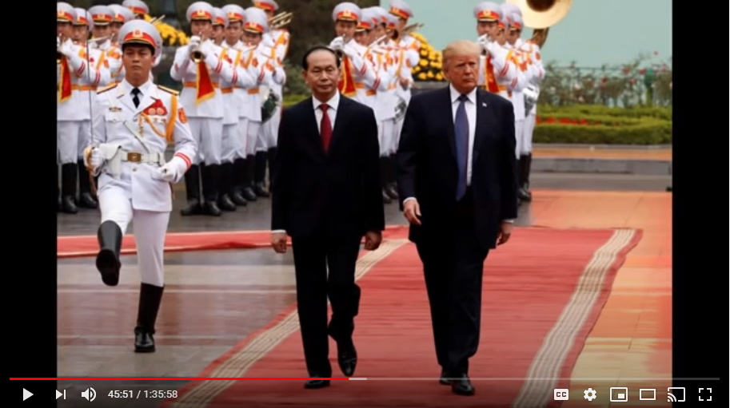
So what the Vietnamese promised was to stop their participation in procuring children.
Colleen: The human trafficking?

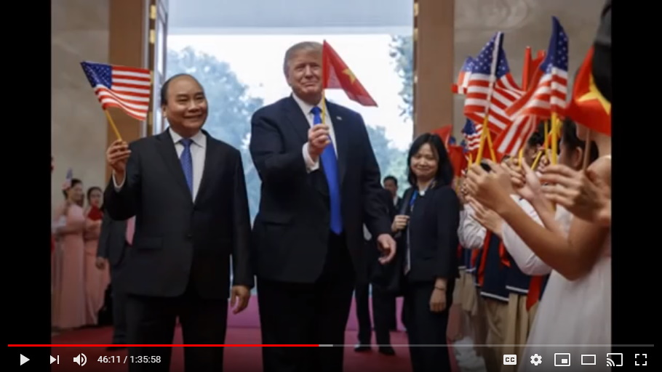
Yep, yep, so he didn't leave...and they capitulated quickly. Most of these did not put up a fight folks. Israel put up the biggest fight.

Step Number Ten – Davos, Switzerland
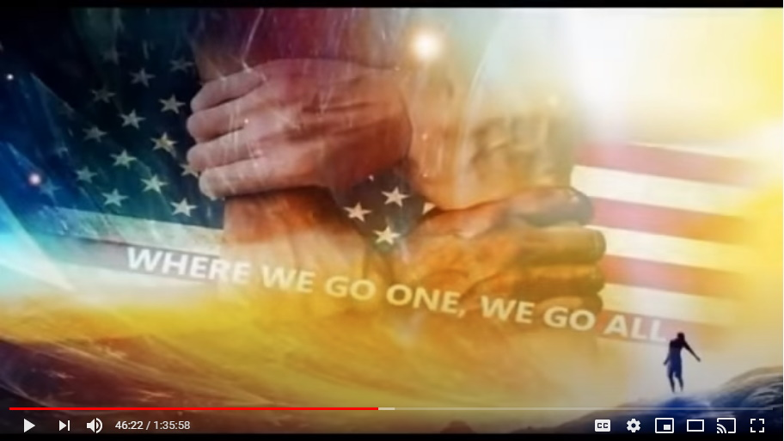
Now this one is a big one for me, and you talk about going into the lion's den. The big one after Vietnam and end of the Asian tour for Trump in January I believe it was, very early in 2018.

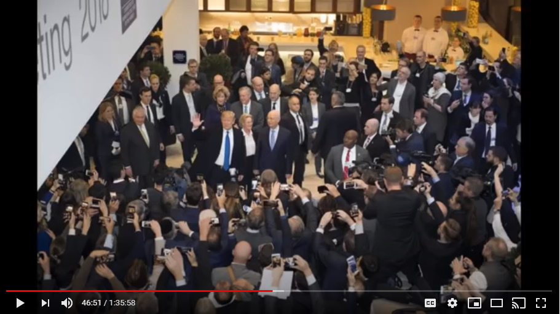
Trump attended a very, very famous meeting because of everyone who was purported to be there.
At Davos Switzerland. You guys remember this? This is January of 2018. This was quite a big deal. Soros was there as well. He was present at this as well.

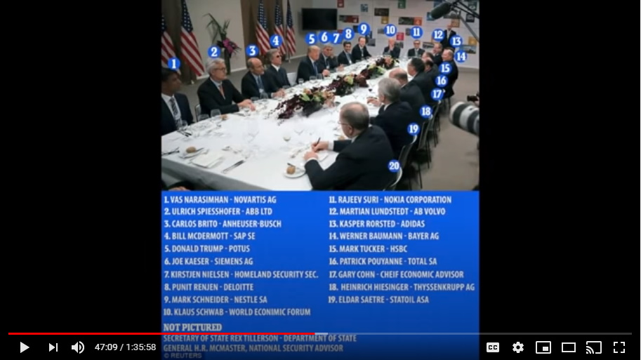
At this meeting you're talking about the biggest international corporations in the world. This is it. These are the key players and these are the biggest, most evil corporations that are at this meeting at Davos, Switzerland. It was called by Trump, that's not what they said publicly of course, but it was called by Trump. Trump came in late again, he sat at the very middle of the table and basically everyone was kind of wrapped around Trump because he was the boss of this meeting.
Trump laid out documents and folders, he started with envelopes, very similar to what occurred at the George Bush funeral when he first arrived and you had a lot of very, very worried people for the meeting the next day because of what was said in these envelopes the day before and then the next day at this meeting he provided a whole bunch more information about each one of these evil fucks.

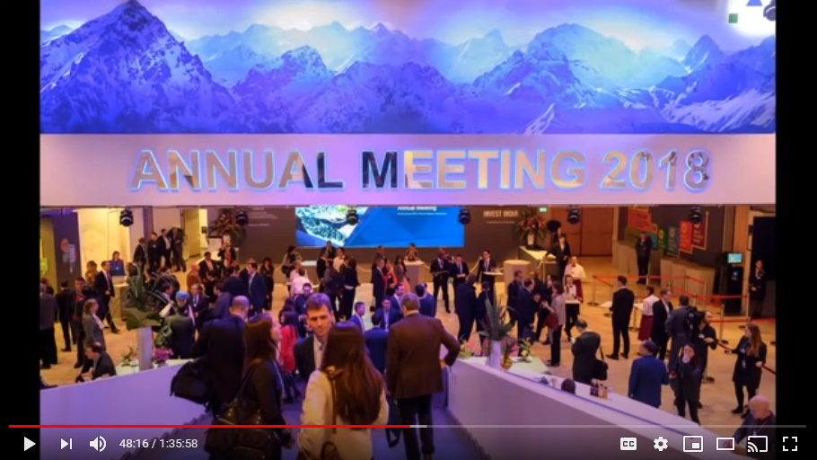
Now this is kind of a scary place. It would be for me anyways...to go to...Davos, Switzerland and all of the caves and tunnels underneath those mountains and they could have abducted him and said that this was some kind of, you know, kidnapping and they don't know where he is, but they're going to use all of their resources to try to....

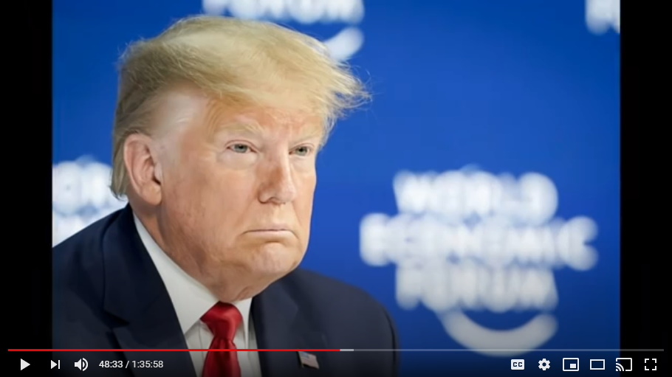
This is scary big stuff that...you talk about cajones...
Colleen: I'm sure he didn't go here alone.
No, I'm sure he didn't either, but still, you talk about cajones.
I think this was, Mark, I think this was Trump at his most vulnerable was this January 2018 meeting in the lion's den at Davos, Switzerland.

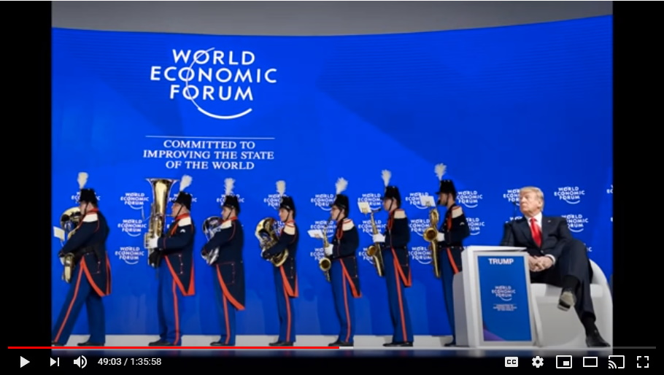
Like scared little rodents, they capitulated quite quickly. I think Trump played it really well with those envelopes the first day, the first night, and then made them sweat it overnight and then the folders the next day and they capitulated.
Trump did not leave without them, and remember again folks, this is not just saying to Nestle that you're not going to poison the water anymore...
Colleen: Or steal the water anymore.

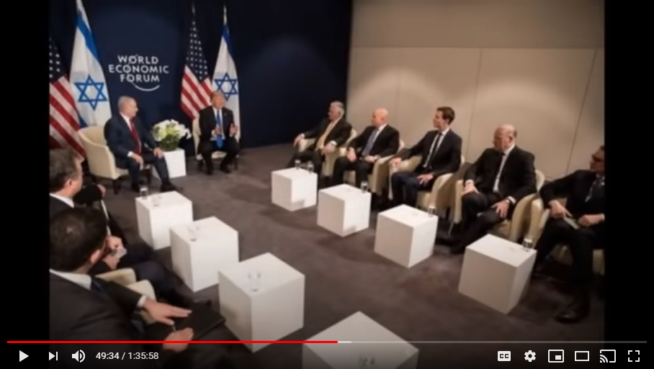
Yeah, well, but you're also working for us, and what we ask you to do, you do, and if you don't do, we go public one by one. We don't make this look like a big conspiracy and we're nuts...uh-uh, you're a lone nut, you're a kook, you're a sick child abuser and we're going to pick on you individually.
What Trump said to each of them, we're not going to make this a conspiracy that'll help you, uh-uh, we're going to single you out and eat you alive. So, they all capitulated at this meeting, and this is a huge one because these are the biggest companies...HSBC was there...this is evil, this is the faces of evil were at this meeting. And George Soros was at this meeting.

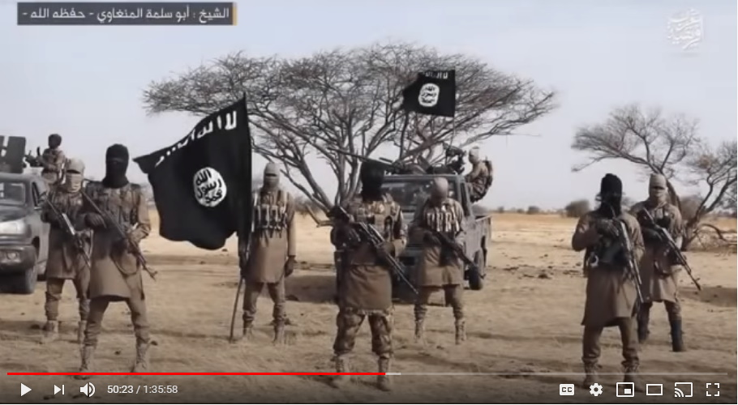
Mark: There has been a notable absence of ISIS terror attacks in recent years. I know there was a huge spate of them, I'm trying to remember the years, maybe it was around 2016-2017, but then I don't think we've heard from ISIS for a good couple of years or more. I wonder if that's a coincidence.

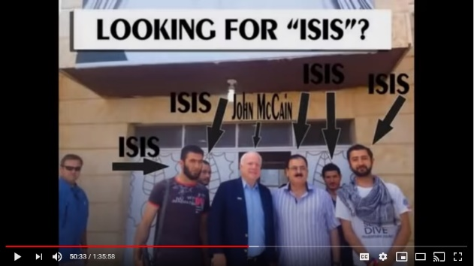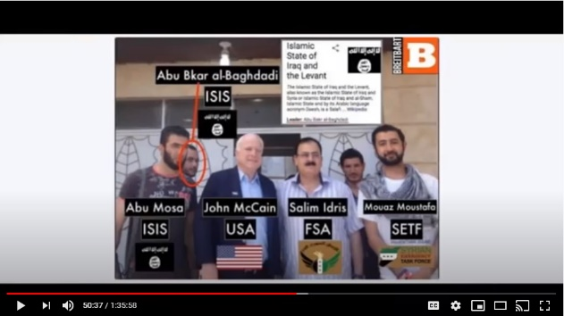
John McCain, now let's just do that. Let's do the John McCain math here.

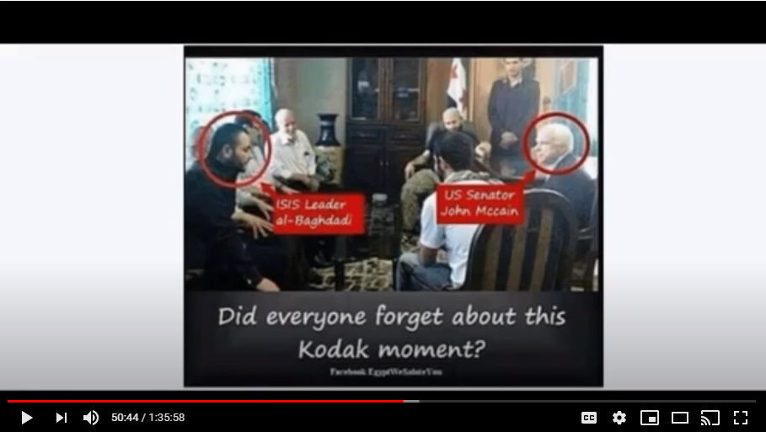
When was John McCain alive? When was John McCain spending a lot of time in the Middle East?

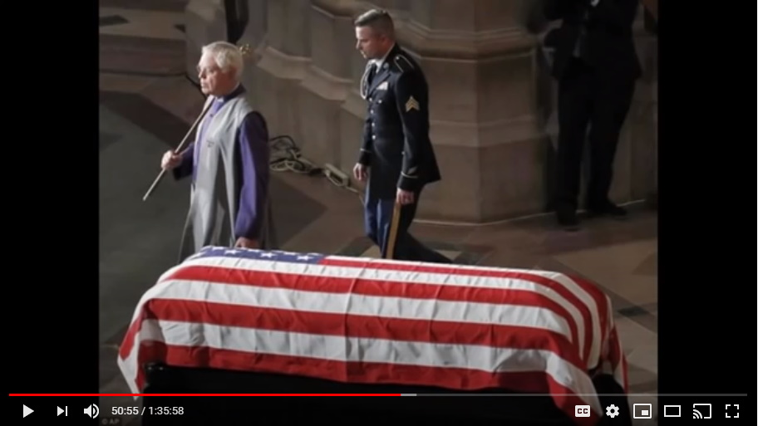
And then, when did John McCain get taken out and have a dishonorable discharge and a dishonorable funeral where the flag on his coffin was skewed, pointing out that he was dishonorably discharged from the military before he was shot in the back of the head.

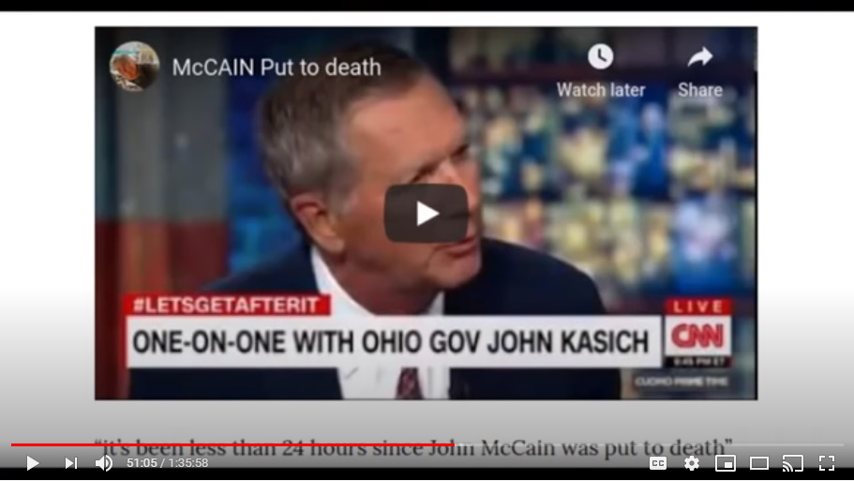
So, yeah, let's do the John McCain mathematics here okay, and then you add that up and I think you can come to an answer. You can figure out when ISIS just seemed to go away.

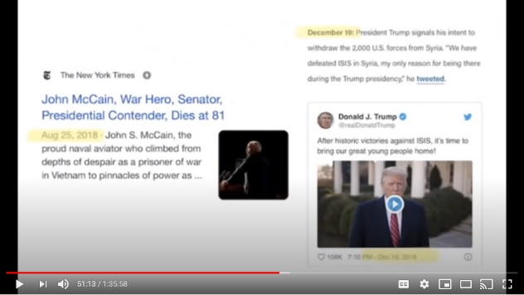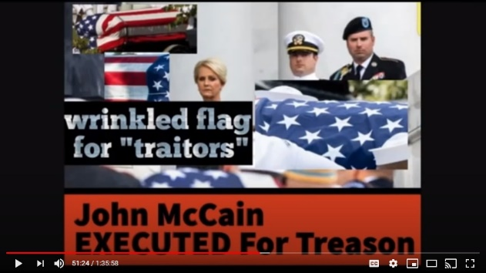
John McCain had to nurse those idiots into doing the things that they.

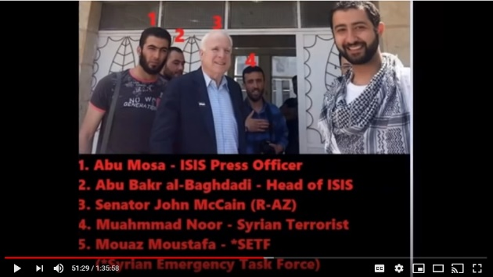
ISIS was his charge and that's why you have so many shots of McCain over in the Middle East hanging out with all four of the main ISIS evil heads.

You know, we're never going to find all of them and no, he just happens to be having lunch with all four of the them. Yeah...they're just his little buddies.
Mark: I think they've all got coronavirus now which is why we don't hear from them.
That's exactly right, these people, sickening.

Step Number Eleven - India
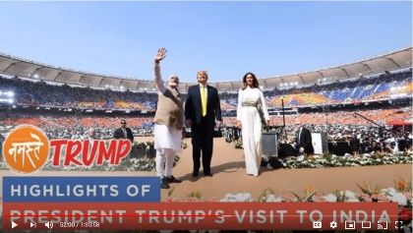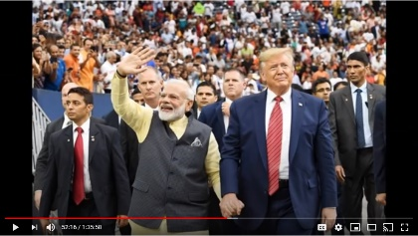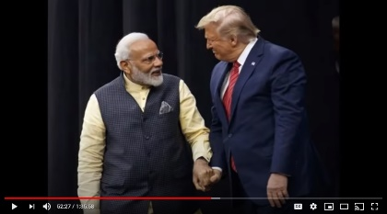
Then Trump went to India and the Modi, who was the Indian leader very publicly...and by the way, this is really, really a good one because, I'm not sure necessarily why it worked this way, maybe it was Trump's idea, I don't know, but from Modi the Indian leader onwards, you see all of these international presidents and prime ministers all coming to these public meetings now with their arms wrapped about and their hands all wrapped about like they're symbolizing their hands are in cuffs.
Colleen: Now that their hands are tied.

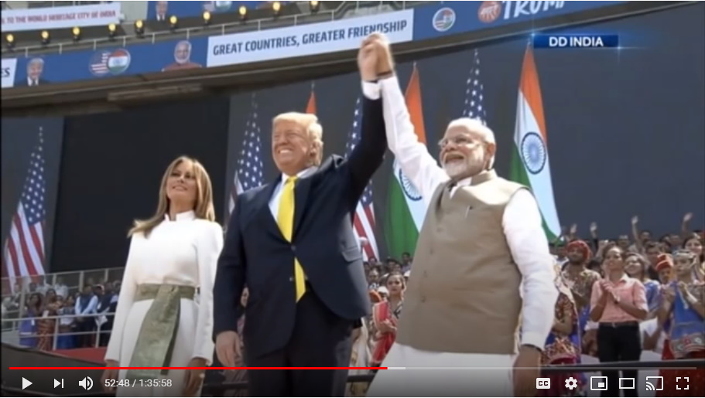
Their hands are literally tied. The first one to do this was Modi. Such a weird thing...people were kind of looking at him going...it's kind of odd, like why does he keep doing this and he was trying to draw attention to the fact that he was clasping his wrists like he had cuffs on them. So, don't blame me, don't get angry at me. I'm sorry my hands are tied is what he was saying.
So, he (Trump) took India and made India work for him.

Step Number Twelve – Mexico
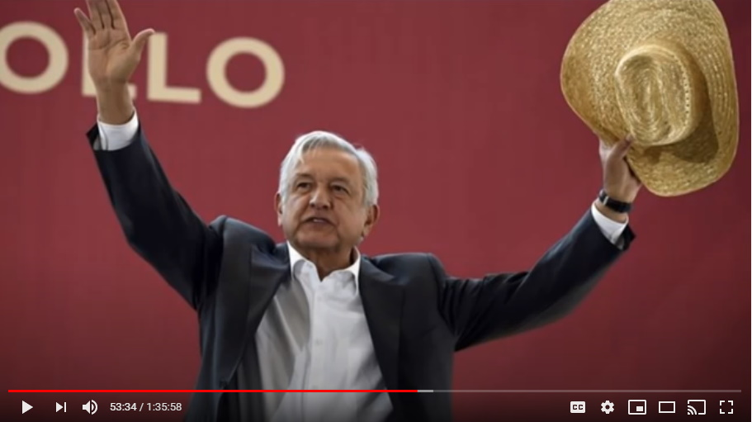
The central Americas starting with Mexico's, AMLO (Andrés Manuel López Obrador), the corrupt, oh no, he's a good guy, no he's a kindly old man and AMLO, he cares about the Mexican people, he's going to change things.

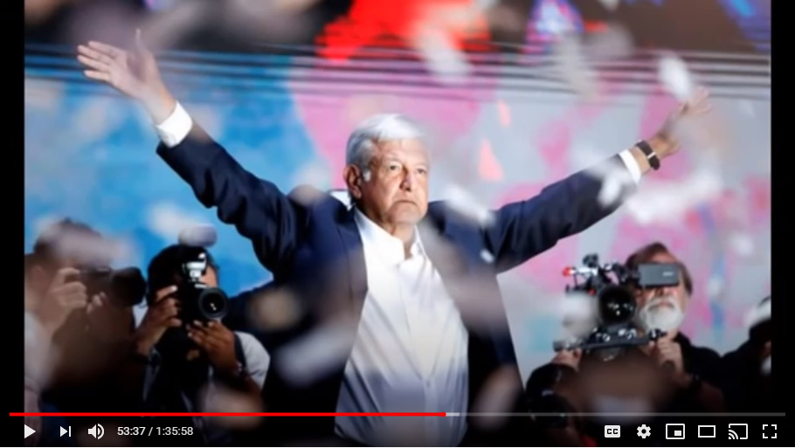
He's evil, but anyways, he was quite resistant and Trump actually made comments to that, about how inhospitable Mexico was to him and people were just like thinking, well, yeah, because you were all doing all that wall stuff and stuff. No, no, no, no...
Colleen: It was about you're racist and you don't like Mexicans. Trump's not racist.

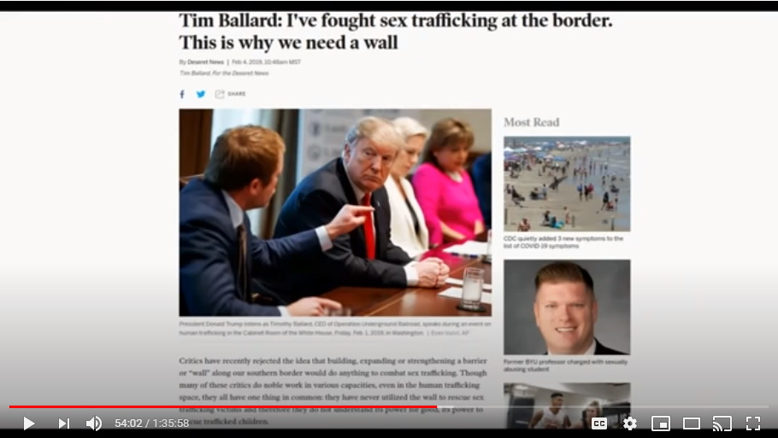
That's right...no, no, no, no it's about AMLO didn't want to give up eating children and give up his power to Trump...kind of liked his little gig...but they did.

Step Number Thirteen – Central American countries
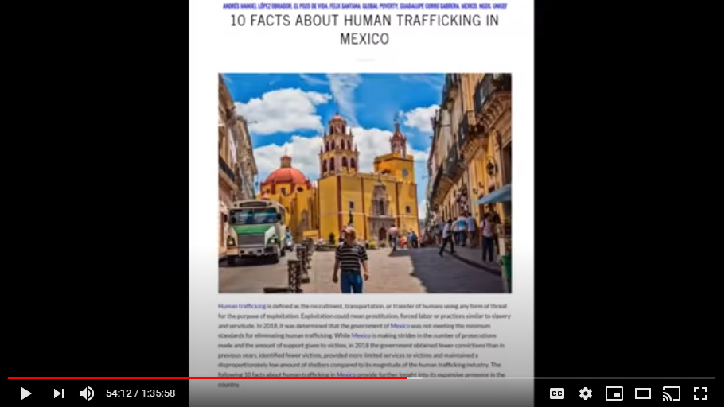
From Mexico City he went to all of the Central American countries and they all signed over and then in all of these meetings, all of these various leaders, AMLO included, were doing these clasping their hands together, and their wrists together.

Step Number Fourteen – Brazil
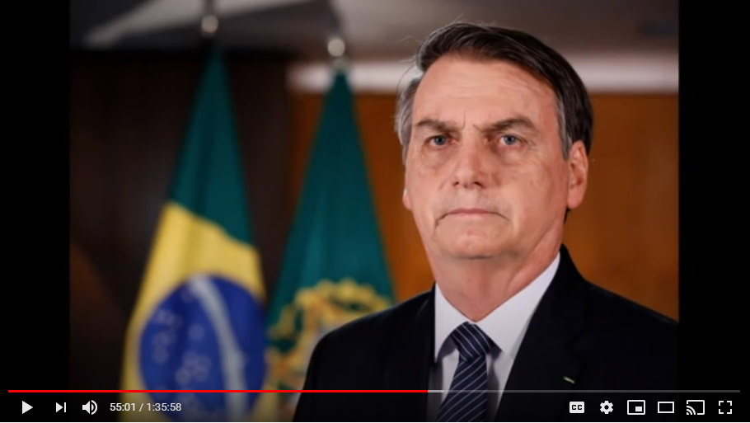
We get to Brazil and the new Brazilian president thinks he's got the best job in the world because he's far away from all the bright lights of the mainstream news and he can just rape and go to the bank in Brazil.

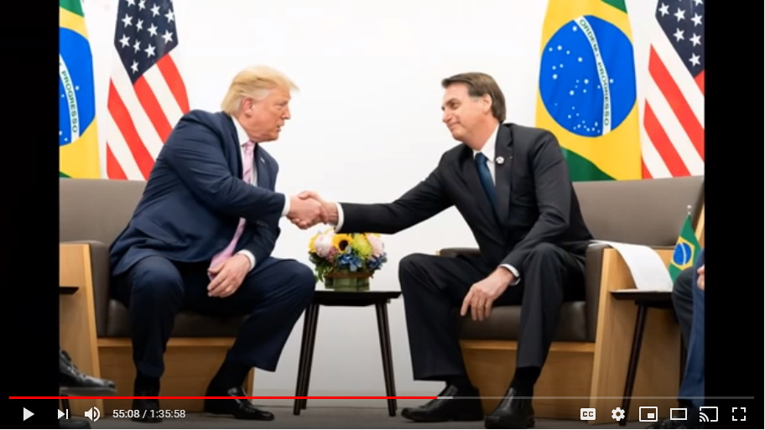
Nope, Trump pays him a visit and tells him he's working for Trump or else and they have this very public meeting where once again, Bolsonaro clamped his hands together and his wrists together showing that he was forced into doing this and he submitted over to Trump as well.
And then, after Trump leaves, guess what one of the first acts that Bolsonaro as the president this is very key everywhere by the way folks, is all of these then key arrests after Trump left these countries of key pedophilia cover companies and individuals.

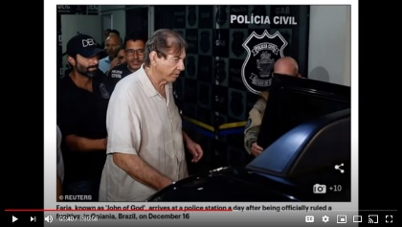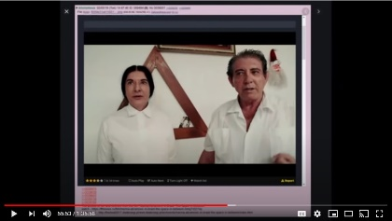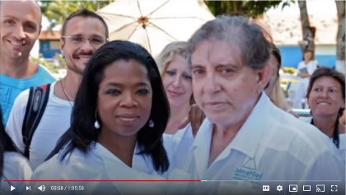
So, Oprah's best friend in the world, that beautiful spiritual man, John of God, who is running one of the largest child trafficking and adrenochrome production facilities in the world, just an absolute monster, Oprah's best pal...he was arrested shortly after Trump left by Bolsonaro, the President of Brazil.

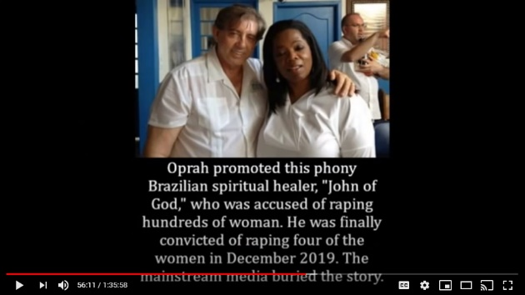
They took dear sweet, man of God, literal Christian Jesus, who maybe looked more Latin than Swiss, but anyways, he was arrested and the rest is history there.

Step Number Fifteen – Argentina
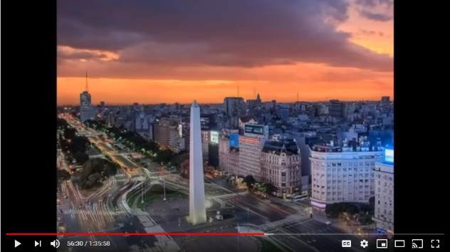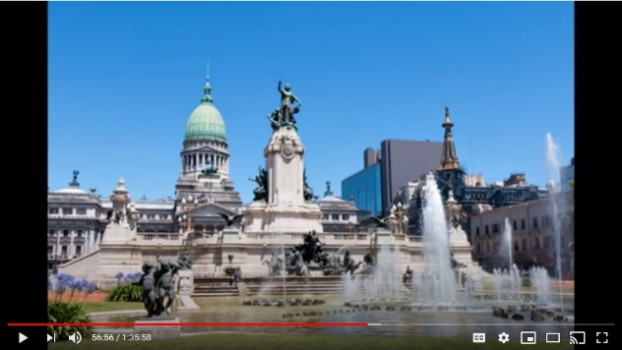
Then he went to Argentina and Argentina has long been kind of a safe haven because it's as far as people can get away. How Obama, uh, at the Obama's, Mike and his little bitch Barack, they used to go there quite a bit because they were planning their safe escape, their retreat if certain things should come out. They spent a lot of time in Argentina as well as did a lot of people. It was kind of like their hideaway place.

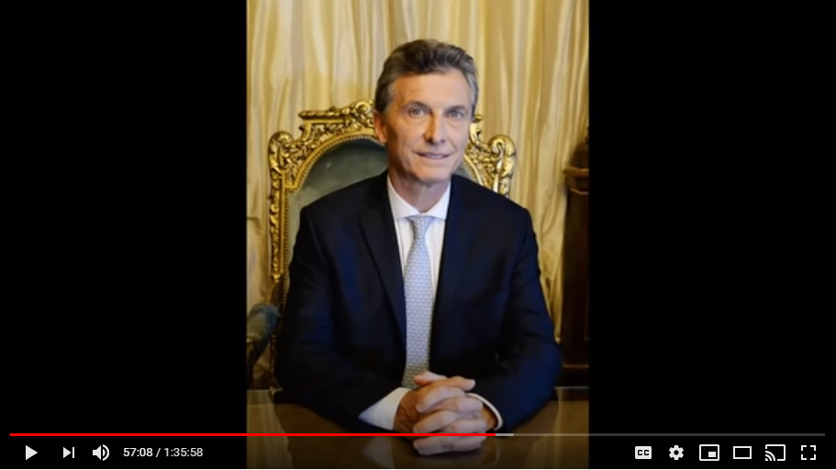
Trump went there...and this Argentinian president who is such a corrupt person it's just brutal...Trump was so disrespectful to this guy.

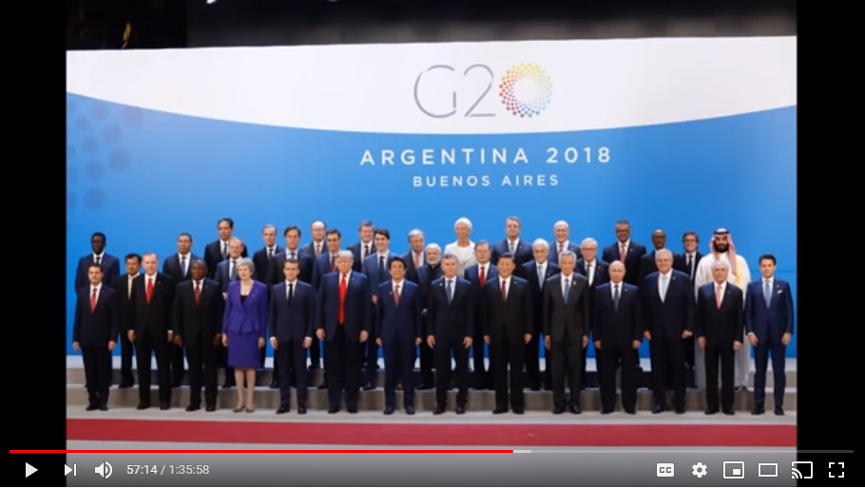
Colleen: Well, they had the G7 (I think she meant G20, pic shows G20) in Argentina.
Yeah, that's right. Therefore that meant they had to have the global banksters there as well and stuff so there's actually quite a lot of people that were there as well.

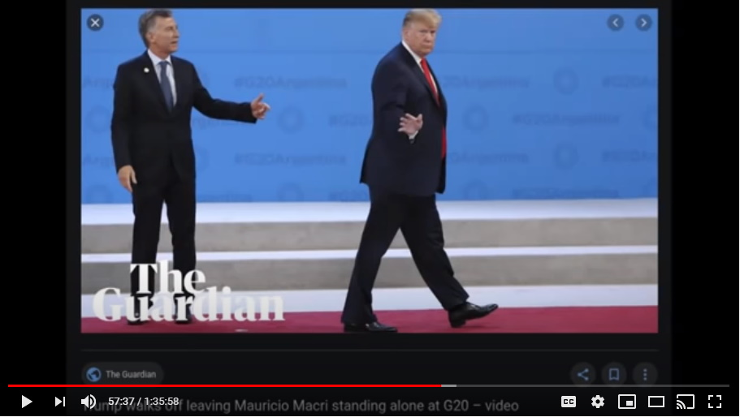
But Trump's behavior to this Argentine president was just brutal. Just treating him like the scum of the earth that he is, and of course he capitulated.
Mark: And press always presents this as Trump just not observing protocol and he's uncouth and all this.
Colleen: Just a buffoon.

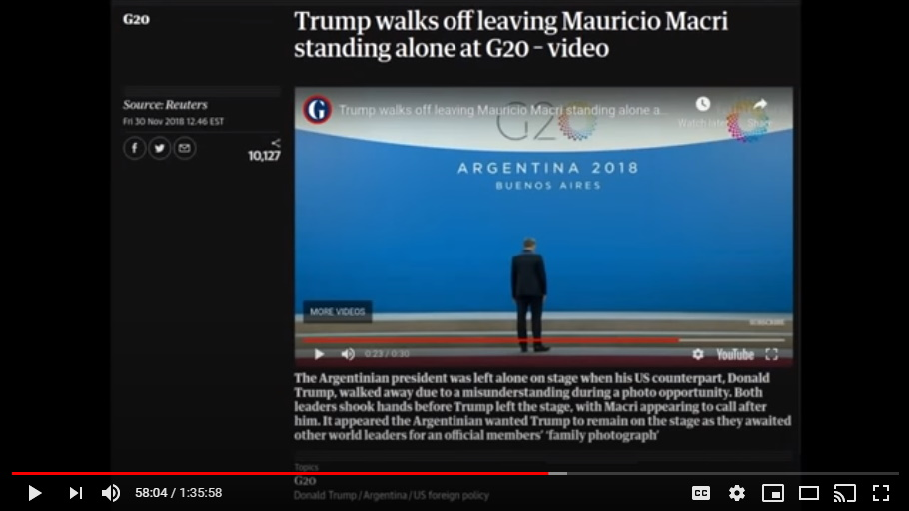
The big thing with this Argentinian president is that Trump just up and walked off the stage after, I guess, he, Trump had spent he felt long enough, five or ten minutes, for a couple of questions and some photo op and he just up and left and didn't say a word to anyone including that Argentine president.
Again, it's a power move basically just saying you're scum of the earth. We know who you are, you're scum of the earth. Just obey what we tell you or else. That's what he did.

Step Number Sixteen – G7 in Canada
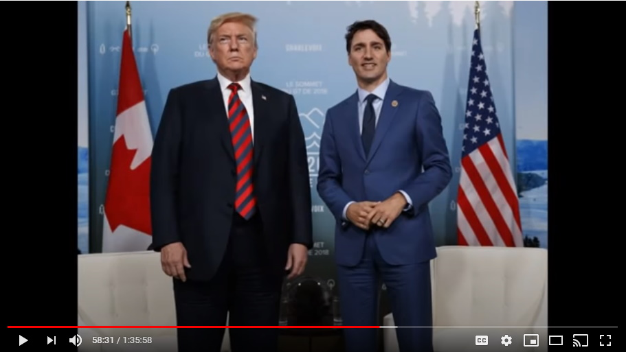
Then at the G7 summit in Canada he, very fortunately of course, had horrific pedophile and adrenochromer Justin Trudeau hosting the meeting.

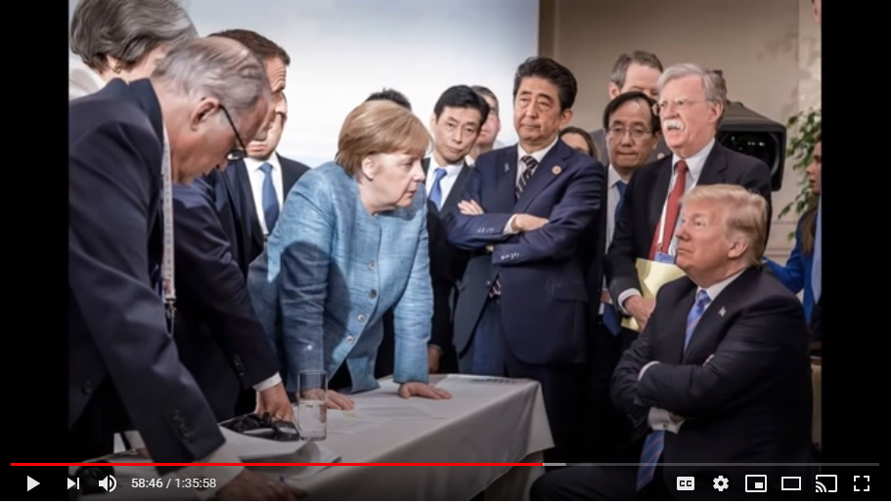
But, Angela Merkel was there as well and she was one of the big ones that he wanted to be there as well because she didn't play a major role back in Brussels.

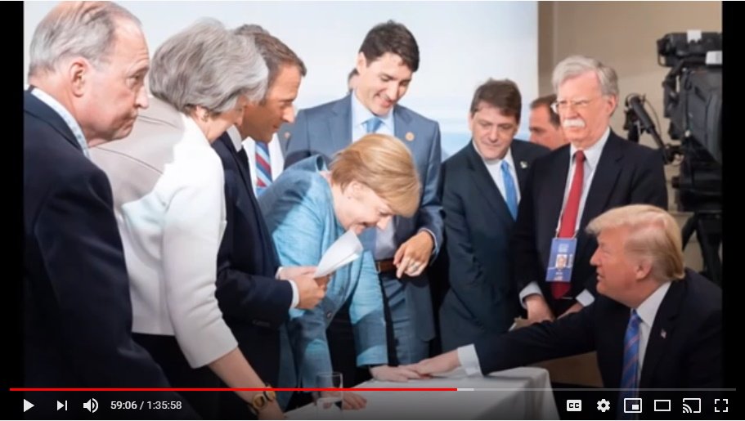
So, at this meeting he got everyone there, but in particular it was the capitulation of Justin Trudeau of Canada and Angela Merkel of Germany.

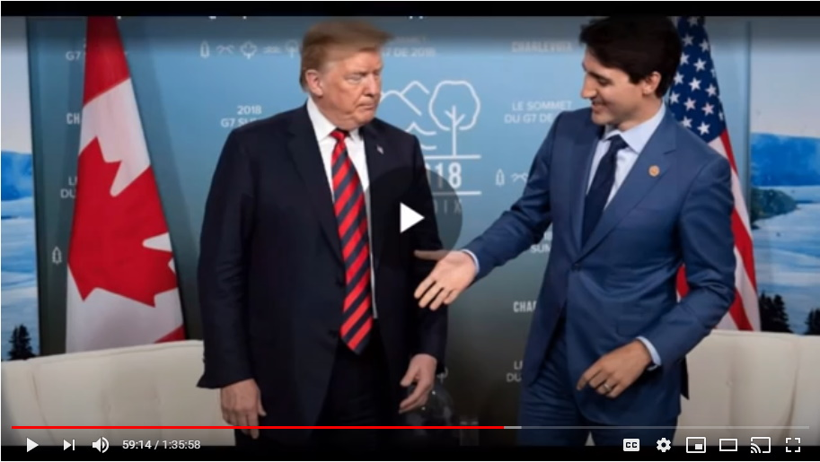
Both of them did the same thing, in fact, Justin Trudeau spent most of the G7 with his hands clasped together like he was in handcuffs.
Trump did a lot of very, very suggestive gestures towards Justin Trudeau as well kind of pointing out some stuff.

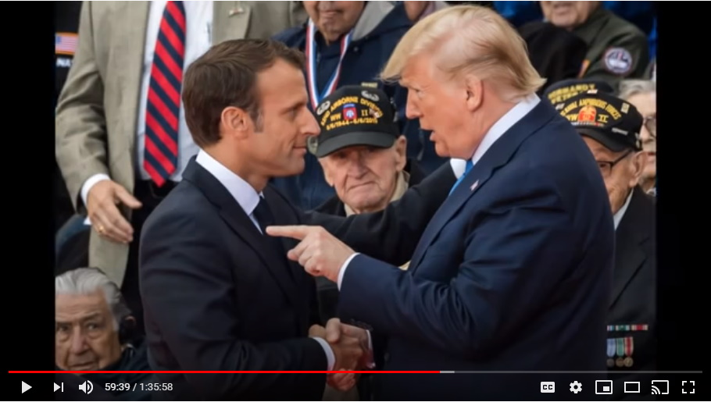
One of the ones that Trump, it's kind of cute, treated the absolute worst with the most disrespect, he just treated him like a little child, was Macron, the French president. Of course he is just so known for being just an absolute Rothschild stooge and a horrible adrenochromer.

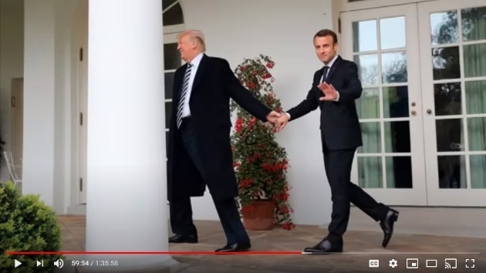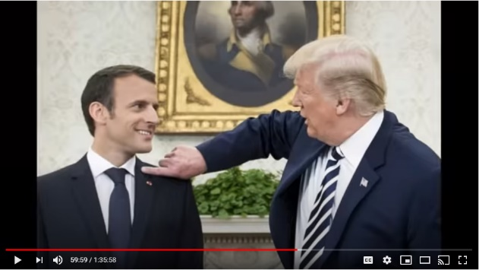
The stuff that Trump did with this clown in public, in front of the press and the media to make him look bad was actually incredible.
He got Macron to submit, capitulate, as well.

Step Number Seventeen – England – Buckingham Palace
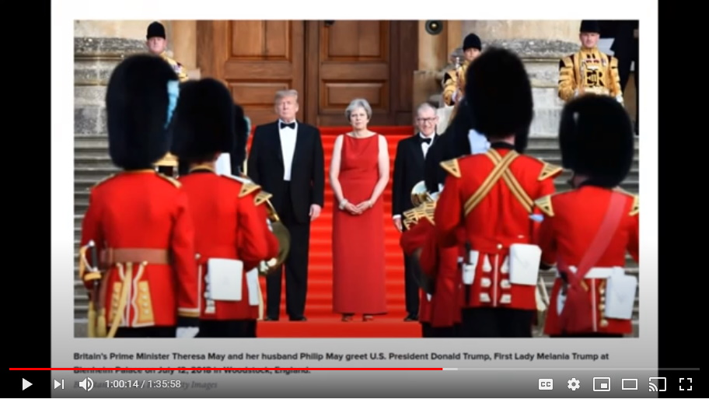
Now, Theresa May, in your country resigned to allow Bojo (Boris Johnson) to take over as a Trump supporter and she exited.

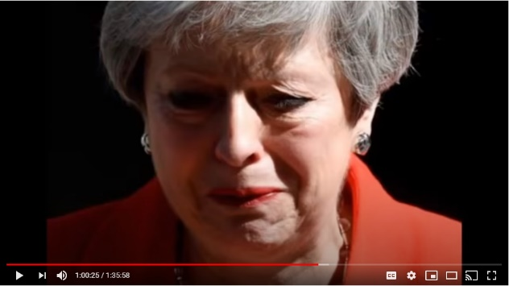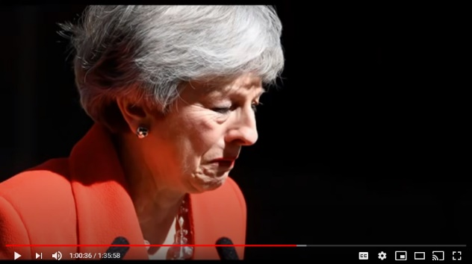
Remember Theresa May, Mark, she was crying and crying and crying and she couldn't control herself?

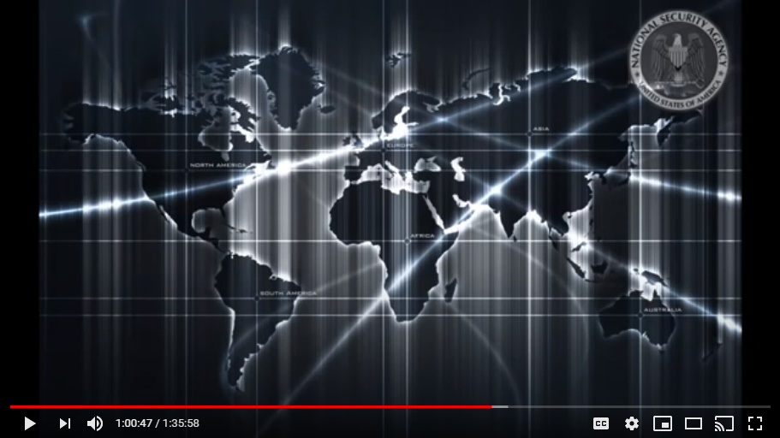
Do you remember? Well, the real reason that she was actually crying is not just all the stuff they had on her and that he showed, but that Trump actually showed the intel from the NSA that the Phoenicians were planning on taking her out. She was actually set for an assassination.

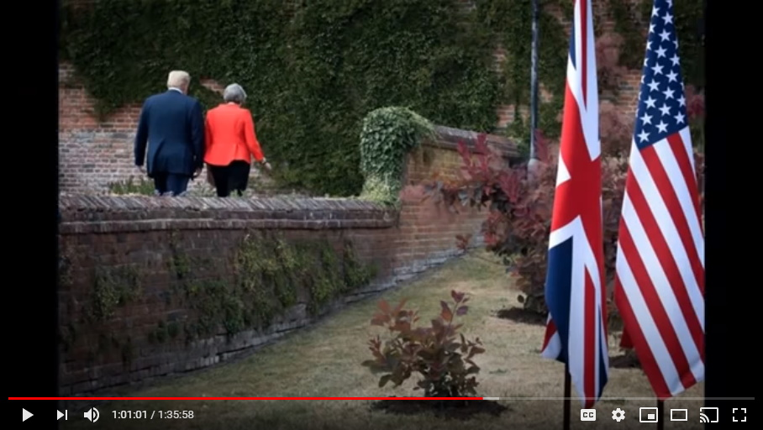
He, Trump, apparently showed her all the intel, all the detailing on where and when she was gonna be hit and how and I guess it just...
Colleen: So, he basically saved her life.
He did save her life.
Mark: What would have been the objective of taking her out then?

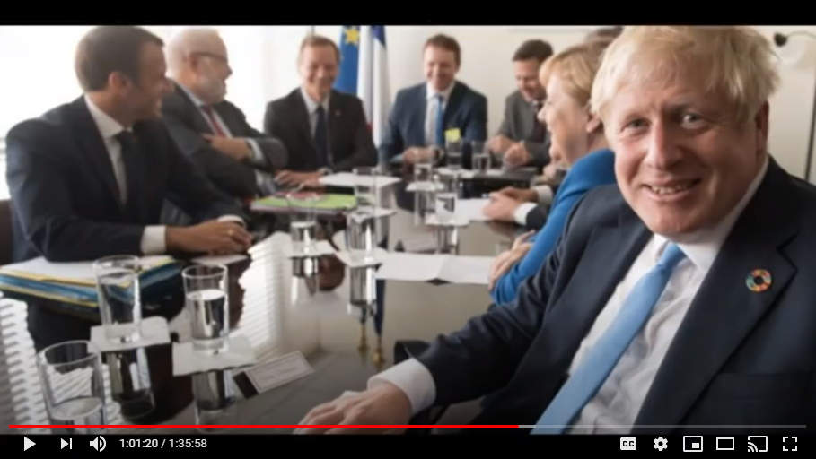
To get Boris Johnson in. Somebody who was going to be strong...and you think about that, Boris Johnson...
Colleen: They have a plan to put somebody else in?
Yeah, that's right, they must have had somebody else that they wanted in.
So, Boris Johnson is a strong character. Now he does appear to be strongly evil, but again if he's playing this role, then he is a very strong, strong character.

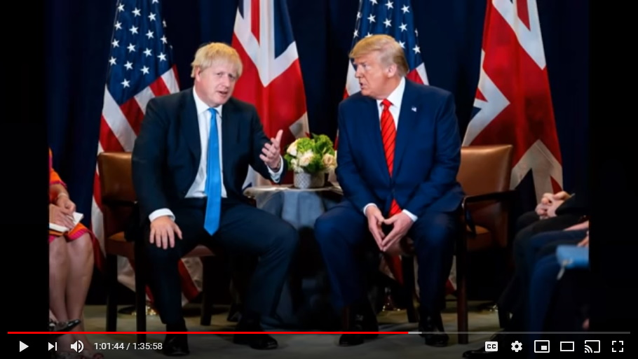
Mark: He must be a dancer because he's got me fooled.
Colleen: I think we should have your awards after all this.
Mark: It took me a while to come around to the idea of Trump, but yeah, I can see that, but I don't see it with Boris.

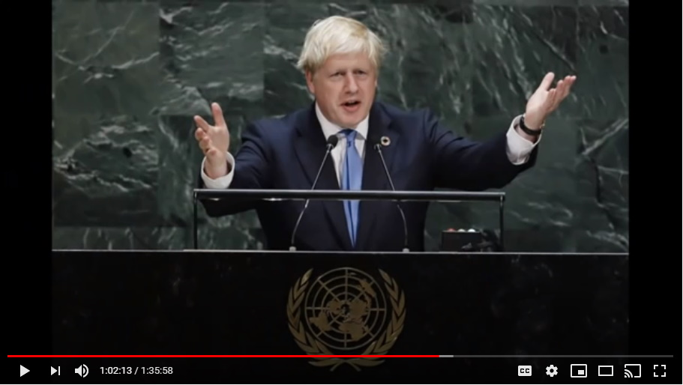
Yeah, and I would agree too. It was...he sure had me fooled as well. I really thought that he was just another one of these, but I guess that the real trigger was that speech at the U.N.
Half the speech was sort of good old Boris, you know, vaccinations, but the first half of the speech at the U.N. that he did, now that was beginning of April, end of March. That speech that he did at the U.N. in New York when there was almost no one in attendance because they had all fled, because they're all child traffickers, they had all fled into hiding.
But, that first half of that speech is Boris Johnson kind of telling you that there's a control mechanism in place and an evil cabal is ruling things...but, you know what, get your shots. He finished his speech with, you know, covid is real and these vaccinations are very good for you and important.

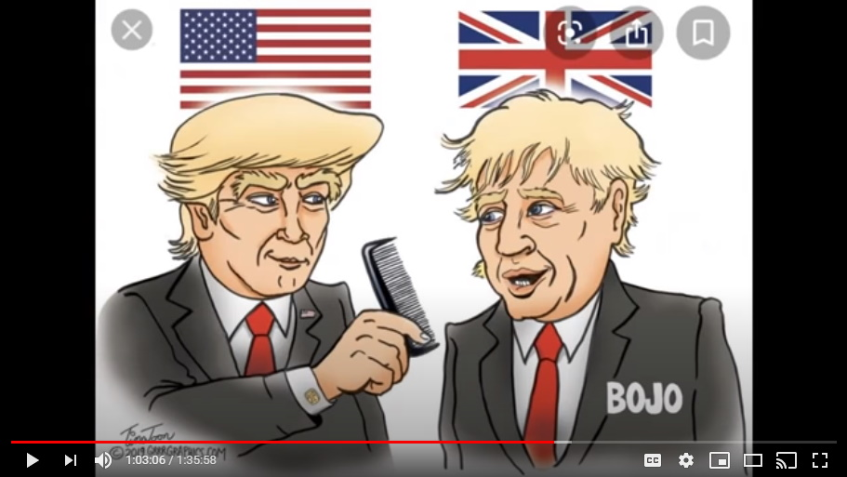
Mark: Well, that's why it's a hard time accepting that he's on the side of the people with all the stuff that he's put out there.
Yes, and I don't think anyone should after hearing this. I don't think anyone should turn and make Boris Johnson a good friend of theirs or anything like that. No, remove this fake illegal evil government from power. Don't wait for the November 2020 election to do it. You make your own change. This is your country. I think Boris Johnson should be taken down. He's just, it has been a horrific prime minister surrounded by horrific people.

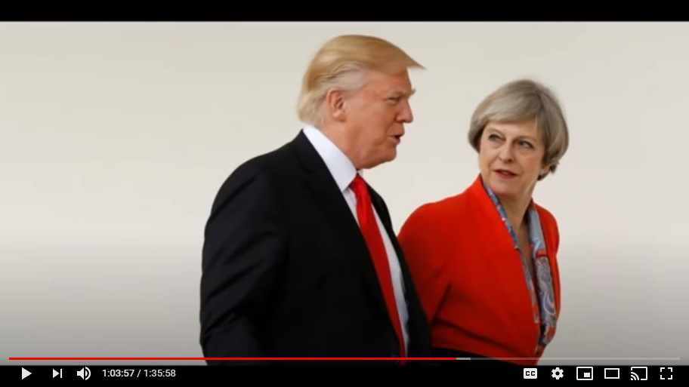
I just want to give you that stuff on Theresa May and her just crying like a baby as she stepped down and stepped away from it all. They didn't even like her in the end. They didn't like her. Nobody likes me.
Mark: We didn't like her either.

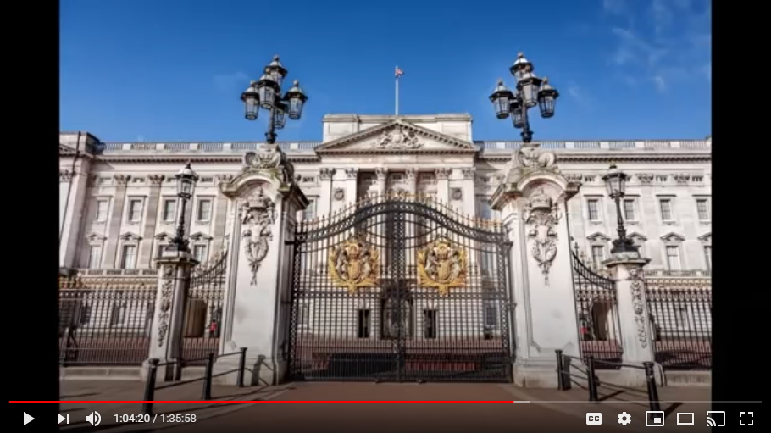
Then of course, very famously, his little trip to Buckingham Palace and the royals.

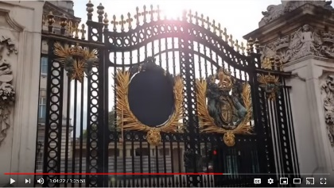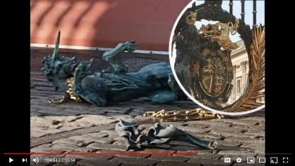
There's a lot of conjecture if that was even the real queen who was there that day, because she most famously has, I think, the most body doubles in place.

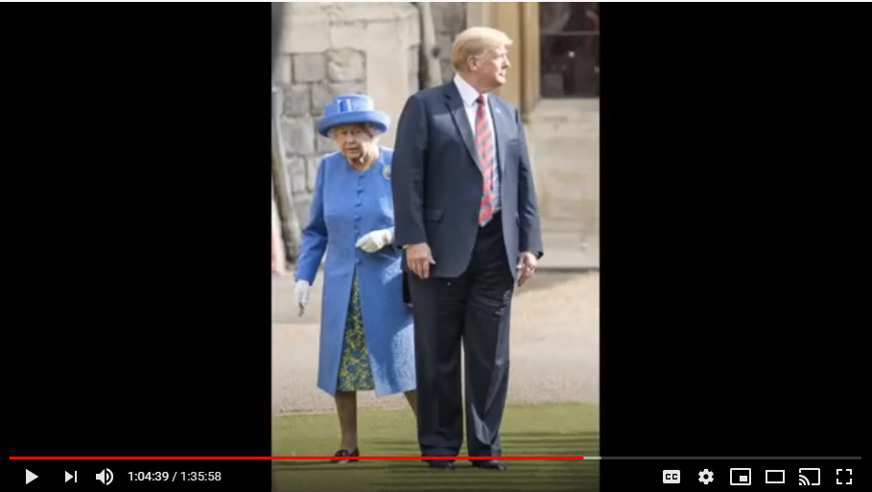
Trump's behavior that day was just incredible. He just walked all over the place. Wherever he went Camilla Parker really hated it.

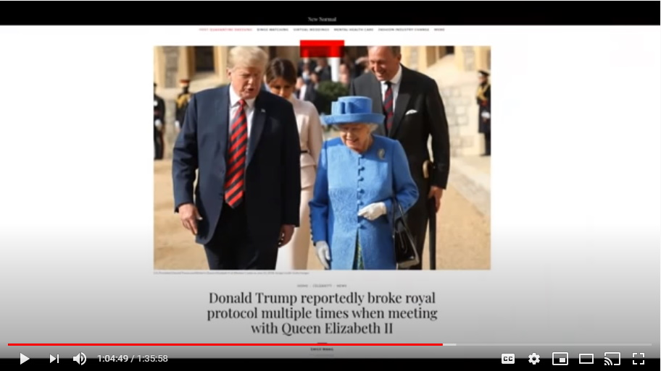
There are lots photos of her just incensed by Trump's apparent lack of protocol, right?

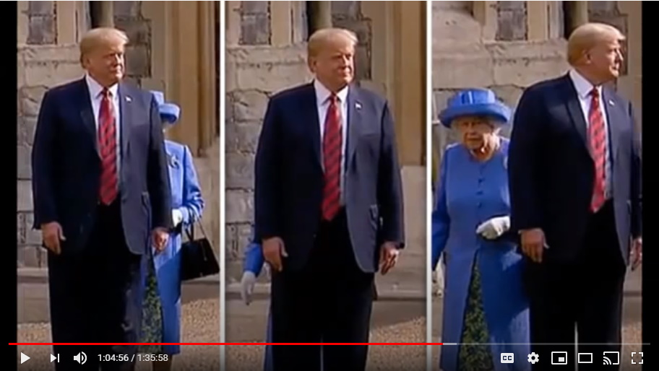
Trump was just walking all over the place and one of the great shots that exist is that Trump walked right up to Prince Charles, which I think is a good indicator that that wasn't Charles who was there because that's what Trump is pointing out.

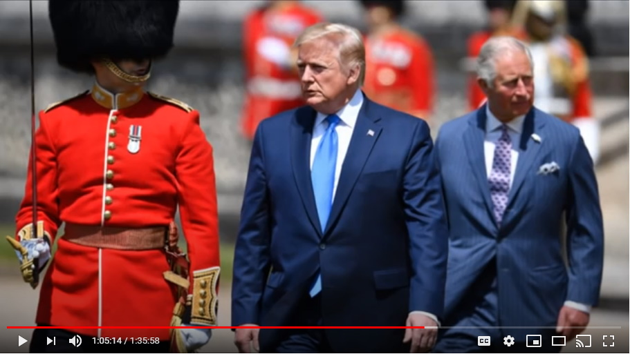
Trump stepped ahead of Prince Charles and started to walk away at a pace that Charles couldn't keep up.

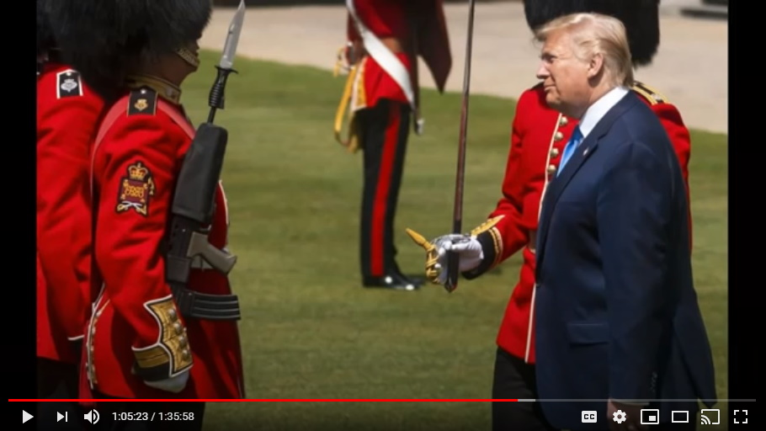
He walked right over to Charles's private guard and just began shooting the breeze with them and having a good conversation.

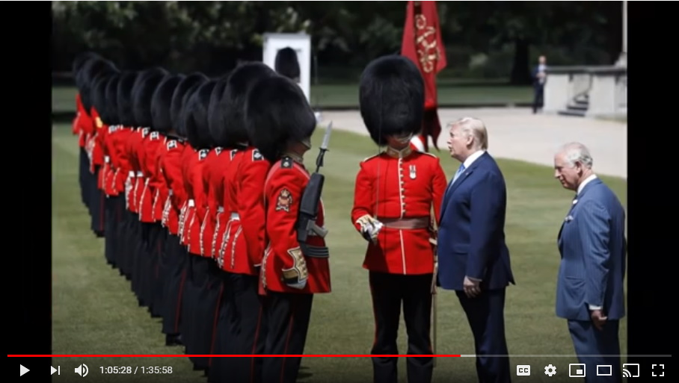
You can imagine the kind of questions, or the kind of statements he was making to these guys that had to observe what the royals were up to.

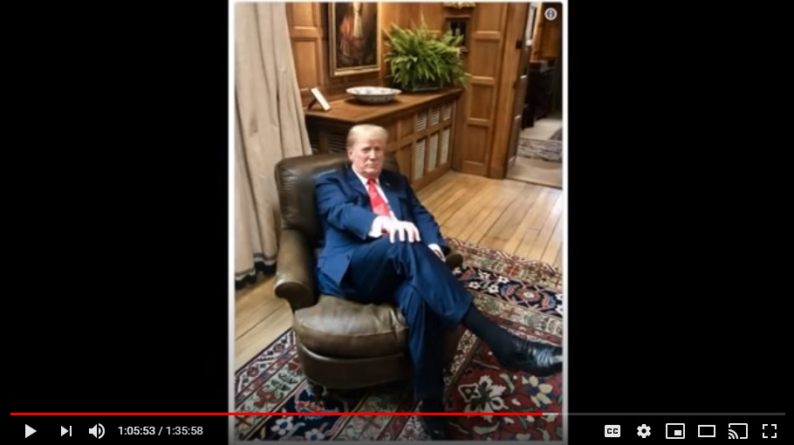
The coup de gras shot was that Trump managed to get himself a photo op in Winston Churchill's very famous leather bound chair.
Trump has the shot where he kind of famously replicates a famous image of Winston Churchill just sort of exerting...
Colleen: Looking like a boss.

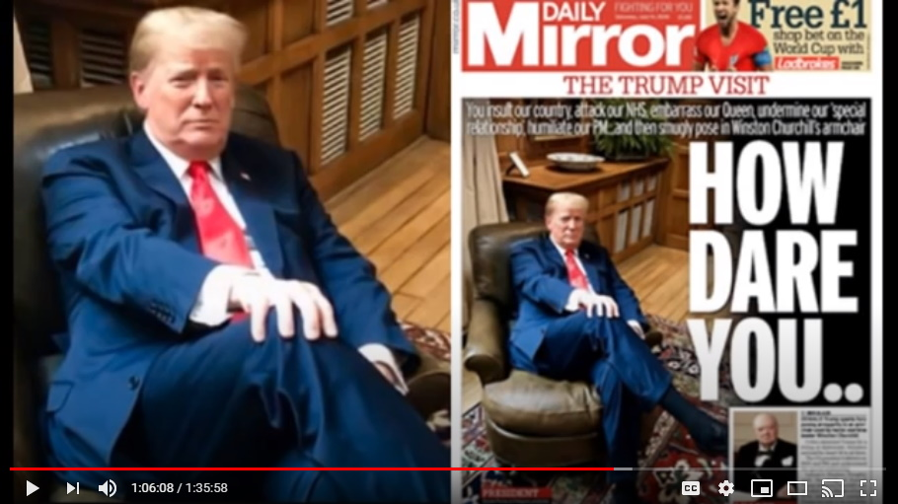
Yep, looking like the boss. Exactly, looking like he did on The Apprentice as the boss and firing people left, right, and center. You're fired! I think that's the significance of that shot.

Step Number Eighteen – Russia
Then from there he went to Russia and boy was this one ever a big one, hey!
If everyone remembers that...uh actually, no, he met Putin in Norway. That's right, they actually did it in Norway.

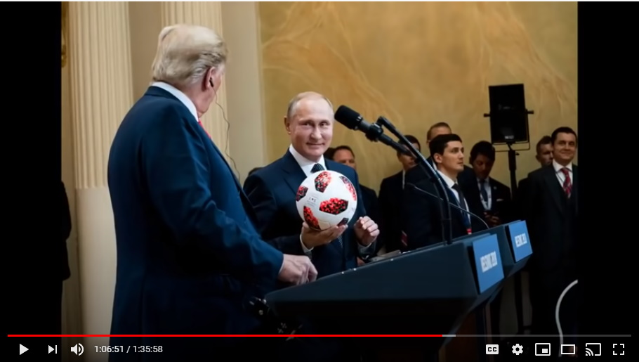
So, at this meeting between the two of them, they're both at the podium and Putin has a soccer ball...

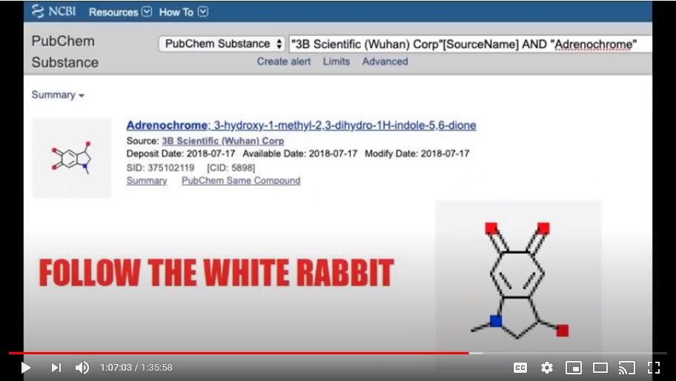
Colleen: Which has connotations so that isn't so funny. I mean that this is what we talked about earlier with the adrenochrome.

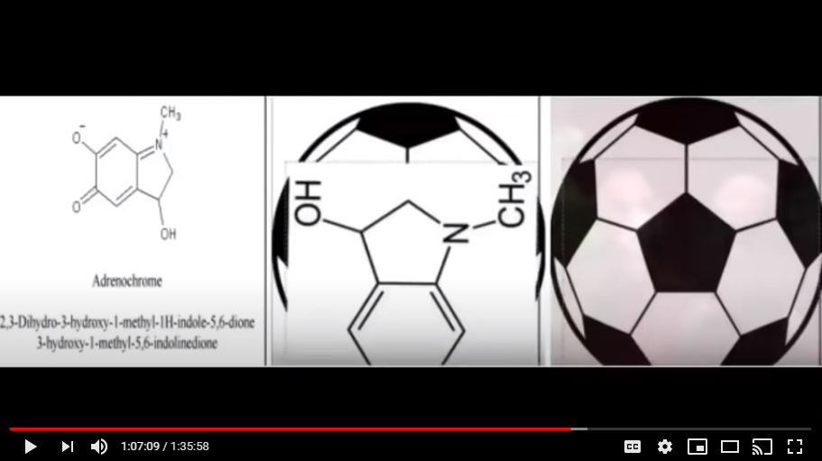
Exactly. It's horrific I know, but I mean it's just you couldn't put it more in plain sight.

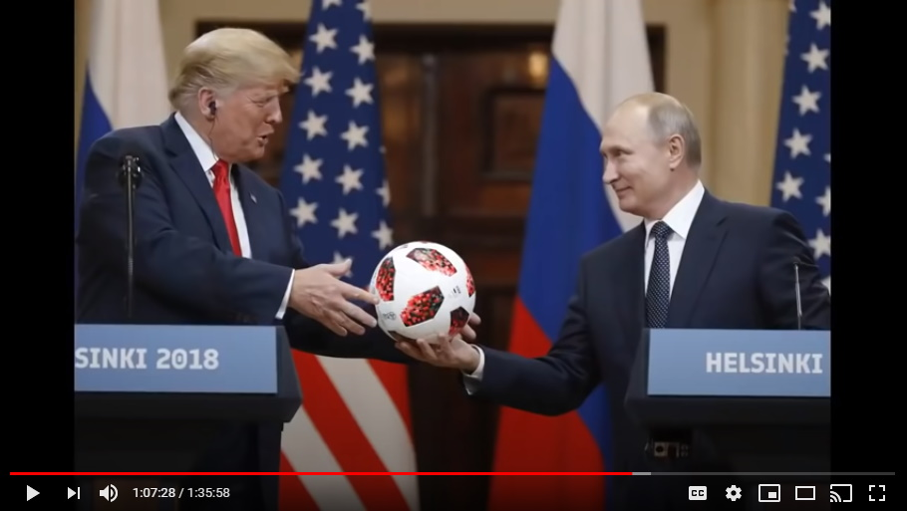
So, at this very public...this is in front of all the press snapping their pictures, taking their video...there is Vladimir Putin and he hands over to Donald Trump a soccer ball and he famously says, "the ball is in your court now Mr. President."

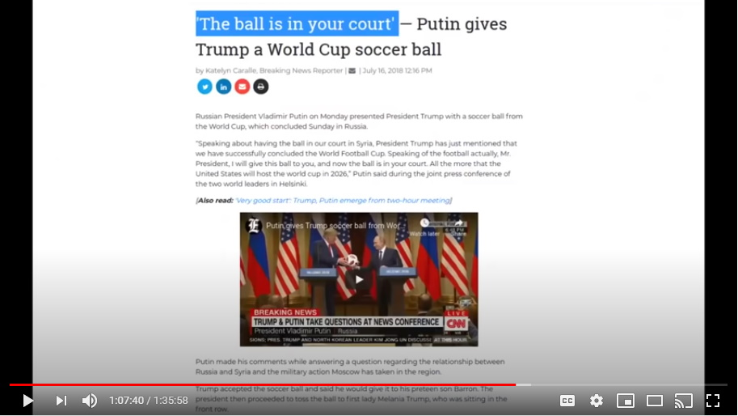
So, does everyone get that? Putin hands Trump, at this public conference, a soccer ball and says the ball is now in your court. So what Putin is saying, we're on your team the ball is in your court.

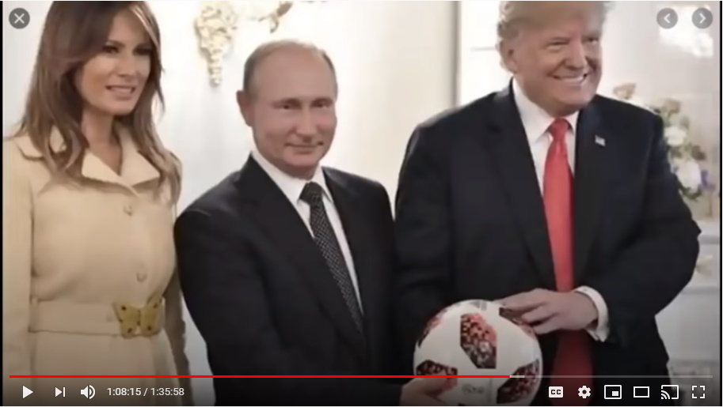
Colleen: I'm sure that'll all come out whether all of these people and who in all of the political realm who has been working because they had to and who's been working because they wanted to.
That's right.
Mark: So not a bad first three and a half years of work really. It's a pretty good track record.
Just incredible, and the soccer ball from Putin...I think for all of you who have been rolling your eyes at this adrenochrome stuff, shame on you.

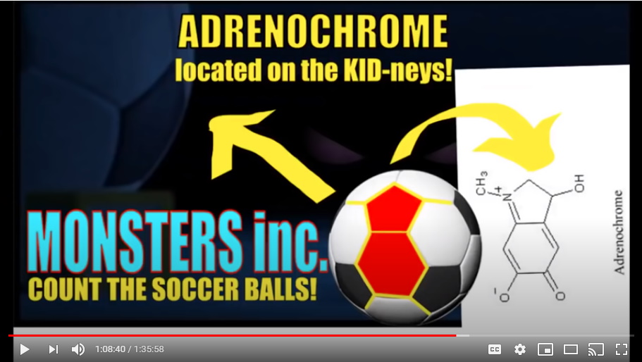
Colleen: I could understand why you'd want to not believe it.
I guess. It's just that it is the children, you need to take this seriously.

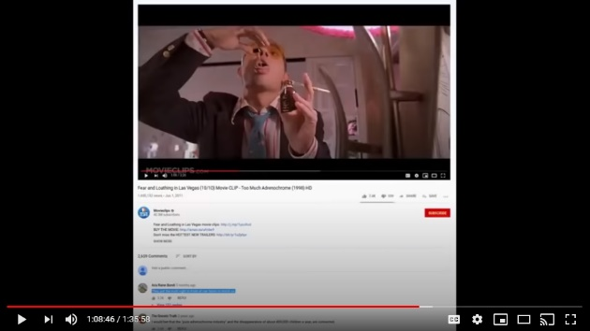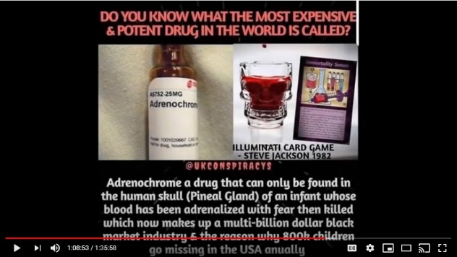
If you do a modicum of research like Mark said, even away from all of the Trump stuff, the adrenochrome stuff just sticks out like a sore thumb. I mean that's just the source of Hollywood movie after Hollywood movie.

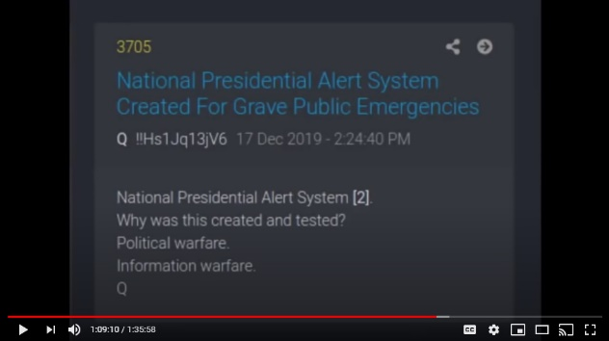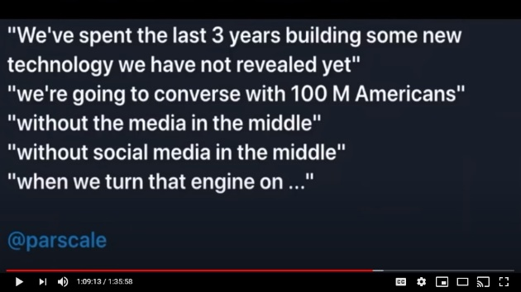
Mark: What is going to be the mechanism for eventually communicating all of this to the general public, to the masses, it's presumably going to involve some kind of emergency takeover of the broadcast networks in all these countries. That's the only way it's going to get out to everyone.

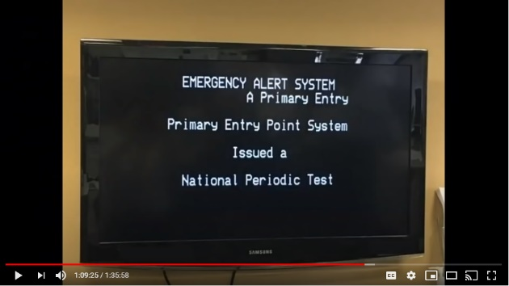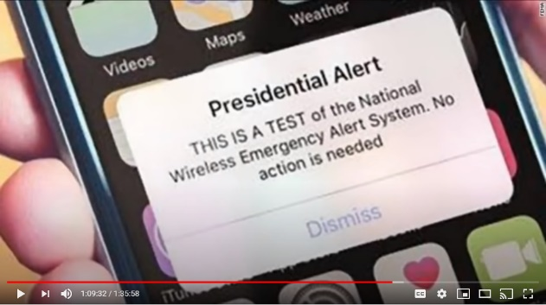
That's exactly right, Mark, and what's going to happen is that the only thing that will be available via multiple sources of signals, but it'll be the one channel.

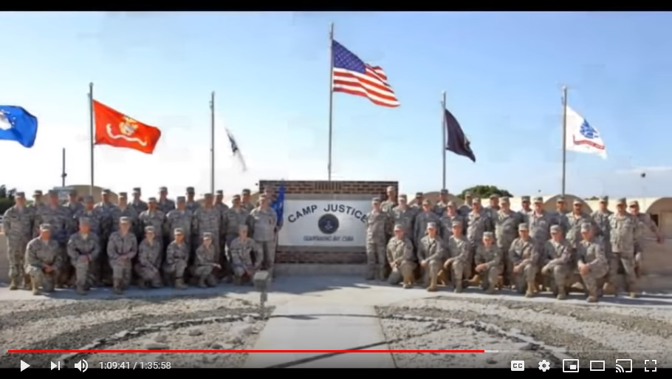
It'll be the one thing and will be from GITMO, Guantanamo Bay, and that's going to be the military tribunals where all these people are left are going to be accused. And that's the big thing I think, how this all plays out because the evidence is...there's no real defense. They've all tried to make their defenses now by capitulating.
So, like again, Kevin Spacey, Jeffrey Epstein, the Bush family...

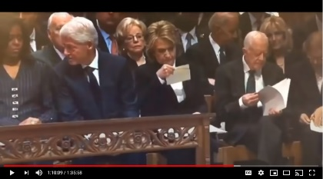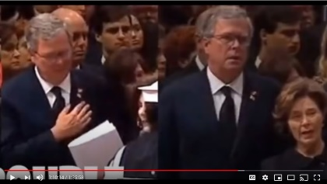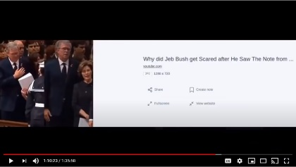
You know when everyone was at the funeral service for "Poppy," good ole 'Timberwolf'...when they were all served those letters they all just panicked. In fact, they requested meetings with Trump after that.

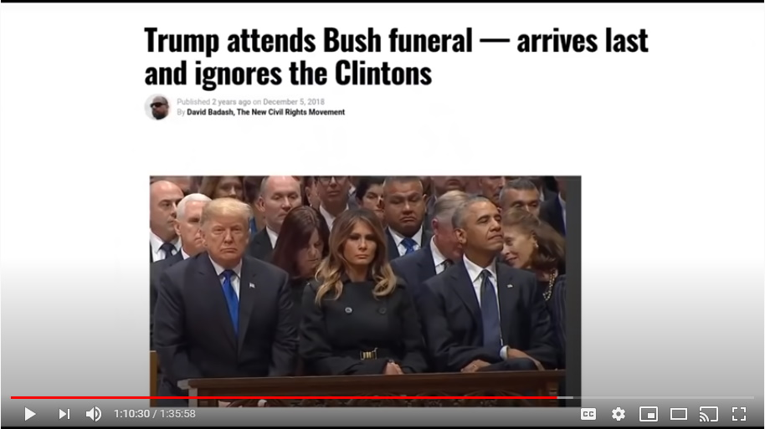
Everyone remembers that right? When did Trump arrive at good old 'Timberwolf's' funeral? Did he arrive early or did he arrive late? He arrived late did Trump and he interrupted the service, and he was in the front row.

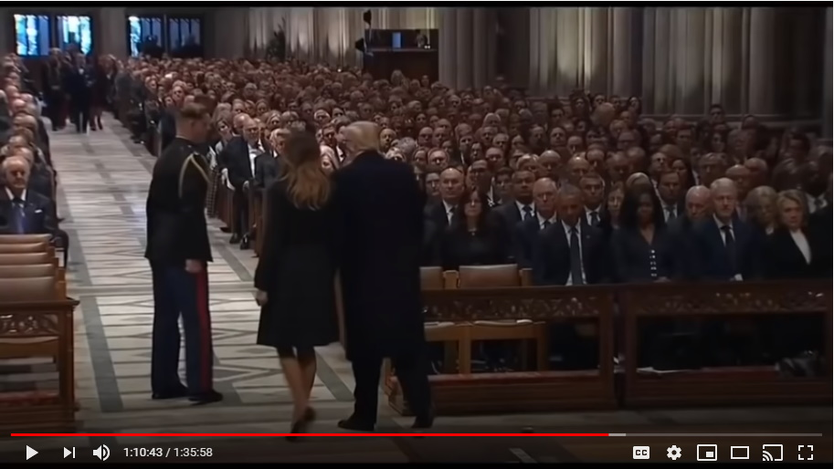
And he interrupted all of these past sitting presidents. He interrupted the entire service. He made a mockery of this service to the monster known as George Herbert Walker Bush, Timberwolf, Poppy...

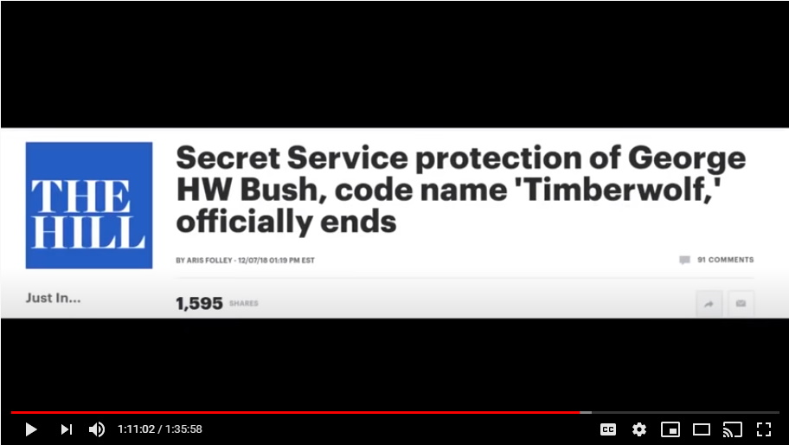
Mark: And they all had the ashen face after they got their envelopes didn't they?

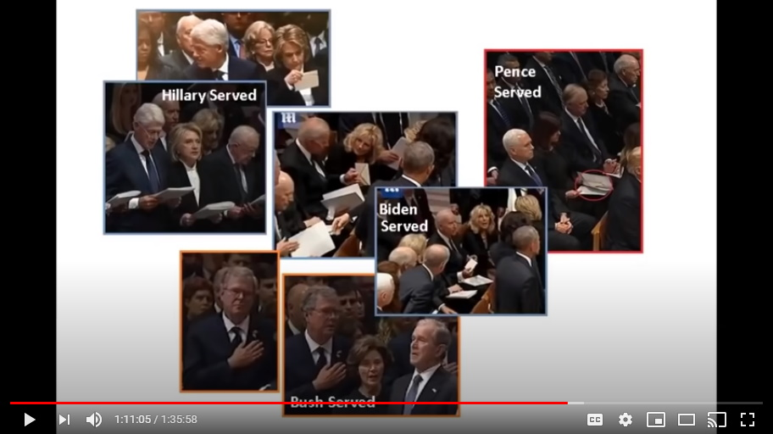
That's right and let me throw you the punch line...they made overtures to Trump.

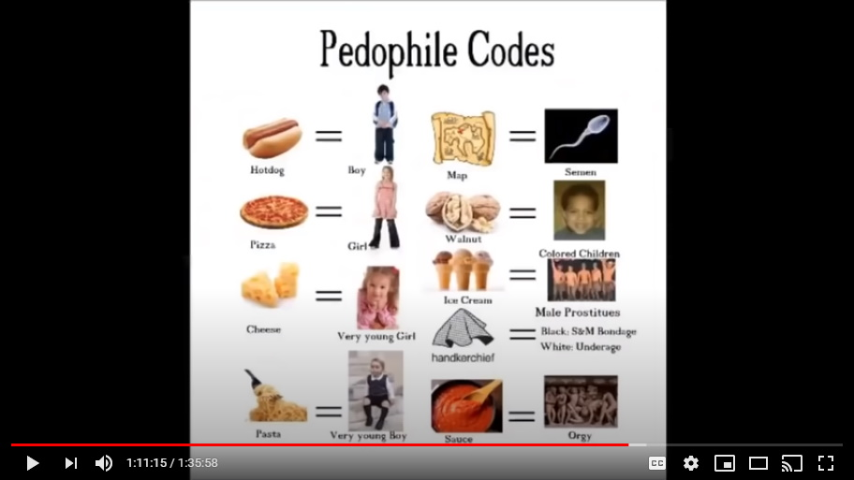
Just to let you know, and then Trump had them, and he's had various famous people deliver pizzas to various groups in public.

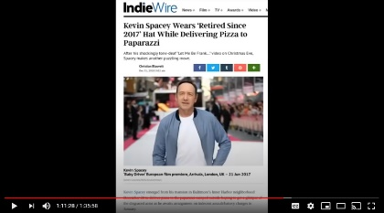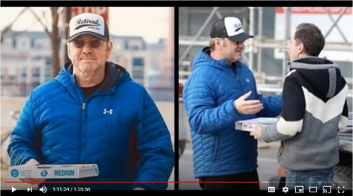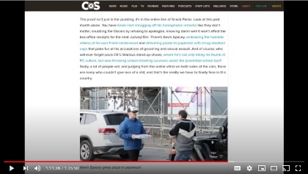
Do you folks see any significance in doing this? Why would Trump have Kevin Spacey deliver pizzas in public?

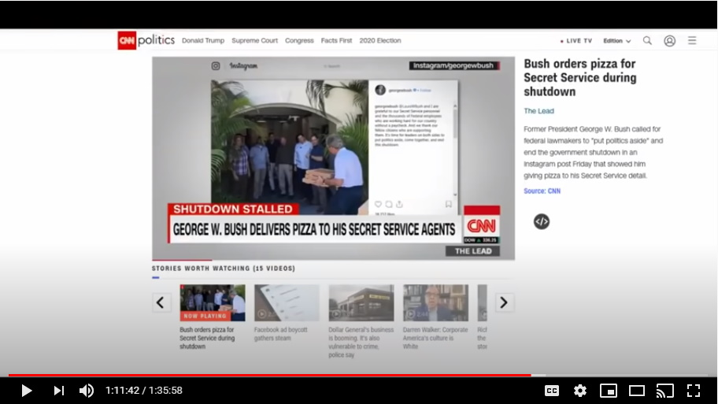
Why would Donald Trump have George W Bush serve pizza to his secret service detail and make sure this was a photo opportunity and have photos taken of it?
Colleen: It's submission.

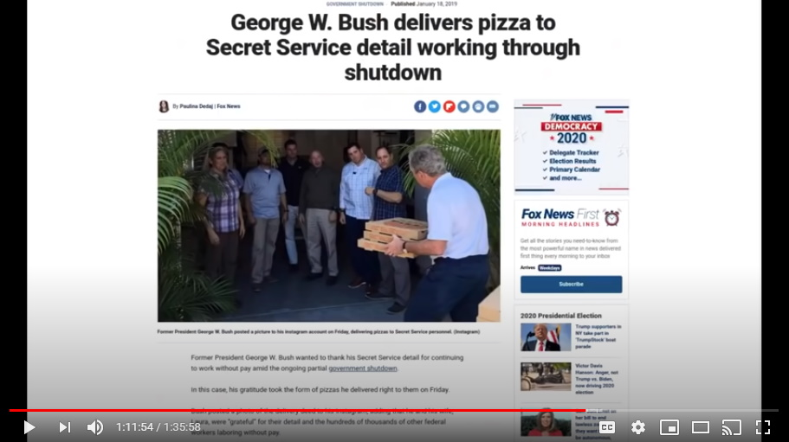
It's submission, but it's also...
Mark: Symbolism will be their downfall.
Yeah symbolism will be their downfall...the pizza and also what the secret service guys had to witness as security for these evil fucks.
So, it's these poor people that you see...remember how I said to you folks at the beginning of the how there are millions of victims of World War III, it's just different.

These secret service agents, all of those guards...Trump famously outpaces Prince Charles, goes over to Prince Charles detail.

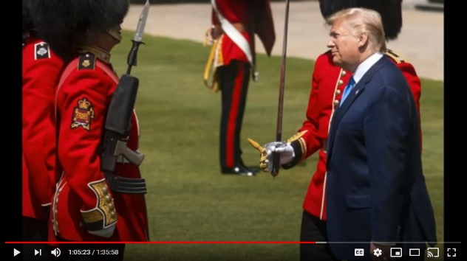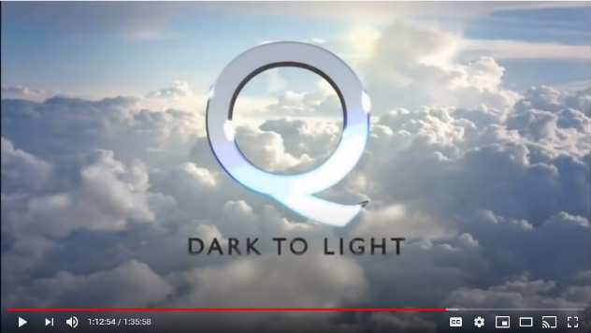
What do you think he was saying to them? I love you guys. I love what you stand for. I can't imagine what you guys have had to witness and what...just know that help is coming. I bet that's exactly what Trump was saying to Charles' royal guard.

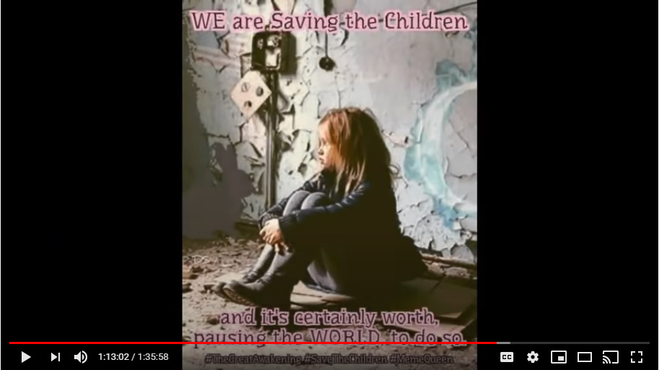
There are a ton of victims. There are millions and millions. Of course, the number one victims are the kids and when the numbers come forward you're gonna be sick to your stomach.
So, this World War III is the worst war ever. It just doesn't seem that way, but it is folks.

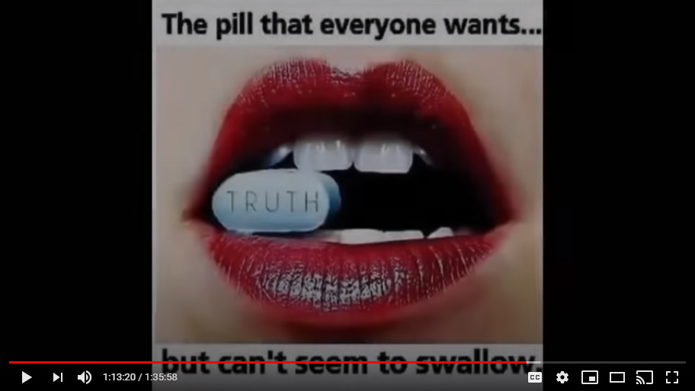
Nancy Pelosi...he took Nancy Pelosi down very famously.

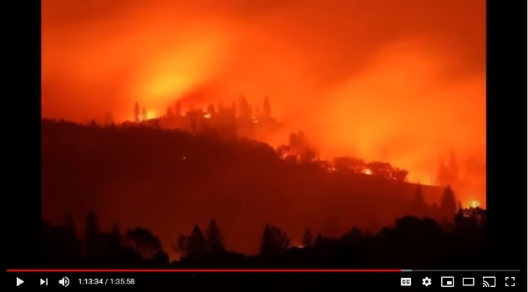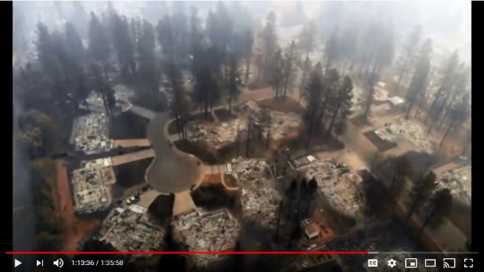
Governor Newsom of California, former Governor Jerry Brown...he took them down very, very publicly.

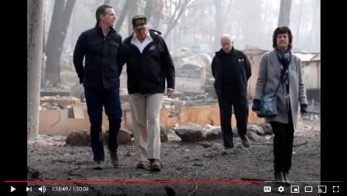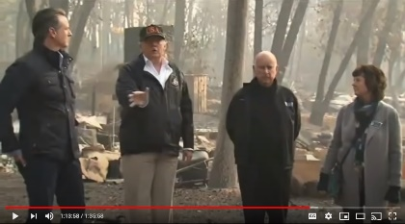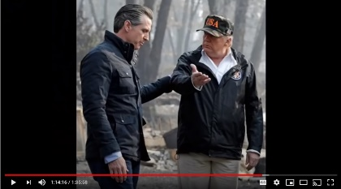
In fact it's after those Paradise fires in California, there was a video that was shot of boots on the ground checking out the source of the fires and for three straight minutes both Newsome and Jerry Brown, governor and former governor, had their hands wrapped together behind them for the whole three minutes. They were told to have their hands...look like they were handcuffed and behind their backs for the whole three minutes as they're walking in and amongst all of the wreckage...you know, the flotsam and jetsam of the insanity of those Paradise fires.

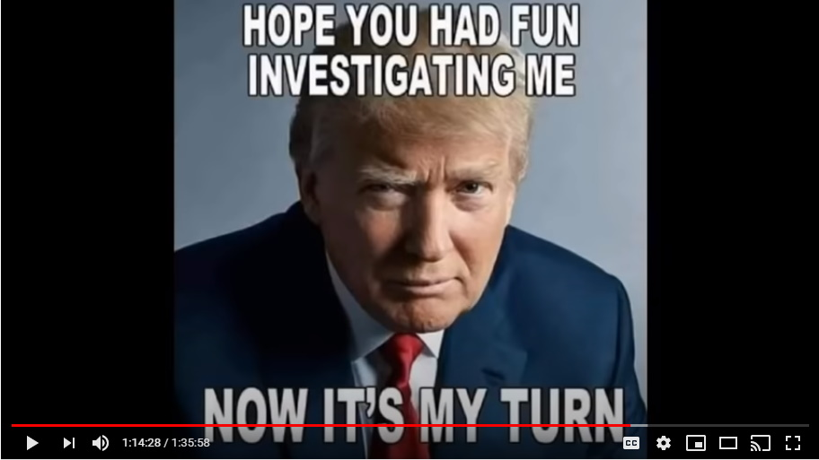
They're walking about with their hands cuffed behind them without cuffs on for three minutes.

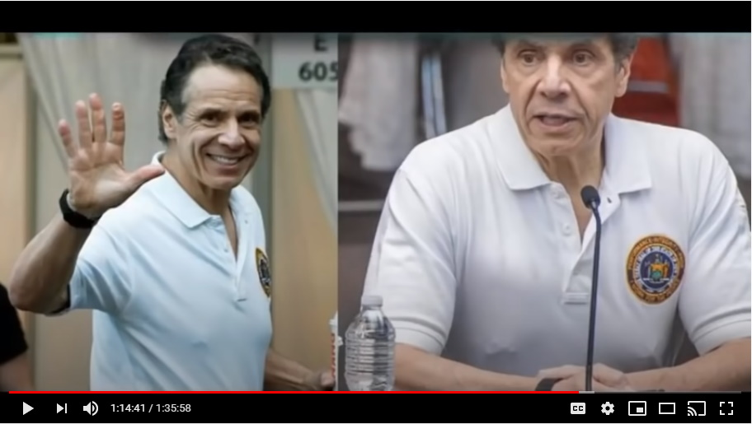
Then the picture that I posted on our page the other day, I think going back to the end of March or beginning of April, Trump forced New York Governor Cuomo to show up to his press conference with his nipple piercings in and they were showing underneath his white shirt.

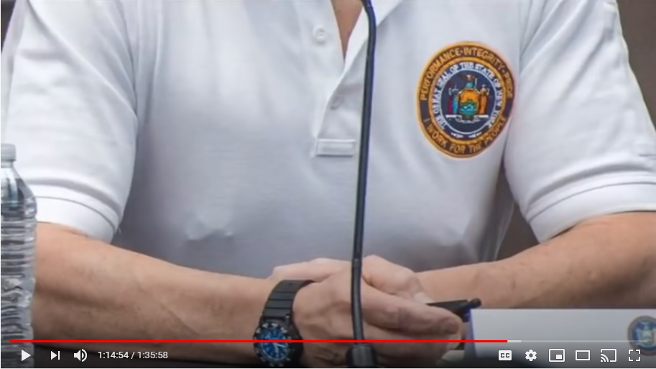
You can see them plain as day. Not a single person in the press noticed it, or if they did not a single person in the mainstream media said anything.

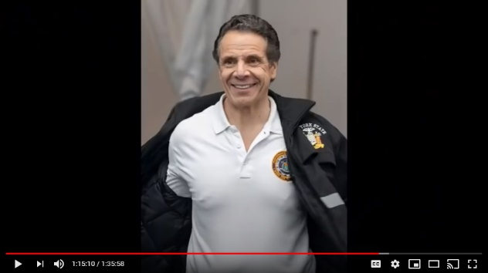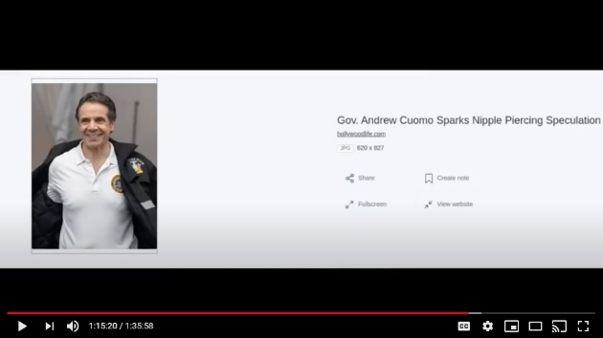
In one shot Cuomo was forced to pull back his jacket and unveil for some bizarre reason the whole front of his chest and still nobody got it, or asked him about hey governor, why are you wearing nipple piercings...and they appear to be huge nipple piercings.
Colleen: It would be the bar.

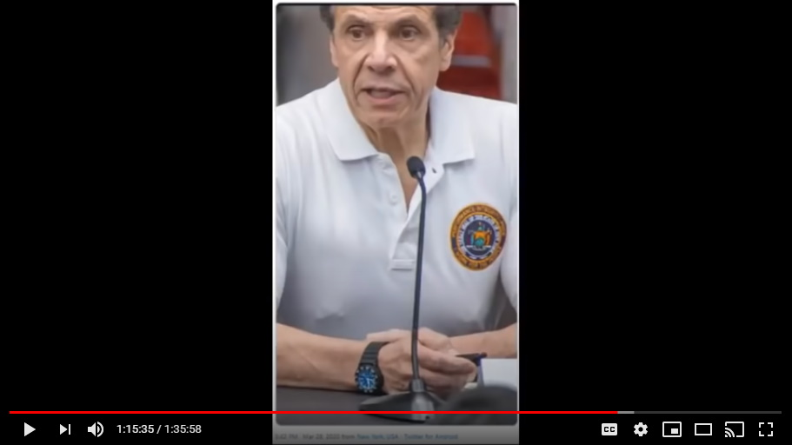
Just so you know folks, it's the bar. The back story to this is that the footage that Trump had on Cuomo at a spirit cooking event and Abramovic was there, there was a child murder, torture going on and at this party and all duded up in different paint ceremonial costume and stuff was Governor Cuomo with these big nipple rings.
You can see how Trump can be pretty tough here folks. He said, yeah what I'd like to see is you show up at the next press with...you know, you're pretty proud of those nipple rings when you're killing kids, how about you wear those nipple rings to your next presser and he did what he was told and you can see it.

Mark: I feel like I need to take a shower after this podcast. Now, if the cabal knows its days are numbered there's every chance they might try to roll out every weapon they have in their arsenal at this stage you would think? So, they pulled the George Floyd, Black Lives Matter stunt out of their toolkit. Presumably we can expect more along these lines, or would you say they've been so neutered by now, and they've been rendered so impotent because so many of the ring masters have been put out of action that they don't really have that many tricks left up their sleeve? All they've got is the mainstream media and all the propaganda and fear they can spread through that. I guess what my question is, do you expect more false flag stunts to be forthcoming between now and November?

Yes, but not to the same extent because Soros has been removed. I'm not saying that I know that Soros has been murdered or not, because the Soros trial publically would be exactly what they want. It's just like Oprah, people are calling for, you know, well if they kill Tom Hanks, please, please kill Oprah. Nah, they don't want to do these things. They want these people to have their first of two judgement days.

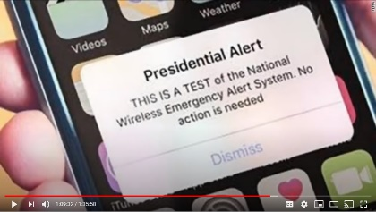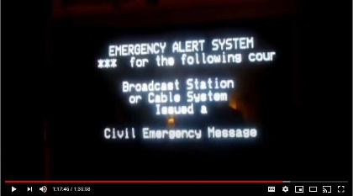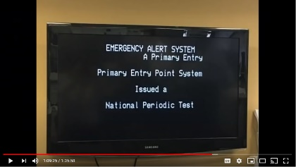
There's going to be the big judgement day, the only one that really matters, but there is also going to be a judgement day here on earth where we all get to tune in if we want.
They want this for Soros. So, it's my belief that Soros has been removed, but I think he's still alive.

They want these key people for these trials...they really do.

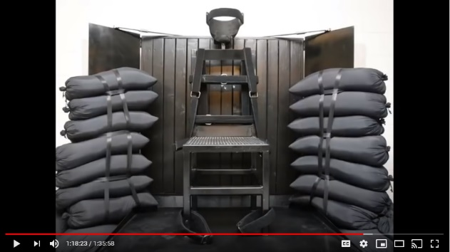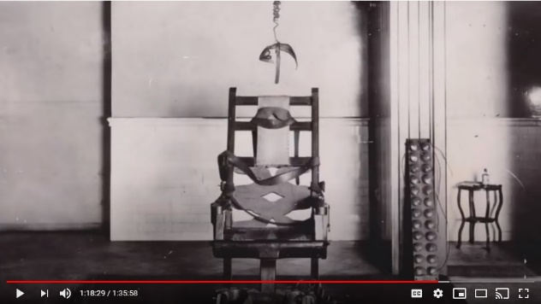
The ones that they have killed they have had to do so, and remember, I'm going to just make this very clear, it's when one child's life is at risk they've made the decision to execute. The ones that have been executed are the ones that have posed the greatest threats to children. That's why Tom Hanks has been taken out

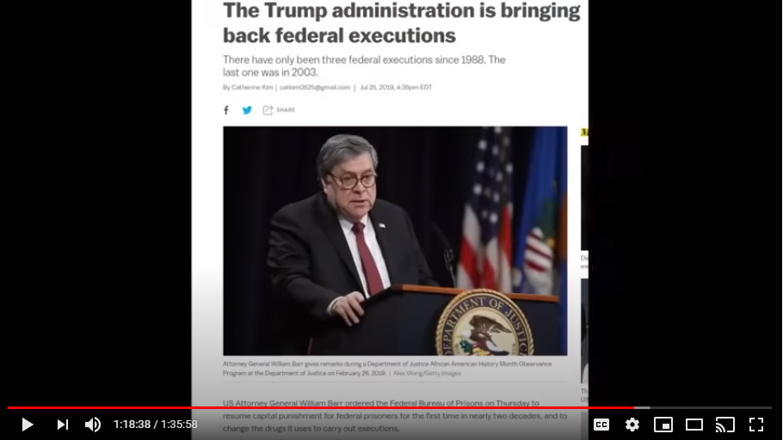
We're told, Rita Wilson as well, I have no idea whether that's true or not, but she might as well be. Do you see those pictures of Rita Wilson in her last days, or the last photos that exist of her? Yike! Yike! Missing your adrenochrome much? Yike!

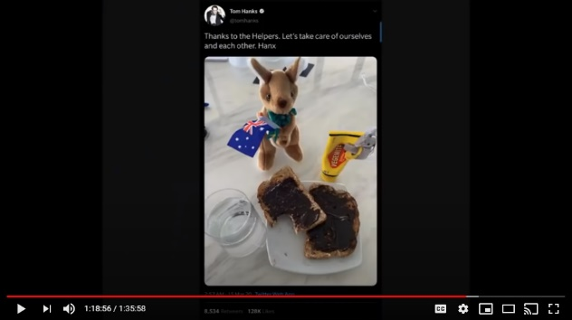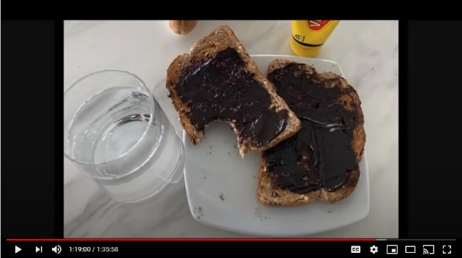
Mark: You posted a picture that Tom Hanks had taken in Australia of some vegemite spread on some toast and there appears to be an image carved into the vegemite on toast, very bizarre story but again, more symbolism.
It is and also most people didn't get the symbolism of the glass of water tilted up on the side of the plate but the water was level, so people are going...see,it's a mistake, it's an error, it's all photoshopped, this isn't real...and stuff.

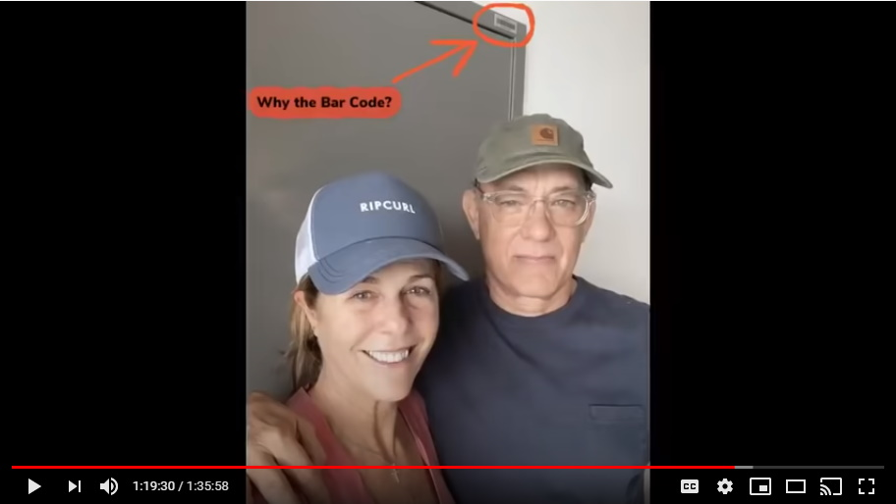
No, this is Australia and he's been taken into custody by the U.S. Marines. The Marines are the ones that have been going...shipped ashore all around the world...the marines have been doing all of the international arrests.
So, he was on, I guarantee it, he was on a U.S. naval ship that was populated by the Marines, and he knew that he was gonna be...I think for me, I take all of that, that he was gonna be executed that day, that that was his last message and stuff, other than you know of course hosting Saturday Night Live, from hell I guess, but...
Mark: It was supposed to be a hanged man, right? The image?

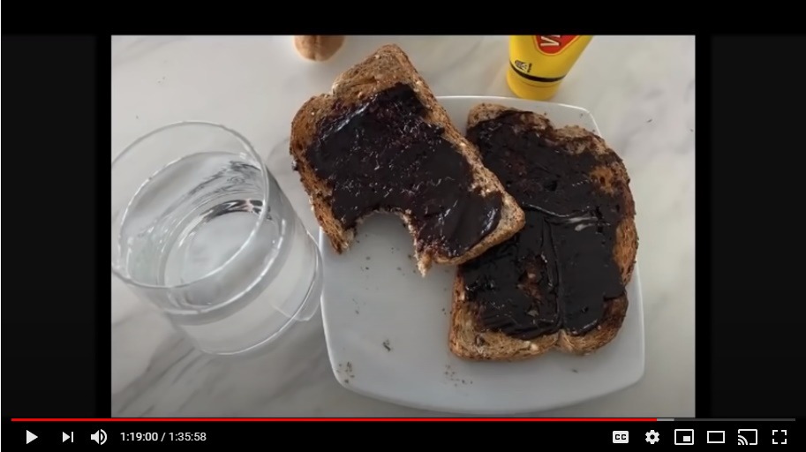
That's right. I took another image and then highlighted so that people could see it a little bit better, kind of outlined it and highlighted the hangman image.

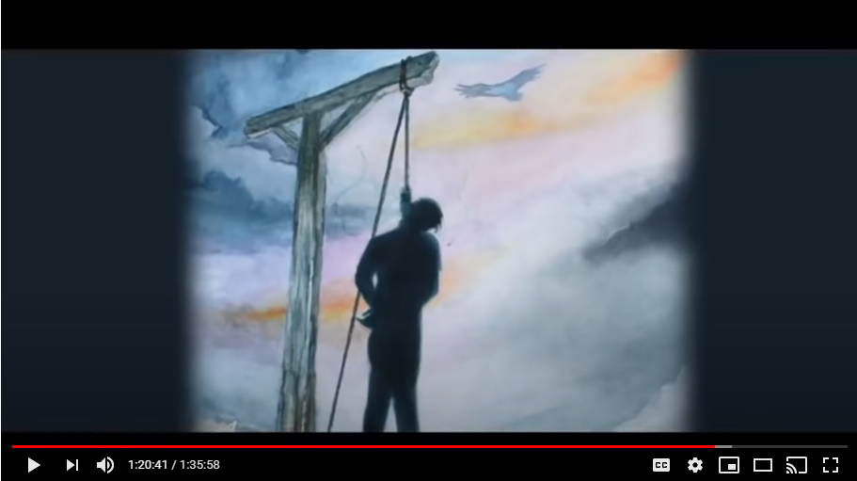
Also, by the way folks, you can see it with toast. Not many have got that itself, but again, to hang a person you have to have a column that is very sturdy, but then the person that's hanging has to be away from that post or they can wrap their legs around it to try to suspend themselves. So, they have to go out to the right, correct? That's what the hangman's pole looks like.

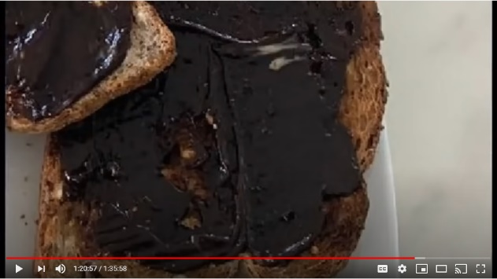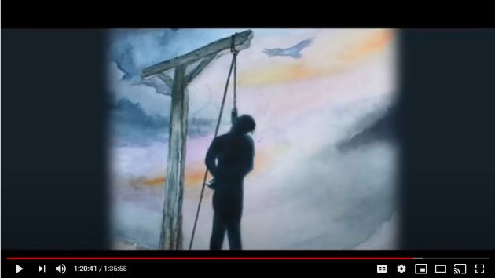
Well, if you look at his breakfast toast...go back and just check it (meaning the hangman's post)...then look at Tom Hanks' toast, and the second piece of toast is up and to the right...and that is the hangman's post with the noose and he just took a bite out of the noose.

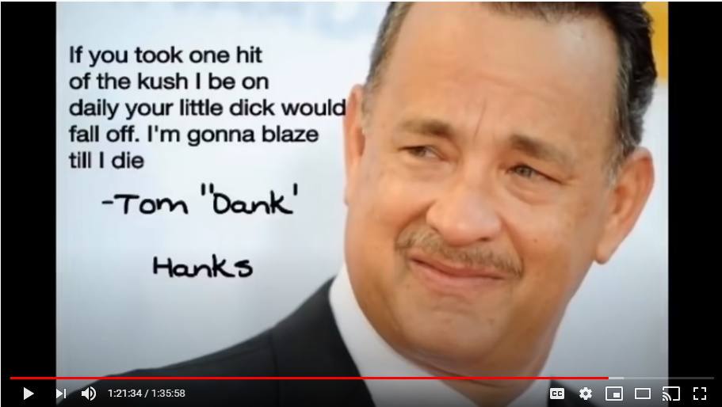
A lot of people have not got in that little post is what I put up at the top there, that little saying, that's from Tom Hanks. That's what Tom Hanks said as his sort of farewell words to this world, which is that I smoke up good shit every single day, and the stuff that I smoke is so strong that'll make your little dick fall off.
Who's he talking about? What's he talking about?

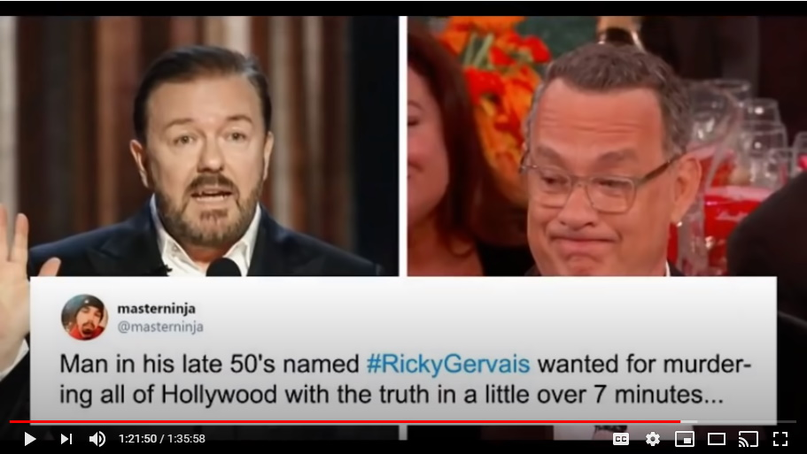
He's talking about little boys...little kids...and then he says I make no apologies. He said I'm gonna go out on fire as I lived. I live my life on fire, I lived it my way. That's Tom Hanks being a devil to the absolute end.

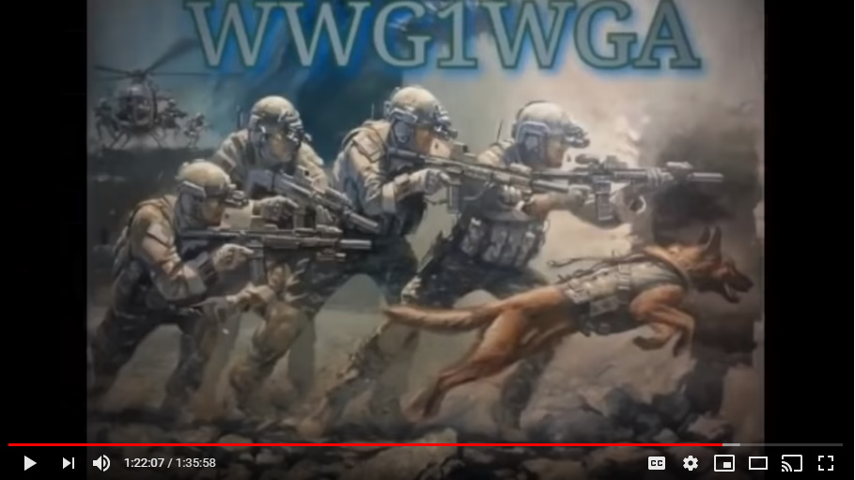
So, if you're wondering why he was taken out...because they could not guarantee the safety of children with that man alive. So how sick and evil is Tom Hanks?

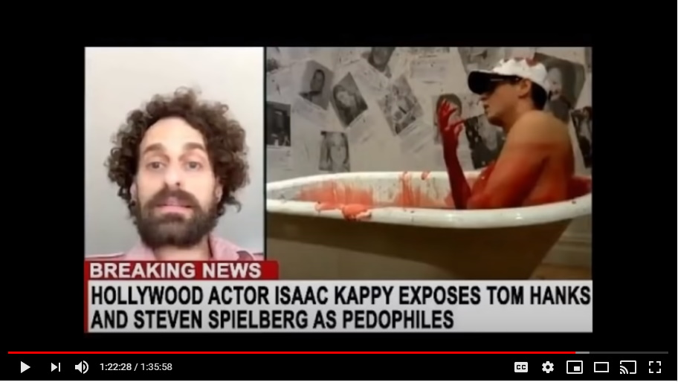
Just telling you folks that it's all going to come out. What he was really doing and what he was really behind. Tom Hanks was behind a massive, massive organization.

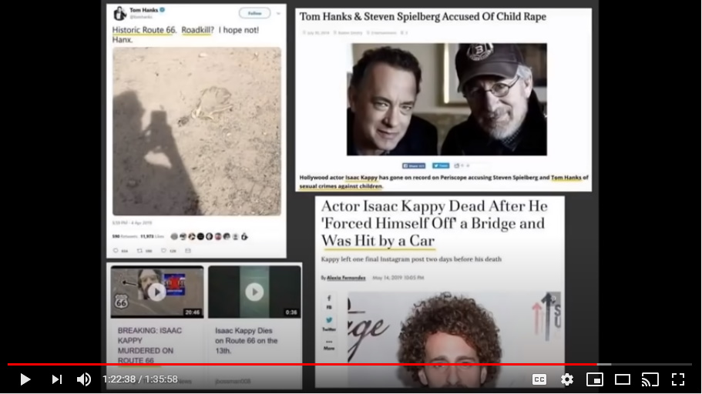
Colleen: How does that psychologically affect you? Like it affects me because I liked Tom Hanks as an actor and I used to think he was, you know, a fairly decent person, and knowing that I even liked someone like that and the thought of the things that he's done, it just makes me feel, like you said, you want to take a shower, you feel so dirty. That's how I feel.

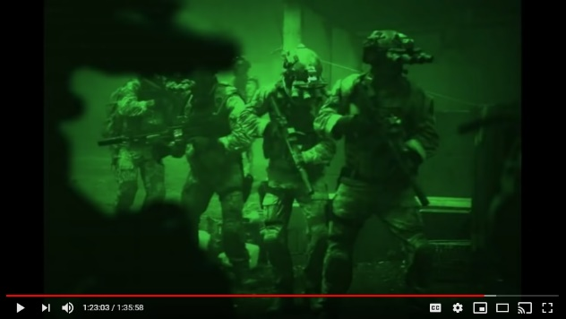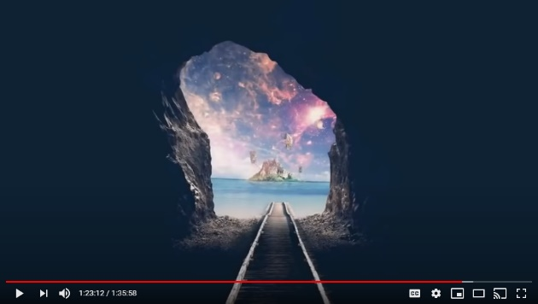
Mark: A very important question that I've got which people have asked me to put to you actually, is the takedown of the deep state criminals and all these pedophiles and stuff is something that would be welcomed by anyone in their right mind, everyone would want that, but what about what lies beyond all this and what would the world look like once this system has been dismantled under Donald Trump?

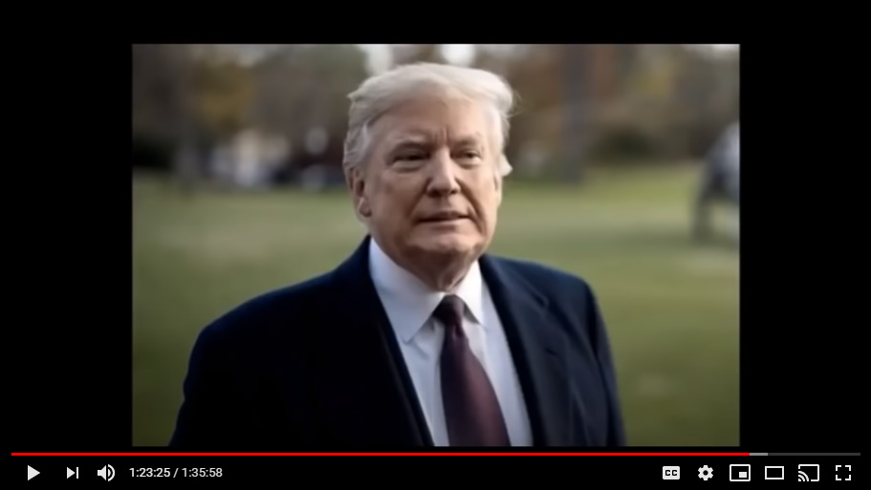
Mark: So when he enters his second term how can we be sure it wouldn't just be another expression of a kind of new world order, one world government, just under Trump in his vision? And also, what would happen at the end of Trump's second term?

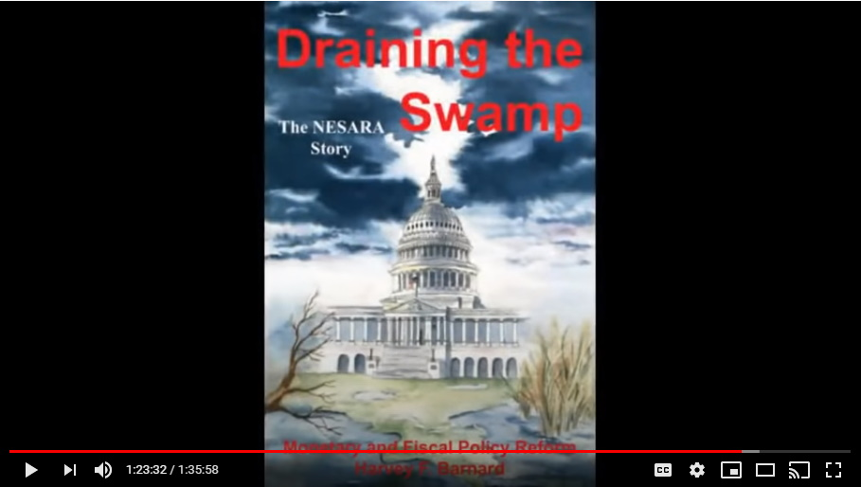
Mark: So presumably, he's gonna get reelected in November, that will take him through to 2024 then, by which point he'll be 78 years of age, imagine that, you know. What happens then? Any insights into that?

For sure, but again, people are just going to believe.... Anyone who's asking that question in relation to all that that man has done, clearly, it's mind-blowing to me, but anyways.

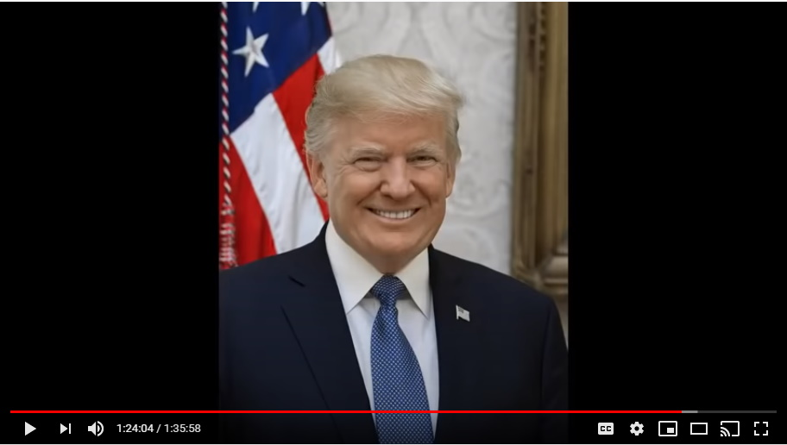
Trump is going to walk away from all of this. He's not going to continue on with this much longer. This has taken an incredible toll on him. He's done it at his age, because Trump is a very remarkable, very remarkable individual. He really is and he has a strong will of life.

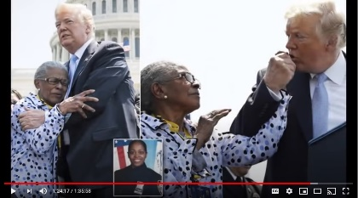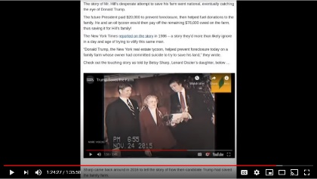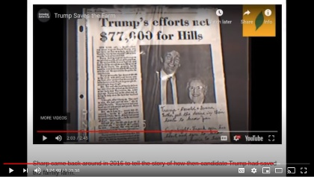
There's a lot of things about Donald Trump that people don't know and about his maturity and wisdom and about the spiritual side of Donald Trump as well. I also really want to point out to everyone through...like here's the thing...if you really understood your numerology and symbology you'd absolutely know.

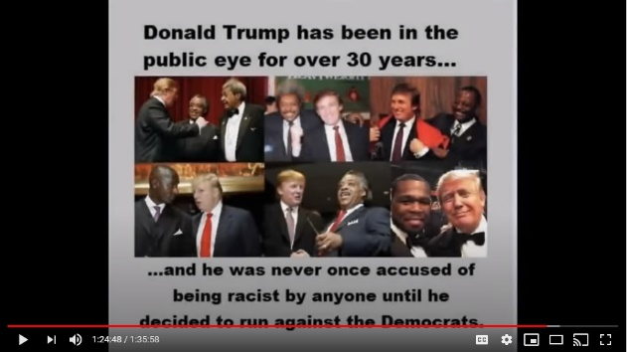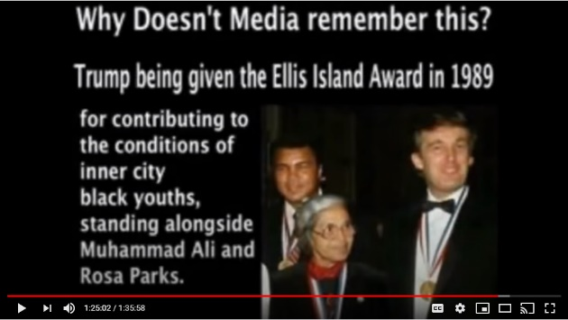
So the biggest reason how we know and are absolutely sure about so many things is because of all of the numerology [not a fan of numerology, but the enemies are] and symbology has always been used by the Q team, by John F Kennedy Jr., by Donald J. Trump.

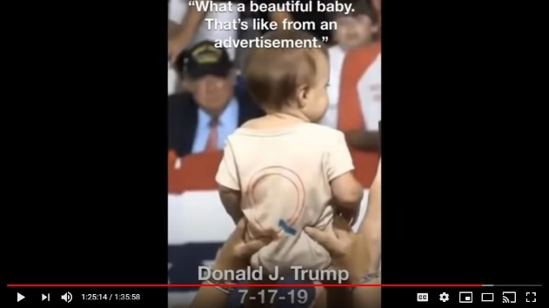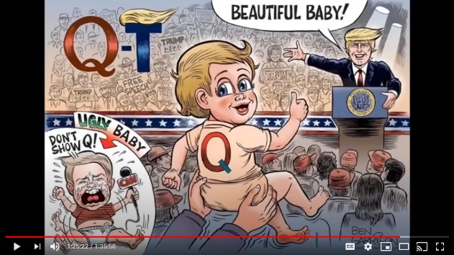
The symbology has never, there's never been a mistake, there's never been a situation where they've used the wrong symbology, it's always beautiful.

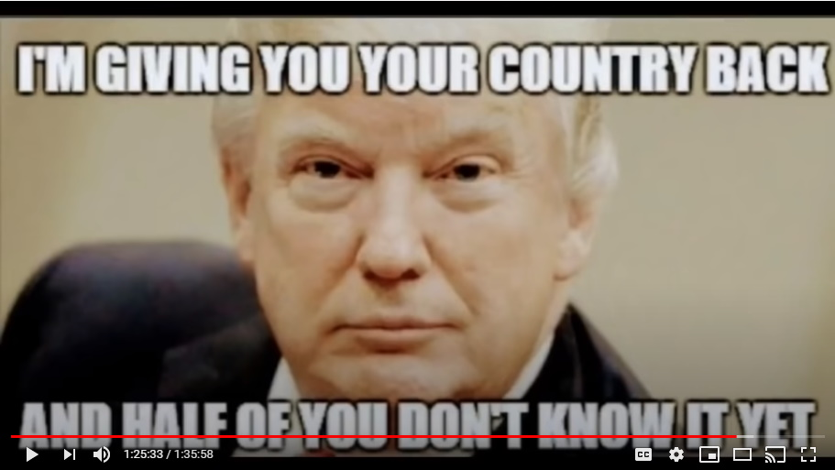
Colleen: Trump is trying to, and the Q movement are trying to really create leaders. We are all to become leaders.

Colleen: That's why they will give it back to the people, but before that we need to find out who we really are and what's really been going on. I would suggest that's what the great awakening is and that's what all this is about and that's why we're doing what we do, and that's why you do what you do, Mark.

Colleen: We're not trying to create followers. This isn't about creating money for ourselves. I mean, those are all bonuses that we can get resources out of it, but it's about creating a mindset for people to go and discover their own truths.

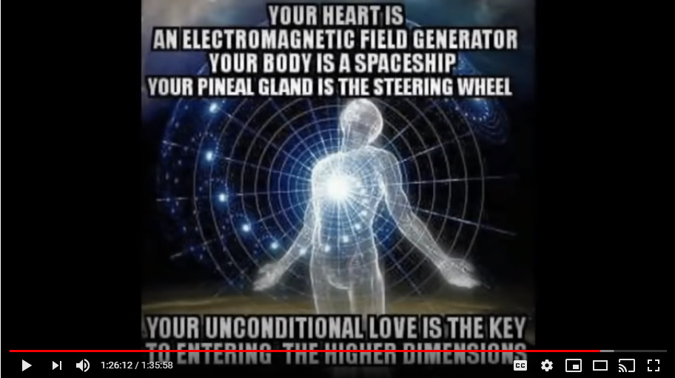
Colleen: There's a truth out there that we need to discover. It's been hidden from us and when we realize all of that we will be the people that we need to be. We can then run our own communities, or own world, we don't need those politicians, we don't need those authorities. We'll not let ourselves get into this predicament again where we give our power away.

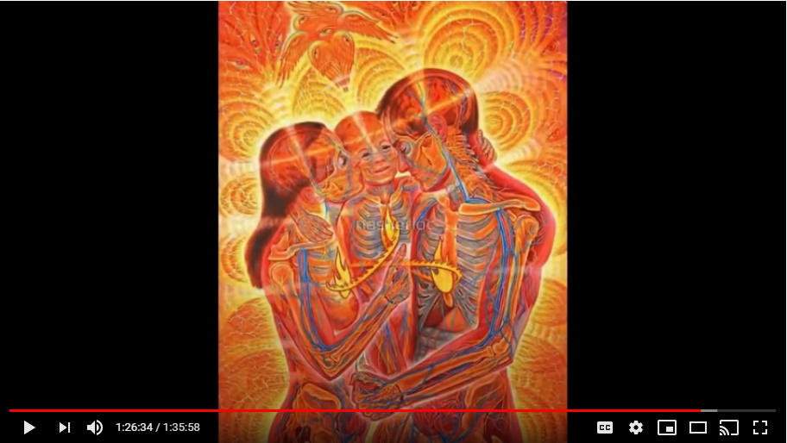
Colleen: What do we have to prove that Trump is going to do this? Well, I think we've laid out a lot of who Trump is, and what he's about. We have to have faith at some point and we have to grow up and become responsible for our own lives and for our families and our own actions.
Colleen: So when that happens we will be the regenerated person that can do all of those wonderful things and share in this incredible world that they're saying, you know, we've taken the evil now what are you gonna do?

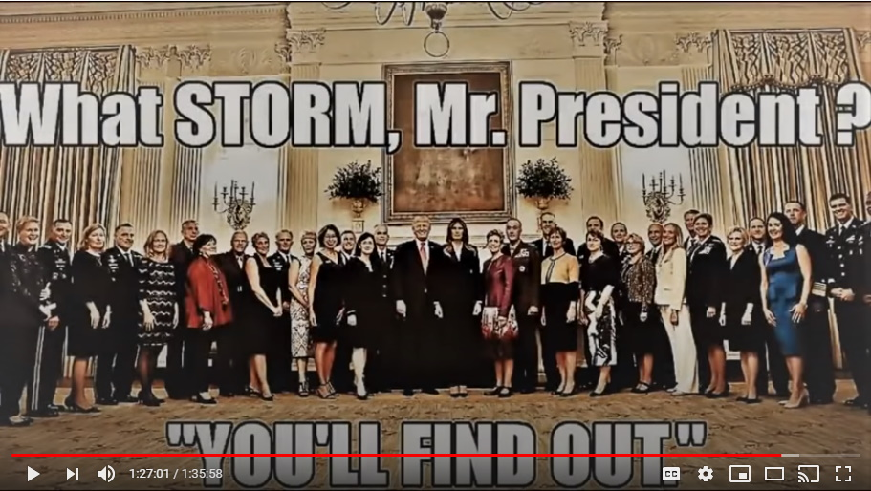
Mark: If this does turn out to be just another social engineering psyop, it will be just about the cruelest psyop ever played on the public psyche. One of false hope.
Colleen: I know it would be, but I know it's not.
That's not just a hope statement. If you know your symbology, if you know your numerology, you know all of this is real. They're just constantly coding, that's the beautiful thing, if you take all of this seriously like the Qanon's do.

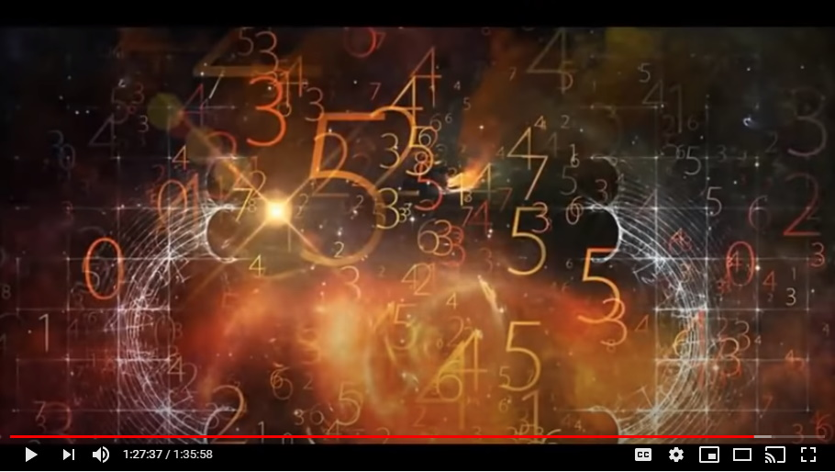
This is amazing stuff because they know their symbol...and this is all godly, ancient spiritual godly symbology and numerology. It's beautiful and that's what they use all the time. That Trump is constantly making references out of the Bible to the highest, beautifulest things.

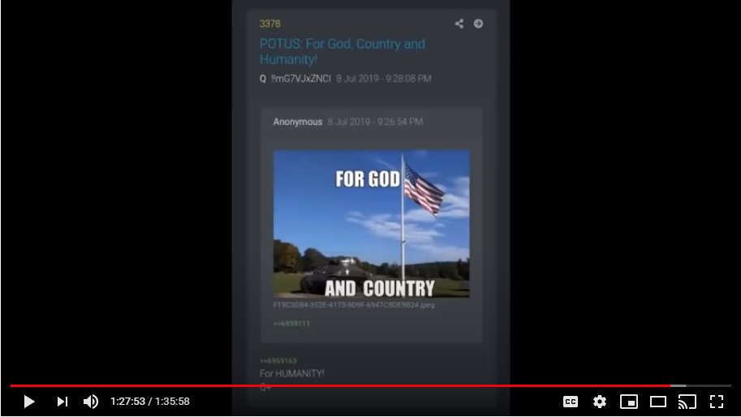
When Trump talks about religion or his spiritual nature, or when John F Kennedy Jr. does, it's always God, it's God, God, God, God, God, God. When you listen to a literalist Christian, it's Jesus is God, Jesus is my lord, Jesus Christ is my savior and don't tell me anything else or I'll...

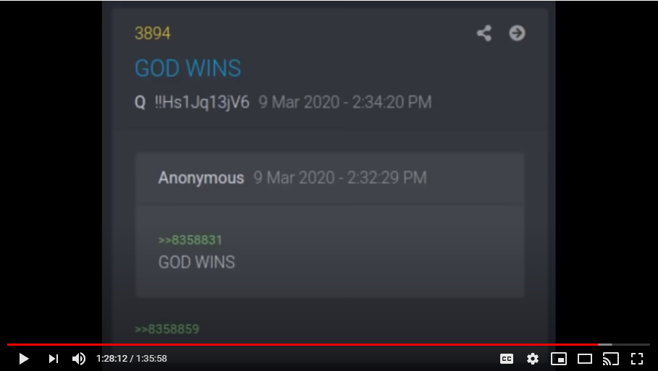
Colleen: So the ultimate power is God and why would we not go straight to God and that's part of the ruse of religion is they've taken, they've become the intermediaries between you and God.

That's right, by taking the chrism oil and personifying it into a fleshy three-dimensional, almost Swiss looking handsome gentleman that was wandering around the holy land with his friends 2000 years ago...

Mark: At the age of 33.

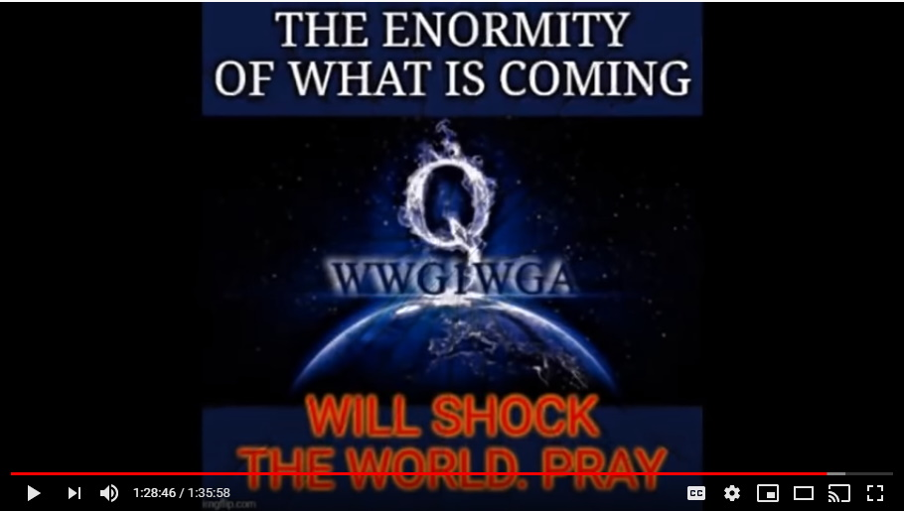
Yeah, it's a horrible subterfuge.
Colleen: So, we need to find our power.
Yeah, it's all gonna come out.

Mark: So, as we record this, we're a couple of weeks away from the 4th of July. Big things on the cusp?

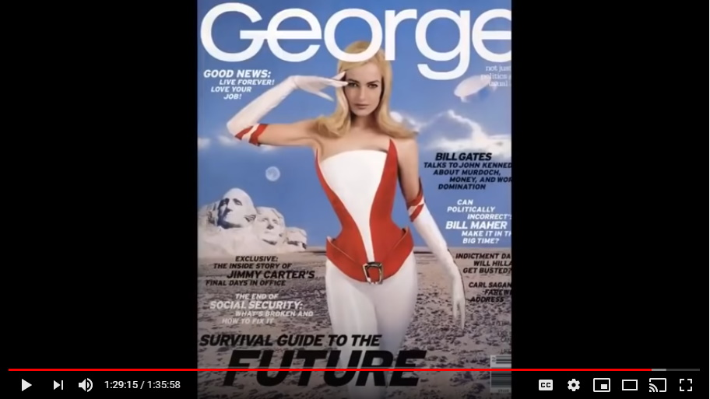
Well, that's always been the plan. They have removed, now this is the other thing that gives me hope, that they'll continue...what we're talking about of course is the resurrection of George from the pages of George Magazine who will make a timely reappearance with a full moon over Mount Rushmore.

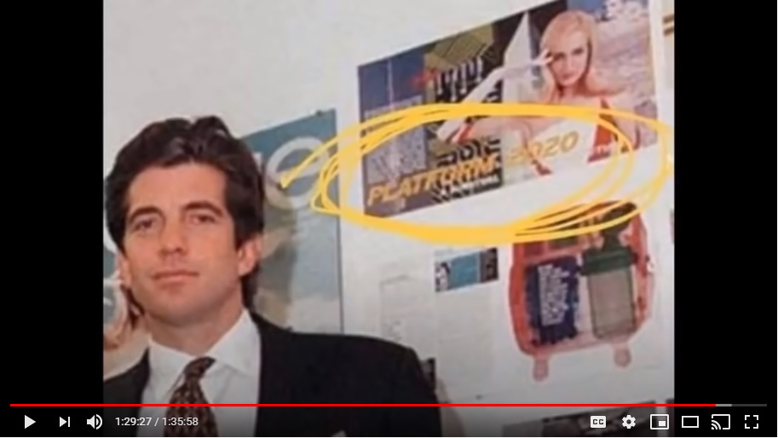
Colleen: Platform 2020
Platform 2020 with a full moon over Mount Rushmore.

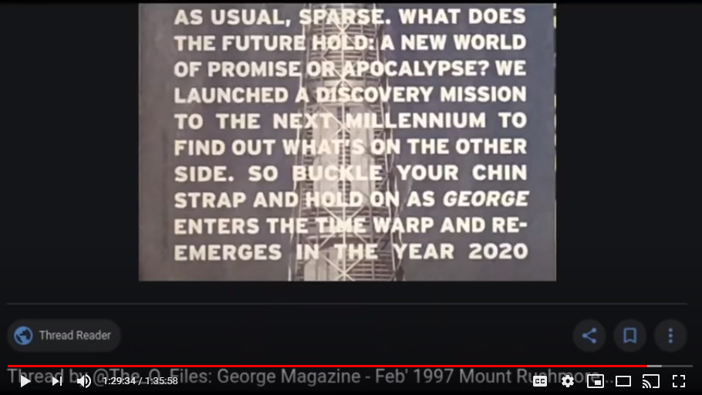
Like Mark knows, the fullest of the moon is July 5th, but July 4th is a very powerful full moon over Mount Rushmore and Donald Trump has announced that he's going to be there on July 4th celebrating Mount Rushmore.

Why I don't know, why would he be there?

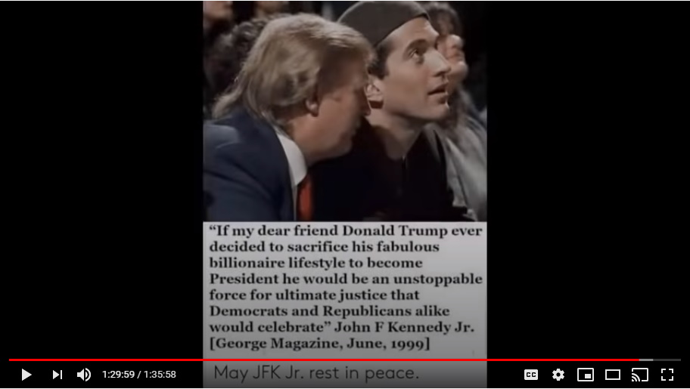
That's weird, and it just happens to be on a magazine cover from February of 1997 for a magazine owned by his best friend in the world which was John F Kennedy, Jr.

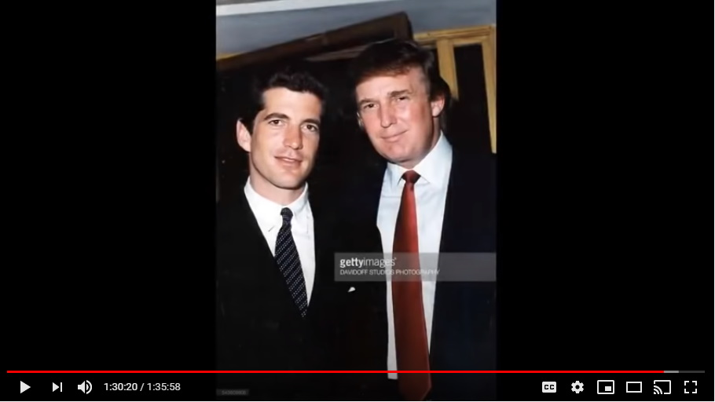
Look folks, at the end of the day, I can speak to this because, I just don't know why, but from a very young age I have been powerfully, powerfully connected to...and it's not fair to say the Kennedy's, I've been very powerfully connected to John Fitzgerald Kennedy and Robert Fitzgerald [Francis] Kennedy. RFK, JFK, I've been powerfully connected.

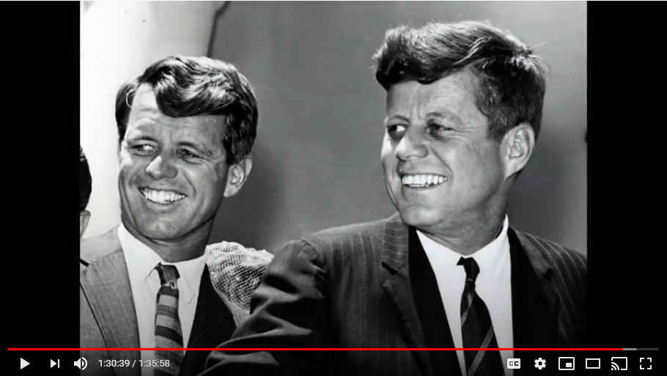
So much so when I was five years of age, I left preschool or kindergarten and I walked home all on my own. I apparently had never done that before. My mom went to pick me up from school, I wasn't there, nobody knew where I was, mom went back home on a chance and she found me downstairs in the basement.

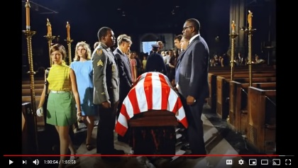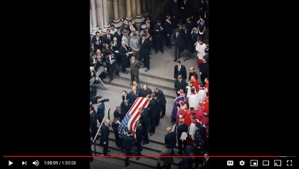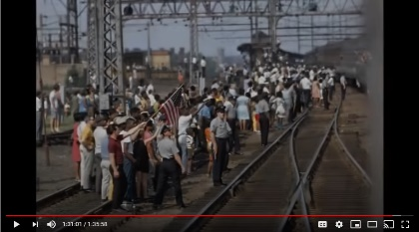
I was watching the funeral train that took RFK's coffin draped in the American flag on a train back across the United States.

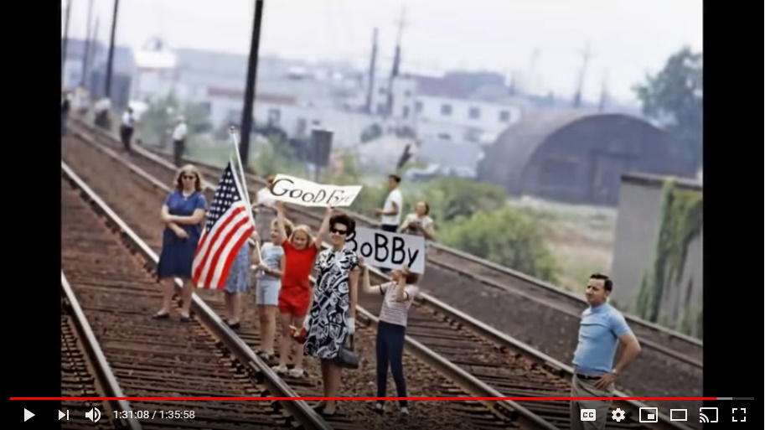
I don't know why, but I have been drawn to this and I have researched it and cared about it desperately my whole life.

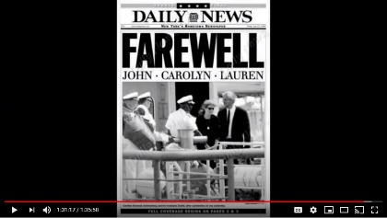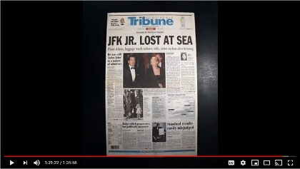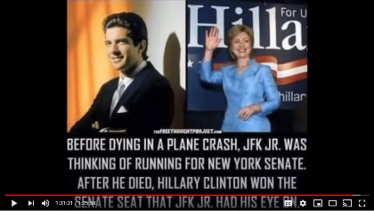
When JFK Jr. was killed in '99 it was a pretty heavy blow to me personally. I just felt like one of the biggest aspects, or parts of hope in my life, was now gone and I was actually very angry for a while because of the carelessness, because he had to have known...

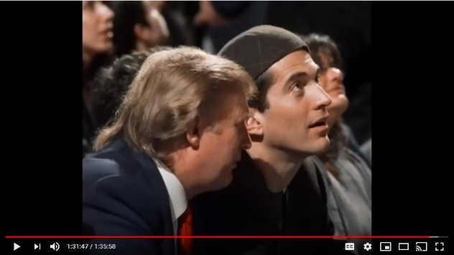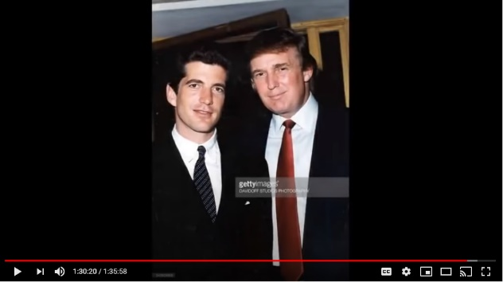
Colleen: So, it's like full circle, this is like completion, this is like the number 12.

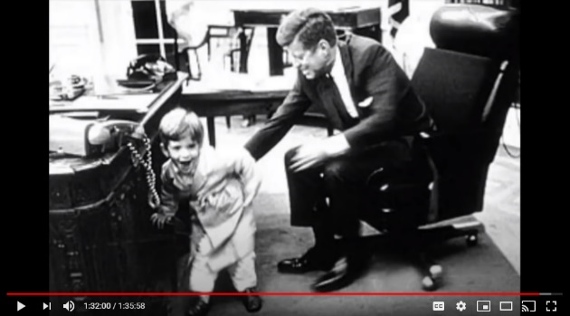
It is for me, so when you hear these stories from behind the scenes that Donald Trump is doing this to aid in the completion of his favorite president which was John F Kennedy and to help the dream of the president's son who went to such an extent that he faked his death and went underground for 21 years to put together the master plan that would take down this world.

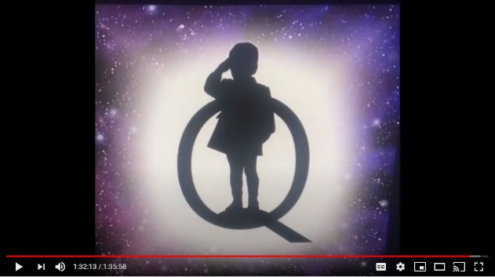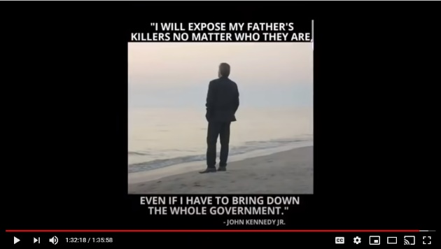
What did John Kennedy say in the very pages of his own magazine publicl*y. He said that I will find the killers, if you remember folks, he said plural killers, of my father and he said I'll evoke justice upon them even if I have to take down the government to do so.
And then he disappeared, or was murdered. You believe what you want to believe, I know what I know.

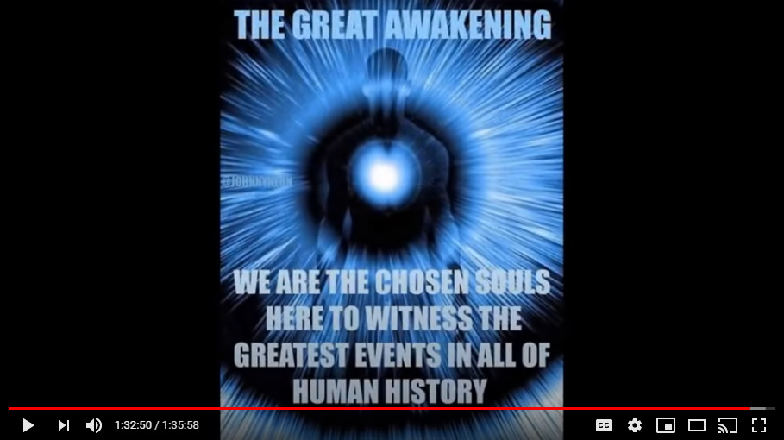
There's a beautifulness to this and the people that don't get this, Mark, have anger in their lives. The people that get this, have love in their hearts. That's about a blunt as I will choose to be right now on this situation.

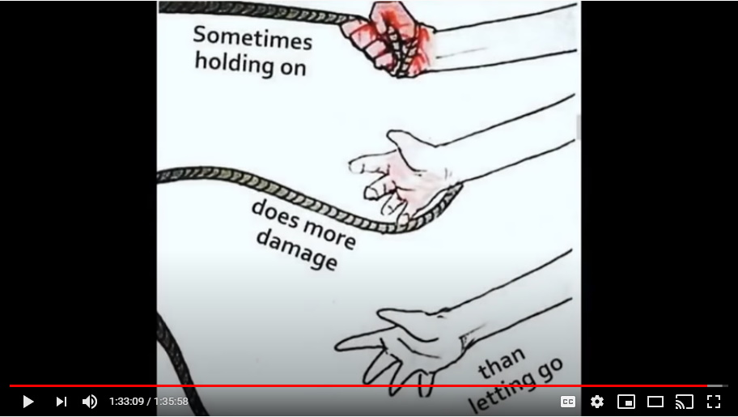
Those that are not getting this and are worried that suddenly this angelic creation and Donald Trump who's doing this because he needs this like he needs a hole in the head, is somehow evil and is now going into a dictatorship and stuff? These people lack love, they lack balance in their minds. That's why we teach meditation, that's why we teach qigong, that's why we teach tai chi, it's why we teach breathing, diet.

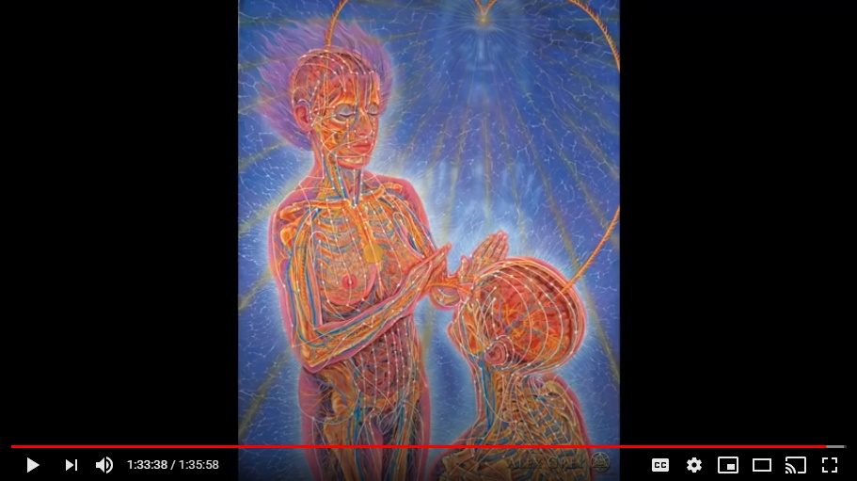
All of these things are going to be so important as we move forward in the year 2021. Healing is what is going to come next.

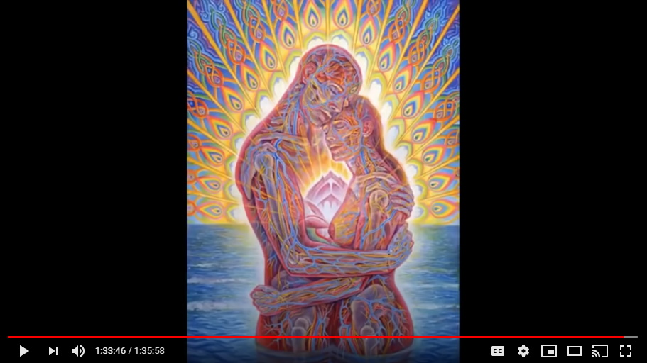
You asked earlier, what's this all going to look like, and how is this going to play out?

I think society is going to be very slow to get back to work. I think there's going to be sort of a feeling like they're getting back to work.

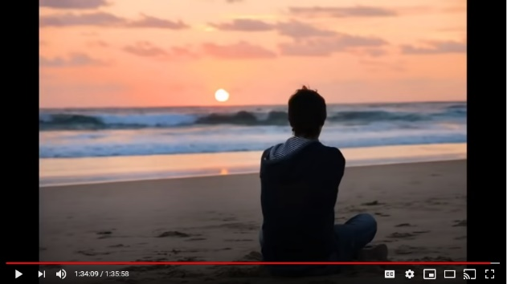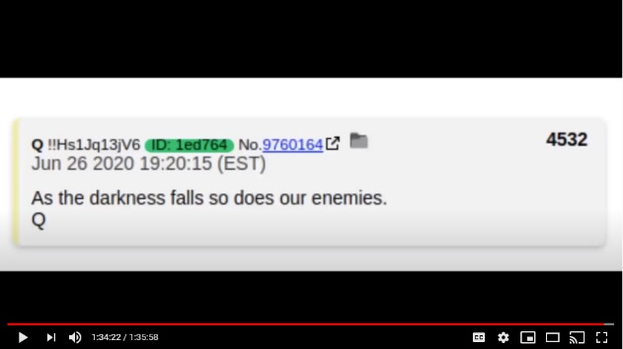
Trump's talking positively getting everybody back to work, but pretty soon it's going to then be the election and then after that election, after the winter solstice, when the sun is the lowest within us that it can possibly be, then I think there's gonna be a time for soul reflection and that's when these tribunals are gonna start.

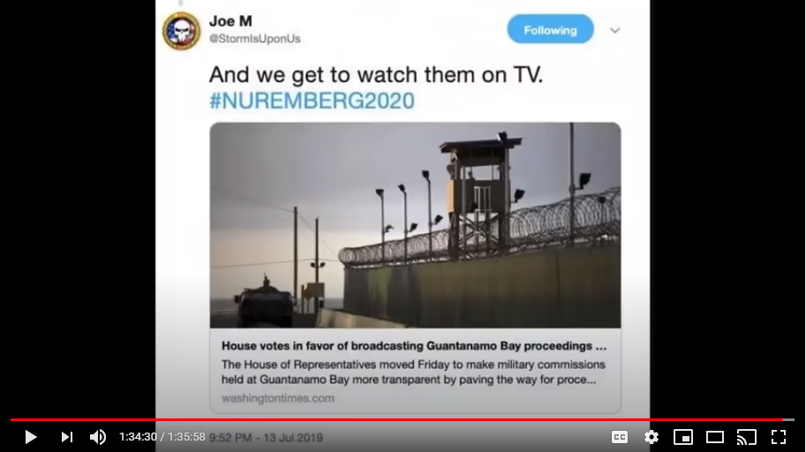
That's when all of this is gonna come out in 2021. It's then we're going to need Mark Devlin. It's then we're going to need Colliwog big time to help all of us process just how dark and evil everything has been.

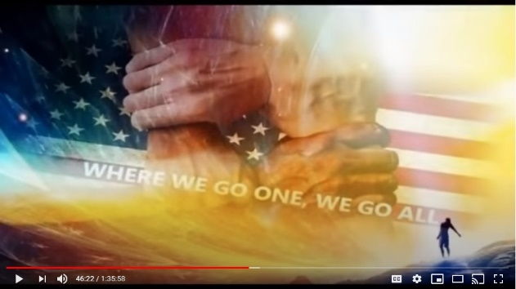
All I can tell you is that I don't guess at these things, I know these things, and I know that Donald Trump is aiding John F Kennedy Jr. revenge his father's plan. It was his father and his uncle's plan.

Many believe “Q” is John F. Kennedy Jr, who faked his death and was placed under witness protection program by the U.S. Military.

